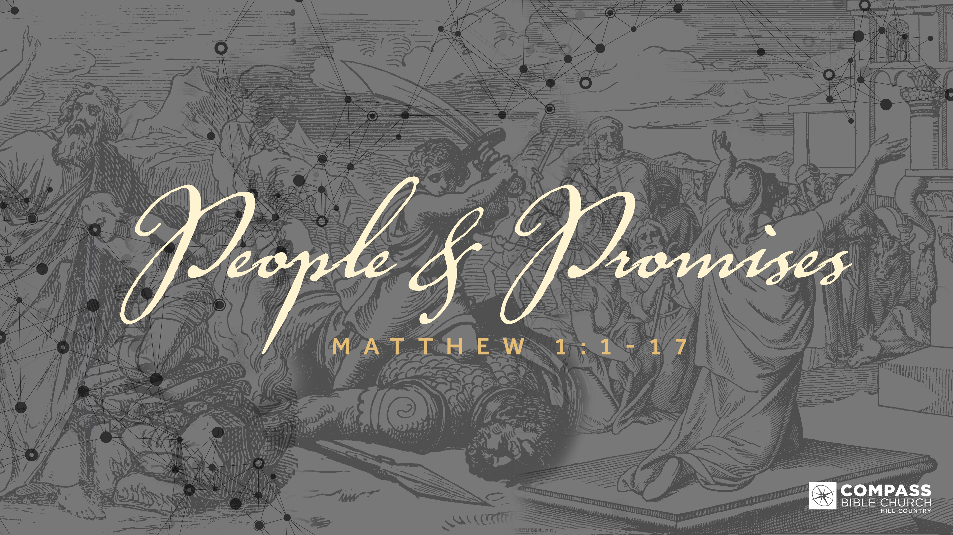
PEOPLE & PROMISES
THE BEGINNING OF A NATION
Matthew 1:1-2
Pastor Hayden Thomas • Compass Bible Church Hill Country • September 4, 2022 • Msg. 22-32

Matthew 1:1-2
1 The book of the genealogy of Jesus Christ, the son of David, the son of Abraham. 2 Abraham was the father of Isaac, and Isaac the father of Jacob, and Jacob the father of Judah and his brothers, (ESV)

1. Let _______________________________ (v.2a)

2. Allow ______________________________ (v.2b)

3. Trust ______________________________ (v.2c)

4. Believe _____________________________ (v.2d)

Application Questions
These questions are provided for your further study and application of today’s sermon. Thoughtfully writing out the answers to these questions will help to drive home the point of today’s study. It is also helpful when you are able to discuss your answers with others. For more information about LifeGroups at Compass Bible Church that utilize these questions as the basis for their weekly discussion, please visit compasshillcountry.org/lifegroups or email us at info@compasshillcountry.org.

1. Write down one observation you found particularly helpful from this week’s sermon.

2. Read Hebrews 11:1. What does a good understanding of God’s long standing track record of promise keeping throughout history do to bolster your faith in Him?
This Week’s Memory Verse
Psalm 139:23-24
23 Search me, O God, and know my heart! Try me and know my thoughts! 24 And see if there be any grievous way in me, and lead me in the way everlasting! (ESV)

3. Read Genesis 17:15–19. What does the story of Isaac and Ishmael show you about the necessity of patient faith? What can you do this week to allow faith to produce patience in your life?
This Week’s
Bible Reading Schedule
September 4th
Prov 5-6 & 1 Cor 14:1-20
September 5th
Proverbs 7-8 & 1 Cor 14:21-40
September 6th
Proverbs 9-10 & 1 Cor 15:1-32
September 7th
Prov 11-12 & 1 Cor 15:33-58
September 8th
Proverbs 13-14 & 1 Cor 16
September 9th
Prov 15-16 & 2 Corinthians 1
September 10th
Prov 17-18 & 2 Corinthians 2
September 11th
Prov 19-20 & 2 Corinthians 3

4. Read Genesis 50:15–21 & Acts 4:27–28. Why is trusting God in dysfunctional situations pivotal for your faith to grow? How do these verses reiterate the need to trust God in dysfunctional situations?

5. Read 2 Peter 3:9–10 and Romans 8:22–25. Like Judah’s life, much of our own lives seem to sit in seasons of obscurity. How do these verses teach you to wait on God in seasons of ambiguity; especially when it concerns the promises of God?

See this sermon and all
Compass-related videos on YouTube.com/
CompassBibleChurchHillCountry
Subscribe to Weekend Sermons, Compass Equip & LifeGroup Leader Podcasts:
CompassChurch.org/podcasts

