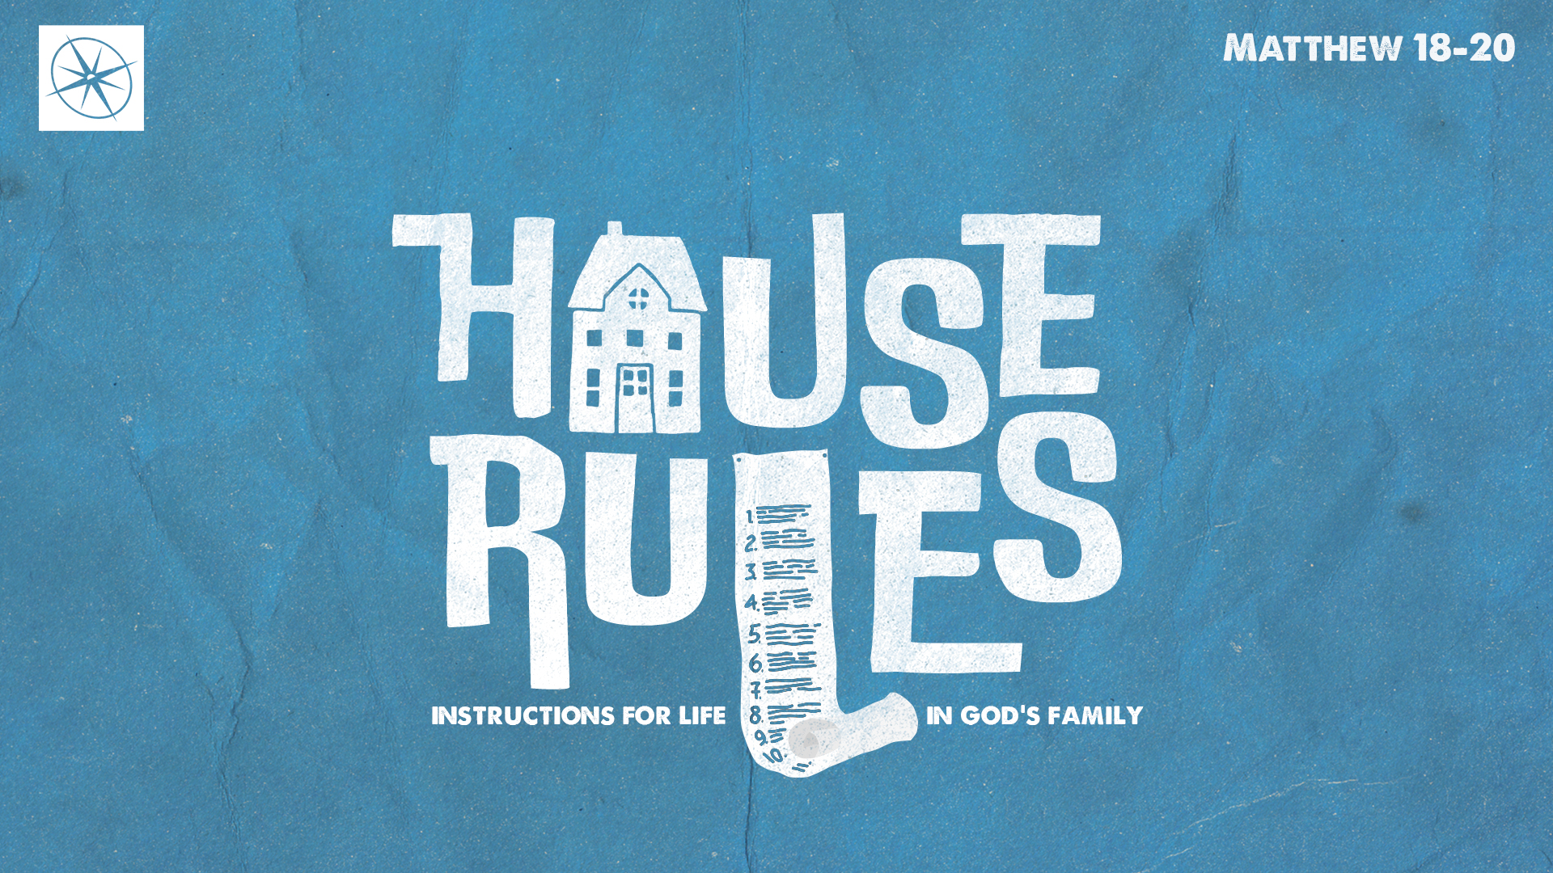

**HOUSE RULES: INSTRUCTIONS FOR LIFE IN GOD’S FAMILY   
WHO IS THE GREATEST?**

Pastor Hayden Thomas • Compass Bible Church Hill Country • September 28, 2025 • Msg. 25-38

**PREACHING POINT: We must remember that in God’s House, the greatest are not ranked by their accolades or how fast they climb the ladder, but by how much they humble themselves in the name of Christ.**

Matthew 18:1–4 (ESV)

1 At that time the disciples came to Jesus, saying, “Who is the greatest in the kingdom of heaven?” 2 And calling to him a child, he put him in the midst of them 3 and said, “Truly, I say to you, unless you turn and become like children, you will never enter the kingdom of heaven. 4 Whoever humbles himself like this child is the greatest in the kingdom of heaven.

1. **Stop __________________________________ (v.1)**
2. **Understand ____________________________ (vv.2-3)**
3. **Excel _________________________________ (v.4)**

**Application Questions**

*These questions are provided for your further study and application of today’s sermon. Thoughtfully writing out the answers to these questions will help to drive home the point of today’s study. It is also helpful when you are able to discuss your answers with others. For more information about LifeGroups at Compass Bible Church that utilize these questions as the basis for their weekly discussion, please visit compasshillcountry.org/lifegroups or email us at info@compasshillcountry.org.*

1. Write down one observation or application you found helpful from this week’s sermon.

*This Week’s  
Bible Reading Schedule*

**September 28th**

*Isaiah 13-15 & Galatians 6*

**September 29th**

*Isaiah 16-18 & Ephesians 1*

**September 30th**

*Isaiah 19-21& Ephesians 2*

**October 1st**

*Isaiah 22-23 & Ephesians 3*

**October 2nd**

*Isaiah 24-26 & Ephesians 4*

**October 3rd**

*Isaiah 27-28 & Ephesians 5*

**October 4rd**

*Isaiah 29-30 & Ephesians 6*

**October 5th**

*Isaiah 31-33 & Philippians 1*

1. Read Matthew 18:1-4. What was Jesus’ point in using a child to illustrate greatness in God’s Kingdom, and how does his illustration inform the way we must choose to relationally engage in God’s church family?
2. Read 1 Corinthians 3:1-7 and Romans 12:3. Although most of us would deny the idea that we “think we are better than other Christians,” in what circumstances can you be tempted to think of yourself as “superior,” “better,” or “not as bad” as other Christians in your life?
3. Read James 3:13-18. What are some of the vile consequences of envy, jealousy and rivalry among church members?  
     
     
     
     
   1. How does Jesus’ words in Matthew 18:1-4 combat this kind of attitude in the church?
4. Read Ephesians 2:8-9 and Matthew 20:25-28. Why do we need to be reminded of the terms in which we entered God’s family? How has this reminder encouraged or convicted you this week?
5. Read 1 Peter 5:5-6 and Ephesians 4:1-6. How do these verses add to your understanding of God’s household rules, specifically regarding humility about oneself and humility toward others?