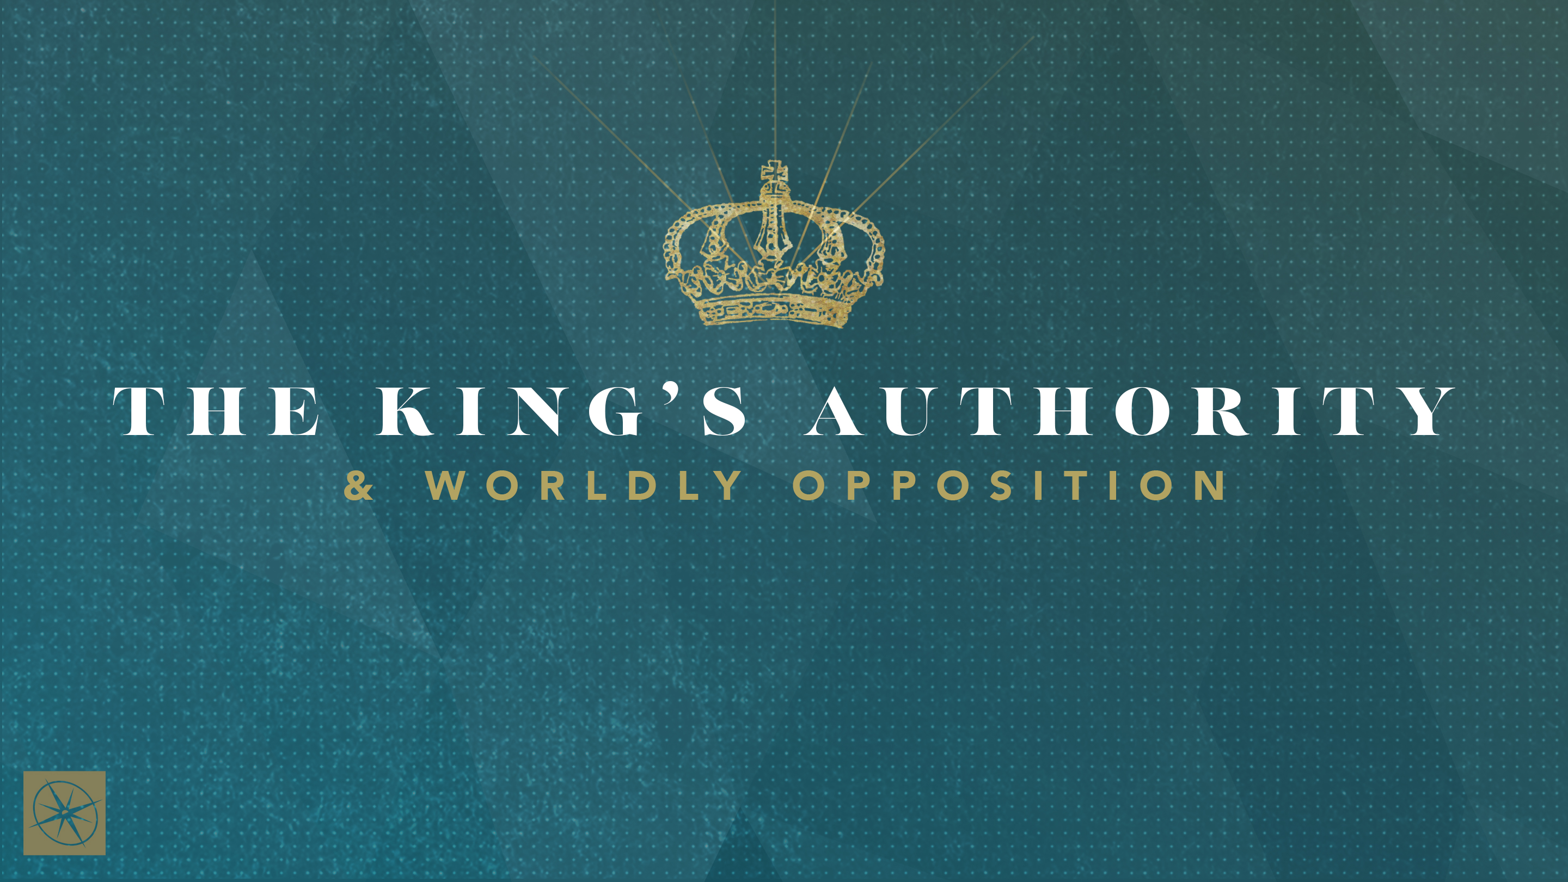

**THE KINGS AUTHORITY & WORLDLY OPPOSITION  
PRIVILEGES AND PREFERENCES**

Pastor Hayden Thomas • Compass Bible Church Hill Country • September 21, 2025 • Msg. 25-37

**PREACHING POINT: Our identities in Christ should empower us to stand up for biblical principles while humbly setting aside our own preferences for the sake of the gospel.**

**Matthew 17:24–27 (ESV)**

24 When they came to Capernaum, the collectors of the two-drachma tax went up to Peter and said, “Does your teacher not pay the tax?” 25 He said, “Yes.” And when he came into the house, Jesus spoke to him first, saying, “What do you think, Simon? From whom do kings of the earth take toll or tax? From their sons or from others?” 26 And when he said, “From others,” Jesus said to him, “Then the sons are free. 27 However, not to give offense to them, go to the sea and cast a hook and take the first fish that comes up, and when you open its mouth you will find a shekel. Take that and give it to them for me and for yourself.”

1. **Recognize ____________________________ (vv.24-26)**
2. **Concede _____________________________ (v.27)**

**Application Questions**

*These questions are provided for your further study and application of today’s sermon. Thoughtfully writing out the answers to these questions will help to drive home the point of today’s study. It is also helpful when you are able to discuss your answers with others. For more information about LifeGroups at Compass Bible Church that utilize these questions as the basis for their weekly discussion, please visit compasshillcountry.org/lifegroups or email us at info@compasshillcountry.org.*

1. Read Galatians 4:4-7 and 2 Peter 1:3-4. How do these passages highlight the privileges you’ve been granted in Christ?

*This Week’s  
Bible Reading Schedule*

**September 21st**

*Song of Sol 1-3 & 2 Cor 12*

**September 22nd**

*Song of Sol 4-5 & 2 Cor 13*

**September 23rd**

*Song of Sol 6-8 & Galatians 1*

**September 24th**

*Isaiah 1-3 & Galatians 2*

**September 25th**

*Isaiah 4-6 & Galatians 3*

**September 26th**

*Isaiah 7-9 & Galatians 4*

**September 27th**

*Isaiah 10-12 & Galatians 5*

**September 28th**

*Isaiah 13-15 & Galatians 6*

* 1. Read Galatians 5:13 and 1 Peter 2:16-17. How can you celebrate your freedom in Christ in a way that causes you or someone else to stumble? How can you keep that from happening?

1. Read 1 Corinthians 10:31-33 and Romans 15:1-3. How can regularly conceding your preferences help your gospel witness? On the other hand, how can insisting on your own way hinder your witness?
2. Read 1 Corinthians 9:19-23 and 1 Corinthians 10:23-24. In what areas of your life are you tempted to use your Christian freedom selfishly rather than responsibly as God’s child?
3. How should your freedom in Christ reshape your daily decisions so that you’re not asking, “What’s best for me?” but “What best advances the gospel and builds others up?” Give two examples of how you can apply this principle this week.
4. Philippians 2:3-8. If the Son of God did not appeal to his equality with the Father, but instead humbled himself for your benefit, how does that intensify your resolve to humble yourself for the benefit of others? Where do you most resist this kind of sacrificial humility?
5. 1 Corinthians 8:9 and Matthew 17:24-27. How have you been guilty of causing unnecessary offense to others based on your personal preferences?   
     
     
     
   1. Keeping in mind Jesus’ words in Matthew 17:24-27, give a few practical examples of how you can deny your own preferences to avoid unnecessarily offending others for the sake of the gospel.question tell you about the importance of prayer when it comes to living by faith in God?