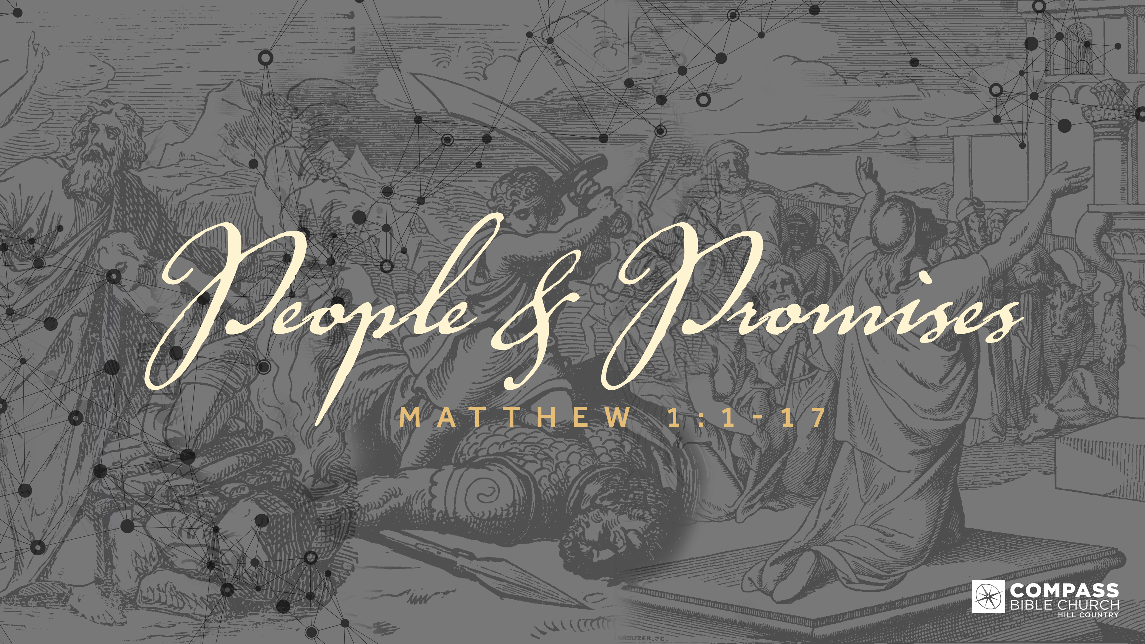
PEOPLE & PROMISES
THE INCUBATION OF A NATION
Matthew 1:3-4
Pastor Hayden Thomas • Compass Bible Church Hill Country • September 11, 2022 • Msg. 22-33

Matthew 1:3-4
3 and Judah the father of Perez and Zerah by Tamar, and Perez the father of Hezron, and Hezron the father of Ram, 4 and Ram the father of Amminadab, and Amminadab the father of Nahshon, and Nahshon the father of Salmon, (ESV)

1. Entrust _____________________________ (v.3)

2. Grasp ______________________________ (v.4a)

3. Embrace ____________________________ (v.4)

Application Questions
These questions are provided for your further study and application of today’s sermon. Thoughtfully writing out the answers to these questions will help to drive home the point of today’s study. It is also helpful when you are able to discuss your answers with others. For more information about LifeGroups at Compass Bible Church that utilize these questions as the basis for their weekly discussion, please visit compasshillcountry.org/lifegroups or email us at info@compasshillcountry.org.

1. Write down one observation you found particularly helpful from this week’s sermon.

2. Read Philippians 3:8–10 and Romans 5:3-4. Using these verses (and others you may know) Explain how suffering is a normal part of the Christian experience? How does your faith in God’s plan increase when you realize that suffering and faith are not mutually exclusive?

3. Read Isaiah 53:2–6, Matthew 26:26–29 and Romans 3:21-26. How does grasping the continuity of God’s redemptive plan in the Old Testament through the New Testament help you understand God’s plan to deliver his people through Christ?
This Week’s
Bible Reading Schedule
September 11th
Prov 19-20 & 2 Corinthians 3
September 12th
Prov 21-22 & 2 Corinthians 4
September 13th
Prov 23-24 & 2 Corinthians 5
September 14th
Prov 25-27 & 2 Corinthians 6
September 15th
Prov 28-29 & 2 Corinthians 7
September 16th
Prov 30-31 & 2 Corinthians 8
September 17th
Ecc 1-3 & 2 Corinthians 9
September 18th
Ecc 4-6 & 2 Corinthians 10

4. Read Hebrews 12:11, Revelation 3:19, and Deuteronomy 8:5-6. Why is accepting that God is a disciplinarian hard for some people? What fruit do you see in your own life that is directly related to God’s discipline in your life?

This Week’s Memory Verse
1 Corinthians 6:11 (ESV)
11 And such were some of you. But you were washed, you were sanctified, you were justified in the name of the Lord Jesus Christ and by the Spirit of our God.

5. What can you do to better embrace God’s discipline moving forward?

See this sermon and all
Compass-related videos on YouTube.com/
CompassBibleChurchHillCountry
Subscribe to Weekend Sermons, Compass Equip & LifeGroup Leader Podcasts:
CompassChurch.org/podcasts

