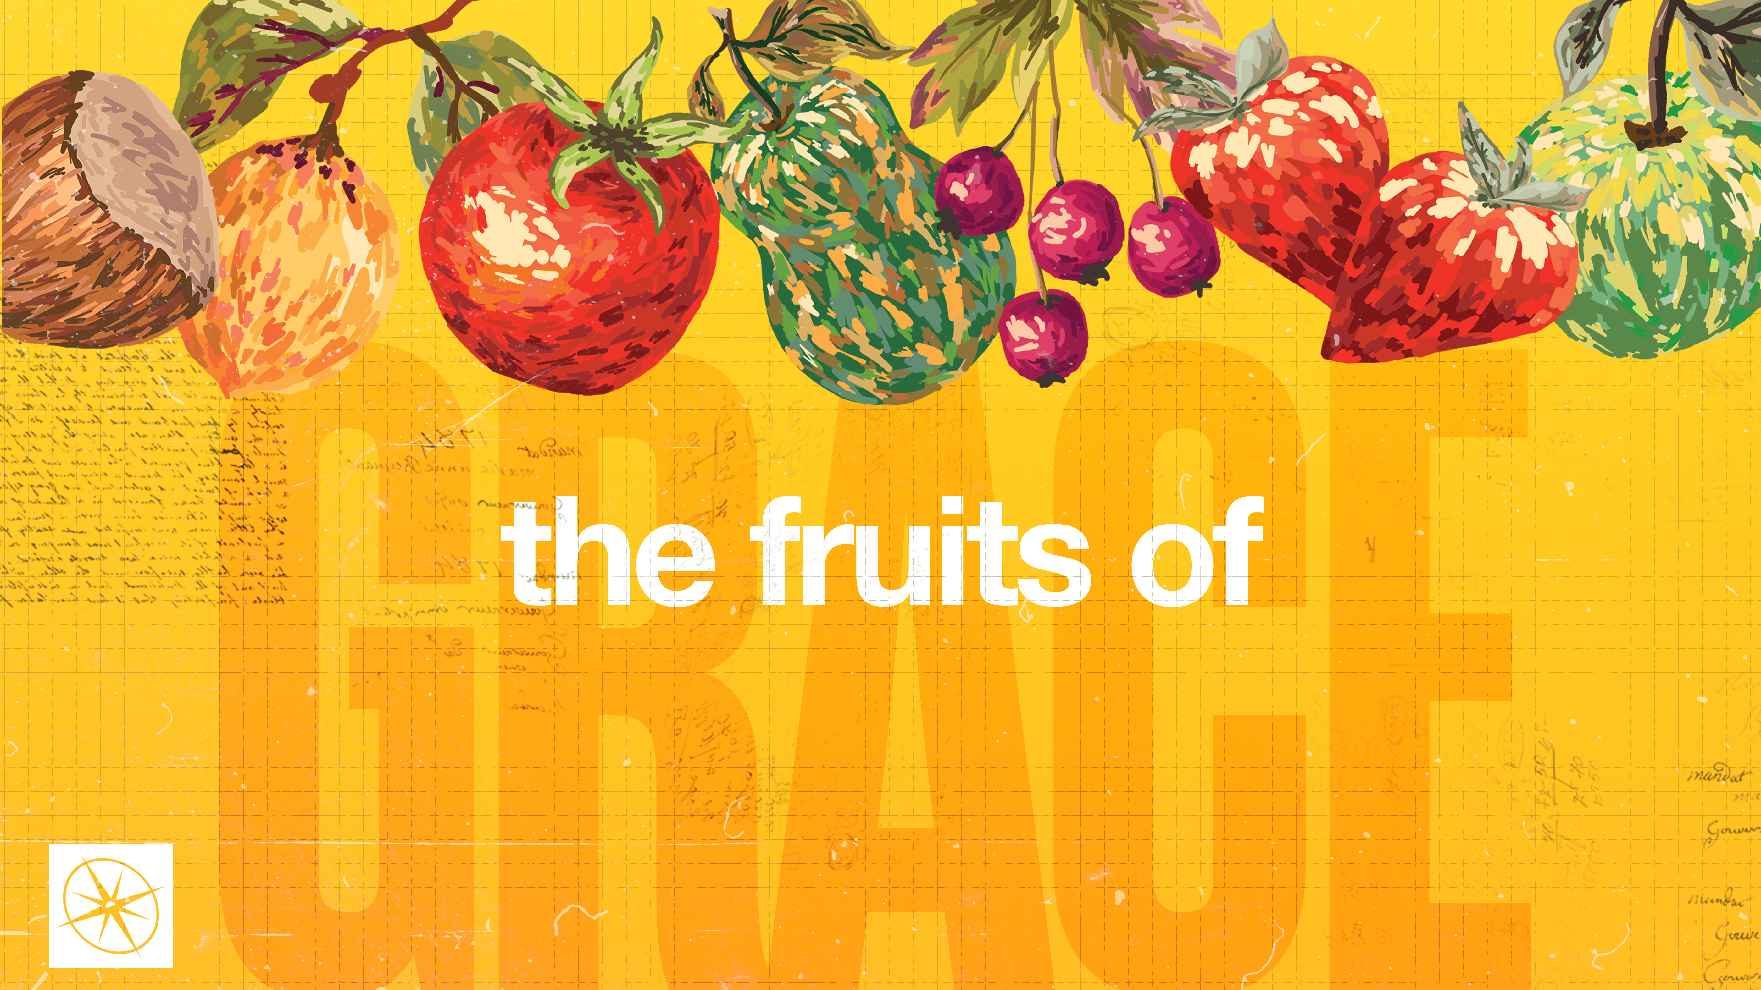

**THE FRUITS OF GRACE  
GOODNESS**

Pastor Hayden Thomas • Compass Bible Church Hill Country • August 31, 2025 • Msg. 25-34

**PREACHING POINT: Resolve to display the Holy Spirit’s fruit of goodness in every arena of your life.**

**Galatians 5:16-23 (ESV)**

16 But I say, walk by the Spirit, and

you will not gratify the desires of the

flesh. 17 For the desires of the flesh

are against the Spirit, and the desires

of the Spirit are against the flesh, for

these are opposed to each other, to

keep you from doing the things you

want to do. 18 But if you are led by

the Spirit, you are not under the law.

19 Now the works of the flesh are

evident: sexual immorality, impurity,

sensuality, 20 idolatry, sorcery,

enmity, strife, jealousy, fits of anger,

rivalries, dissensions, divisions, 21

envy, drunkenness, orgies, and

things like these. I warn you, as I

warned you before, that those who

do such things will not inherit the

kingdom of God. 22 But the fruit of

the Spirit is love, joy, peace,

patience, kindness, goodness,

faithfulness, 23 gentleness, self-

control; against such things there is

no law.

1. **Grasp ________________________________**
2. **By __________________________________**

**Application Questions**

*These questions are provided for your further study and application of today’s sermon. Thoughtfully writing out the answers to these questions will help to drive home the point of today’s study. It is also helpful when you are able to discuss your answers with others. For more information about LifeGroups at Compass Bible Church that utilize these questions as the basis for their weekly discussion, please visit compasshillcountry.org/lifegroups or email us at info@compasshillcountry.org.*

1. Write down one takeaway or application that encouraged or convicted you from this week’s sermon or baptisms.

*This Week’s  
Bible Reading Schedule*

**August 31st**

*Ps 145-147 & 1 Cor 11:1-15*

**September 1st**

*Ps 148-150 & 1 Cor 11:16-34*

**September 2nd**

*Proverbs 1-2 & 1 Cor 12*

**September 3rd**

*Proverbs 3-4 & 1 Cor 13*

**September 4th**

*Proverbs 5-6 & 1 Cor 14:1-20*

**September 5th**

*Proverbs 7-8 & 1 Cor 14:21-40*

**September 6th**

*Prov 9-10 & 1 Cor 15:1-32*

**September 7th**

*Prov 11-12 & 1 Cor 15:33-58*

1. Read Romans 8:28 and Psalm 145:9. How have you personally seen God’s goodness at work in your life, even in hard circumstances?
2. Read Titus 3:4-7 and Colossians 1:15-20. How is God’s goodness chiefly manifested in the person and work of Christ?
3. Read 2 Corinthians 3:17-18. How does God’s plan to sanctify you “from one degree of glory to the next” through the Holy Spirit in this life enhance or change the way you think about what it means to produce the fruit of the Spirit?
4. Read Galatians 6:8-10. How should your view of sowing for the long-term benefits of eternal life keep you from growing weary in doing good in the present age?  
     
     
     
     
   1. In light of your pursuit of doing good, how are you doing at displaying goodness to all, especially to your brothers and sisters in Christ?
   2. How are you resolving to display more goodness in your life this week?