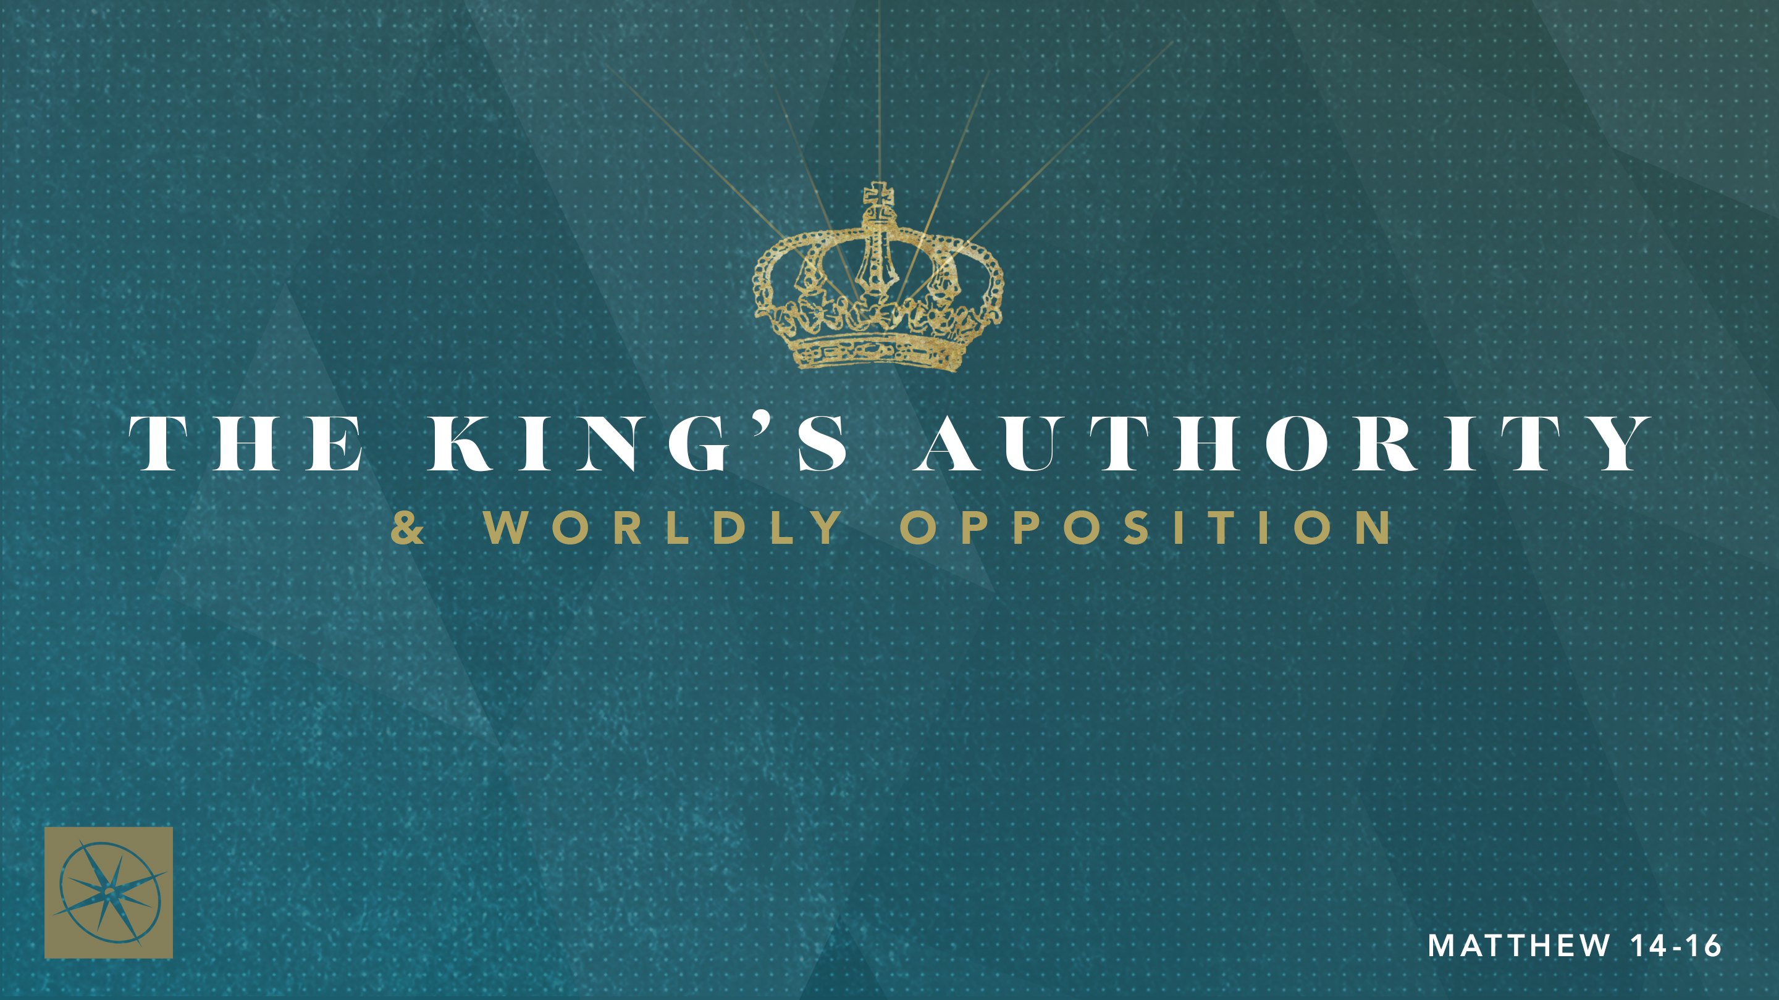

**THE KING’S AUTHORITY & WORLDLY OPPOSITION**

**THE KING OF THE UNSTOPPABLE KINGDOM**Pastor Evan Jacobsen • Compass Bible Church Hill Country • August 3, 2025 • Msg. G25-01

**PREACHING POINT: To make a real difference for God’s Kingdom, deepen your love for Him first.**

**Matthew 16:13–20 (ESV)**

13 Now when Jesus came into the district of Caesarea Philippi, he asked his disciples, “Who do people say that the Son of Man is?” 14 And they said, “Some say John the Baptist, others say Elijah, and others Jeremiah or one of the prophets.” 15 He said to them, “But who do you say that I am?” 16 Simon Peter replied, “You are the Christ, the Son of the living God.” 17 And Jesus answered him, “Blessed are you, Simon Bar-Jonah! For flesh and blood has not revealed this to you, but my Father who is in heaven. 18 And I tell you, you are Peter, and on this rock I will build my church, and the gates of hell shall not prevail against it. 19 I will give you the keys of the kingdom of heaven, and whatever you bind on earth shall be bound in heaven, and whatever you loose on earth shall be loosed in heaven.” 20 Then he strictly charged the disciples to tell no one that he was the Christ.

1. **Love _____________________________ (vv.13-17)**
2. **Love _____________________________ (vv.18-19)**
3. **Love _______________________________________ (v.20)**

**Application Questions**

*These questions are provided for your further study and application of today’s sermon. Thoughtfully writing out the answers to these questions will help to drive home the point of today’s study. It is also helpful when you are able to discuss your answers with others. For more information about LifeGroups at Compass Bible Church that utilize these questions as the basis for their weekly discussion, please visit compasshillcountry.org/lifegroups or email us at info@compasshillcountry.org.*

1. What is one observation or application you found helpful from Sunday’s sermon?

*This Week’s  
Bible Reading Schedule*

**August 3rd**

*Psalms 70-72 & Romans 4*

**August 4th**

*Psalms 73-74 & Romans 5*

**August 5th**

*Psalms 75-77 & Romans 6*

**August 6th**

*Psalms 78 & Romans 7*

**August 7th**

*Psalms 79-81 & Rom 8:1-18*

**August 8th**

*Psalms 82-84 & Rom 8:19-39*

**August 9th**

*Psalms 85-87 & Romans 9*

**August 10th**

*Psalms 88-89 & Romans 10*

1. Read Psalm 146, Ephesians 2:1-10 & Acts 26:9-23. How does grasping the depth of your rebellion and the cost of your salvation fuel you to have deeper love for God and, in turn, increase your boldness to proclaim Him to others?
2. Read 2 Corinthians 5:17-20, Colossians 3:1-14, Philippians 2:1-5, & Matthew 28:18-20. What are some of the Kingdom responsibilities that God gives Christians?   
     
     
     
   1. Why is it wrong to say you love God but ignore the responsibilities He’s called you to steward?
3. Read Matthew 16:18, Romans 8:31-39, & 1 Corinthians 15:51-58. How should God’s guaranteed victory change the way you approach your assigned Kingdom responsibilities as a spouse, parent, boss/employee, neighbor, etc.?  
     
     
     
   1. What specific Kingdom task have you been avoiding that needs your full effort—this week?
4. Read Psalm 4 & Matthew 6:25-33. Why are impatience, anxiety, depression, anger, and other negative responses toward circumstances reveal a lack of love for God?  
     
     
     
   1. What emotions have taken hold of you lately?
   2. To help counsel your heart with truth, what Scripture can you memorize that will guide you to wait for God’s plan to come to fruition with joy, hope, and peace?