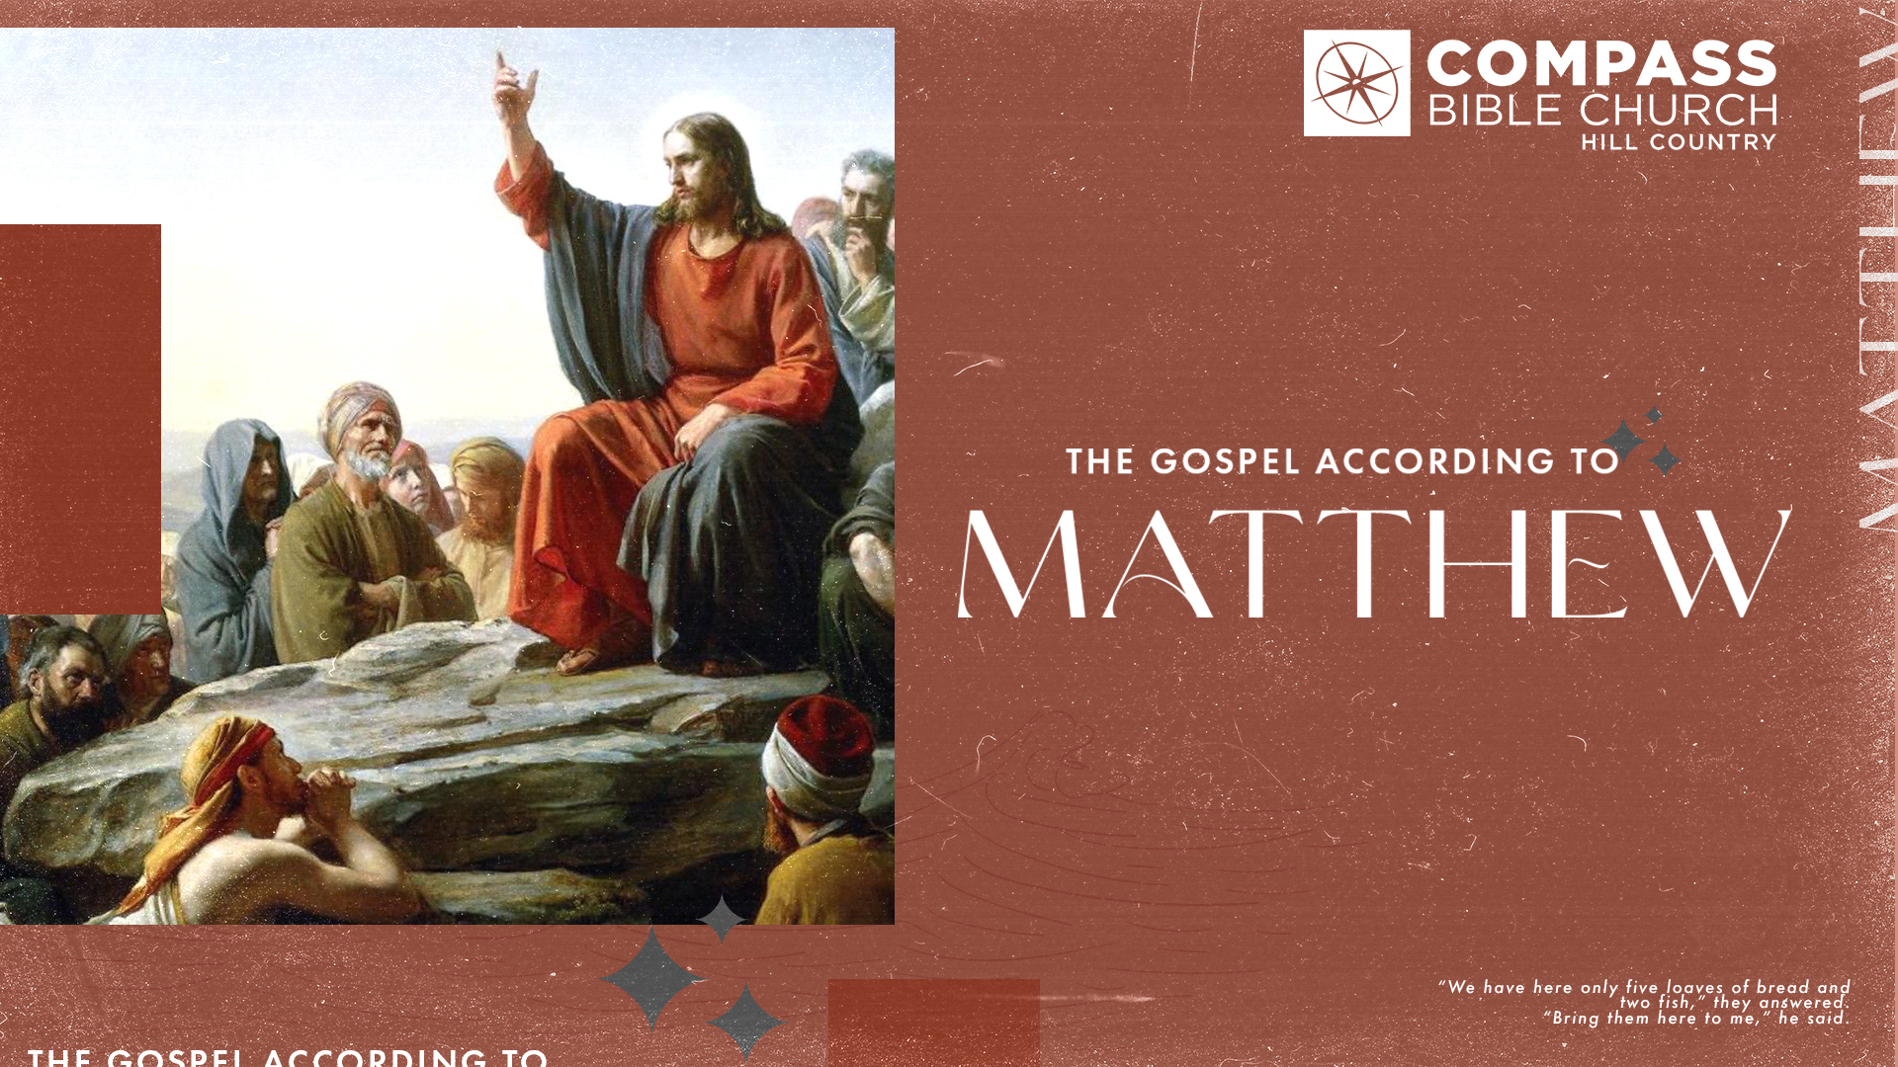
THE GOSPEL OF MATTHEW
INTRODUCTION
Pastor Hayden Thomas • Compass Bible Church Hill Country • August 28, 2022 • Msg. 22-31

1. Identify__________________________

This Week’s
Bible Reading Schedule
August 28th
Psalm 136-138 & 1 Cor 9
August 29th
Psalm 139-141 Cor 10:1-13
August 30th
Ps 142-144 & 1 Cor 10:14-33
August 31st
Ps 145-147 & 1 Cor 11:1-15
September 1st
Ps 148-150 & 1 Cor 11:16-34
September 2nd
Proverbs 1-2 & 1 Cor 12
September 3rd
Proverbs 3-4 & 1 Cor 13
September 4th
Proverbs 5-6 & 1 Cor 14:1-20

2. Know ___________________________
This Week’s Memory Verse
1 Corinthians 1:18
For the word of the cross is folly to those who are perishing, but to us who are being saved it is the power of God (ESV)

3. Deal ___________________________

1. Write down one observation you found particularly helpful from this week’s sermon.

2. Read Matthew 2:22-23, Matthew 2:4-5, and Matthew 5:17-20. Matthew uses Old Testament (OT) references over 55 times and points to Jesus fulfilling OT scripture 12 times in his gospel account. How does Jesus’ fulfillment of so many Old Testament prophecies concerning the coming Messiah undergird your faith with confidence?

3. Read Matthew 1:18–23, Matthew 9:1-8, and Matthew 26:26–29. What do these scriptures explain as the purpose of Jesus’ earthly ministry? As we study the Gospel of Matthew, why is keeping this central theme of “forgiveness of sins” pivotal to understanding all of Jesus’ parables and narratives?

4. Read Matthew 6:33–34, Matthew 6:9–10, and Matthew 19:23–30. These verses show how much Jesus taught us to deal with our lives here by singularly focusing on the Kingdom of God. Why do you think Jesus spent so much time telling people to focus on the Kingdom? What can you do this week to ensure that your heart, mind, and hands are staying focused on the Kingdom of God and not the Kingdom of Earth?

