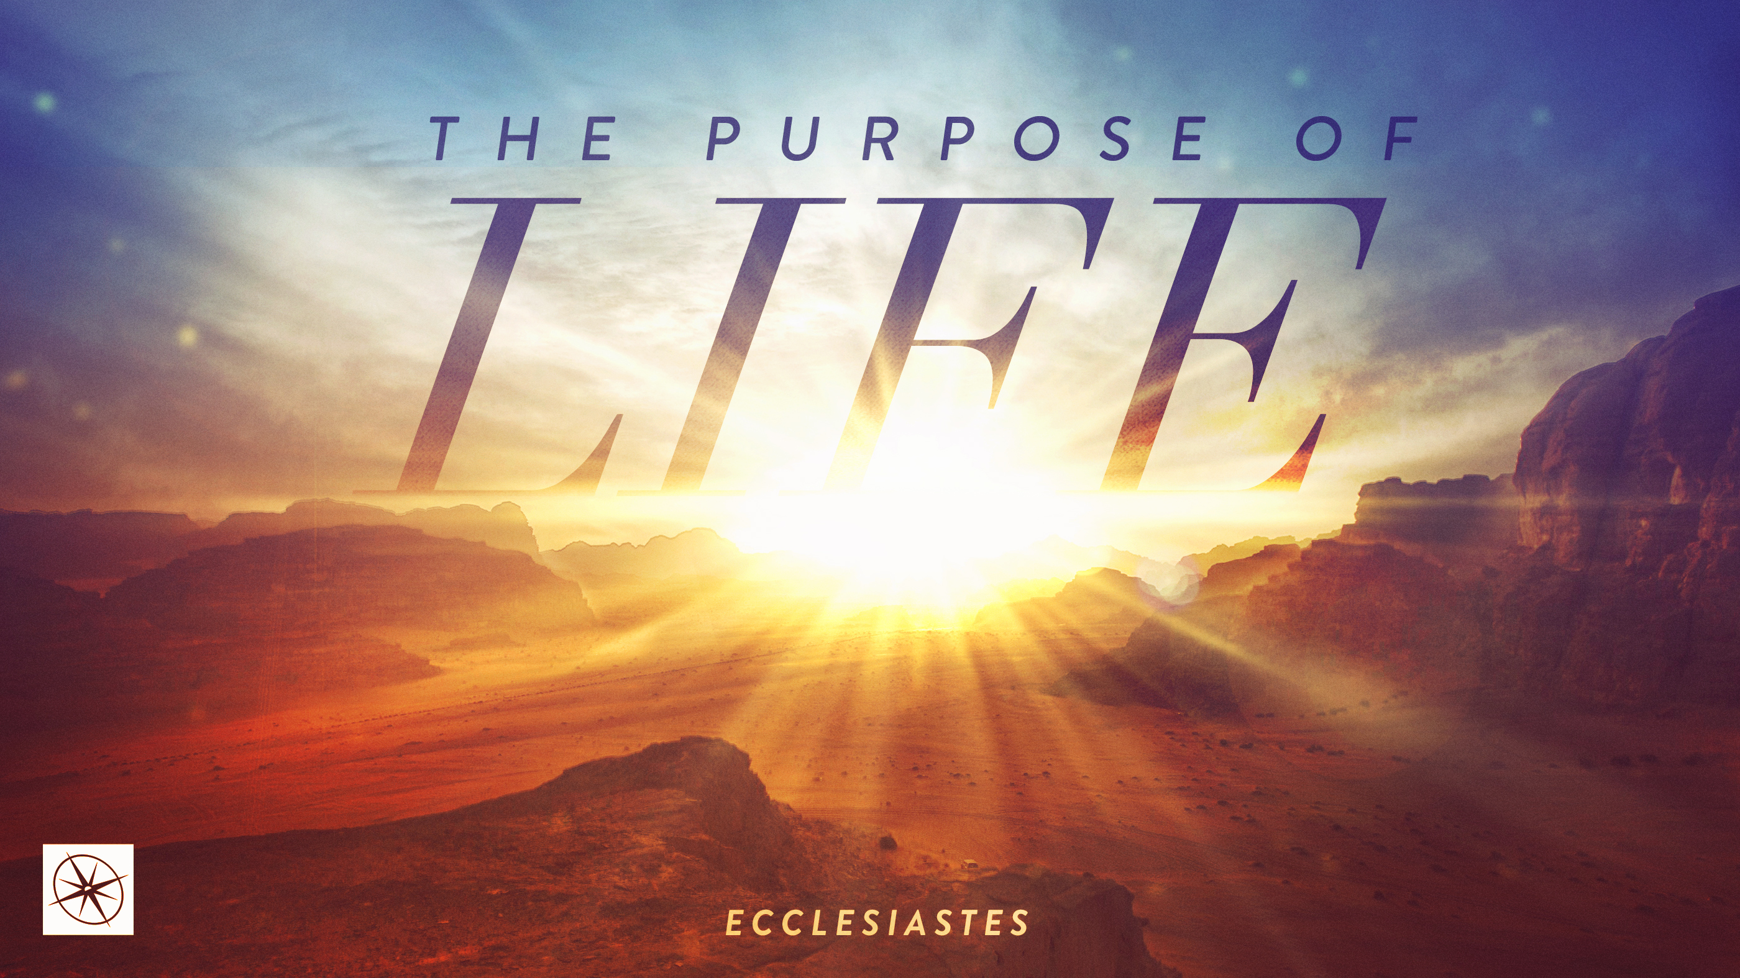

**THE PURPOSE OF LIFE**

Pastor Hayden Thomas • Compass Bible Church Hill Country • August 24, 2025 • Msg. 25-33

**PREACHING POINT: Fulfill your life's purpose by fearing God and obeying His commandments, while keeping the final judgment in view.**

**Ecclesiastes 12:13-14 (ESV)**13 The end of the matter; all has been heard. Fear God and keep his commandments, for this is the whole duty of man. 14For God will bring every deed into judgment, with every secret thing, whether good or evil.

1. **Make ________________________________ (v.13a)**
2. **Make __________________________________ (v.13b)**
3. **Live __________________________________ (v.14)**

**Application Questions**

*These questions are provided for your further study and application of today’s sermon. Thoughtfully writing out the answers to these questions will help to drive home the point of today’s study. It is also helpful when you are able to discuss your answers with others. For more information about LifeGroups at Compass Bible Church that utilize these questions as the basis for their weekly discussion, please visit compasshillcountry.org/lifegroups or email us at info@compasshillcountry.org.*

1. What is one observation or application you found helpful from Sunday’s sermon?

*This Week’s  
Bible Reading Schedule*

**August 24th**

*Psalms 120-123 & 1 Cor 6*

**August 25th**

*Ps 124-127 & 1 Cor 7:1-24*

**August 26th**

*Ps 128-131 & 1 Cor 7:25-40*

**August 27th**

*Psalms 132-135 & 1 Cor 8*

**August 28th**

*Ps 136-138 & 1 Cor 9*

**August 29th**

*Ps 139-141 & 1 Cor 10:1-13*

**August 30th**

*Ps 142-144 & 1 Cor 10:14-33*

**August 31st**

*Ps 145-147 & 1 Cor 11:1-15*

1. Proverbs 9:10 and Proverbs 1:7. Why is the fear of God the foundation of wisdom and knowledge?   
     
     
     
   1. How can a lack of fearing God practically show up in your daily decisions?
2. Read through Psalm 33 and identify a list of reasons the psalmist gives for why you should fear the Lord.   
     
     
     
   1. Pick three reasons from your list and explain how you can apply them to your life this week?
3. Read 1 John 2:3-6 and John 14:21-23. Why should you dismiss any ideas that suggest that God does not care about your obedience?   
     
     
     
   1. What can you do practically to demonstrate how much you care about keeping God’s commandments?
4. Read 1 Corinthians 3:10-15. Paul describes your life’s work being tested by fire. How do you think your current life’s work will fare in the fire of God’s evaluation  
     
     
     
     
   1. In what way does Paul’s reminder of your coming evaluation compel you to live more faithfully today?
   2. Why should you care about your final evaluation, even if you are already destined for eternity with God?