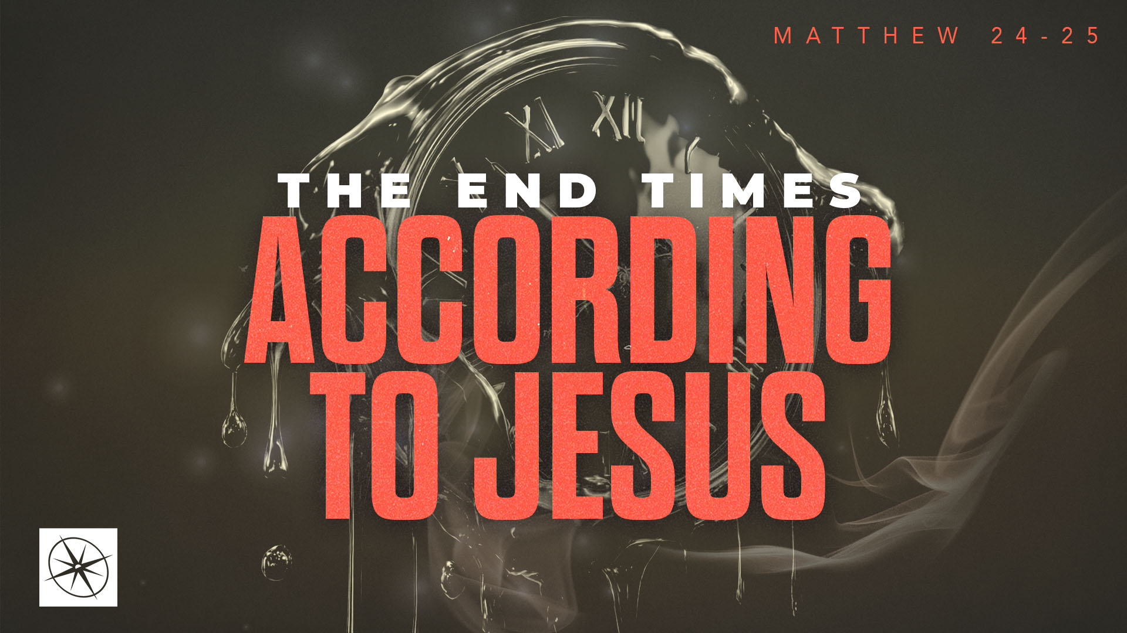
THE END TIMES ACCORDING TO JESUS
GETTING YOUR BEARINGS ON THE END TIMES
Pastor Hayden Thomas • Compass Bible Church Hill Country • August 23, 2026 • Msg. 26-31

PREACHING POINT: To properly grasp what Jesus says about the end times, we must understand both the disciples' historical understanding of the end times and the intentional gap God created in salvation history.

Matthew 24:1–3 (ESV)
1 Jesus left the temple and was going away, when his disciples came to point out to him the buildings of the temple. 2 But he answered them, “You see all these, do you not? Truly, I say to you, there will not be left here one stone upon another that will not be thrown down.” 3 As he sat on the Mount of Olives, the disciples came to him privately, saying, “Tell us, when will these things be, and what will be the sign of your coming and of the end of the age?”

- Understand _______________________________ (vv.1-3)
- Recognize ________________________________ (vv.1-3)
- Grasp ____________________________________ (v.3)

Application Questions
These questions are provided for your further study and application of today’s sermon. Thoughtfully writing out the answers to these questions will help to drive home the point of today’s study. It is also helpful when you are able to discuss your answers with others. For more information about LifeGroups at Compass Bible Church that utilize these questions as the basis for their weekly discussion, please visit compasshillcountry.org/lifegroups or email us at info@compasshillcountry.org.

1. Write down one observation or application you found helpful from this week's sermon. Why did it stand out to you?
This Week’s
Bible Reading Schedule
August 23rd
Ps 119:105-176 & 1 Corinth 5
August 24th
Ps 120-123 & 1 Corinth 6
August 25th
Ps 124-127 & 1 Corinth 7:1-24
August 26th
Ps 128-131 & 1 Cor 7:25-40
August 27th
Ps 132-135 & 1 Corinthians 8
August 28th
Ps 136-138 & 1 Corinthians 9
August 29th
Ps 139-141 & 1 Cor 10:1-13
August 30th
Ps 142-144 & 1 Cor 10:14-33
Have a question about this sermon? Send it via the QR code or link below and the pastors will do their best to address it in this week’s EQUIP podcast.

qrco.de/askaquestion

See this sermon and all Compass-related videos on YouTube.com/
CompassBibleChurchHillCountry
Subscribe to Weekend Sermons, CompassU & LifeGroup Leader Podcasts: compasshillcountry.org/
podcasts

2. Read Isaiah 9:6–7, Daniel 7:13–14, and Acts 1:6. What do these passages reveal about the kind of kingdom the disciples were expecting? Why is it important to let Scripture, rather than our own assumptions, define our expectations about the future?
a. How can you wrongly allow culture, headlines, or a theological system shape your expectations about the future instead of starting with what God actually promised?

3. Read Zechariah 9:9–10 and Luke 19:11. How does understanding the gap between Christ first coming and his second coming help you understand many Old Testament prophecies better?

4. Read Matthew 23:37–39 and Matthew 24:1–3. What events prompted the disciples’ questions, and why must we understand exactly what they were asking before interpreting Jesus’ answer in Matthew 24–25?
5. Read 1 Corinthians 13:1–2 and Jude 1:3. How can you have charity in your eschatological views while remaining convictional about what you believe is to come?
a. How have you either dismissed eschatology as unimportant to keep the peace or caused dissension amongst brothers or sisters in Christ with how you’ve handled your eschatological views?

6. Read Revelation 1:3 and Titus 2:13. Why is disregarding eschatology because it can be divisive or confusing the wrong attitude for a Christian to have?
a. How can avoiding end times teaching, because it feels complicated or controversial, hinder your faith and your attitude about Christ's return?

