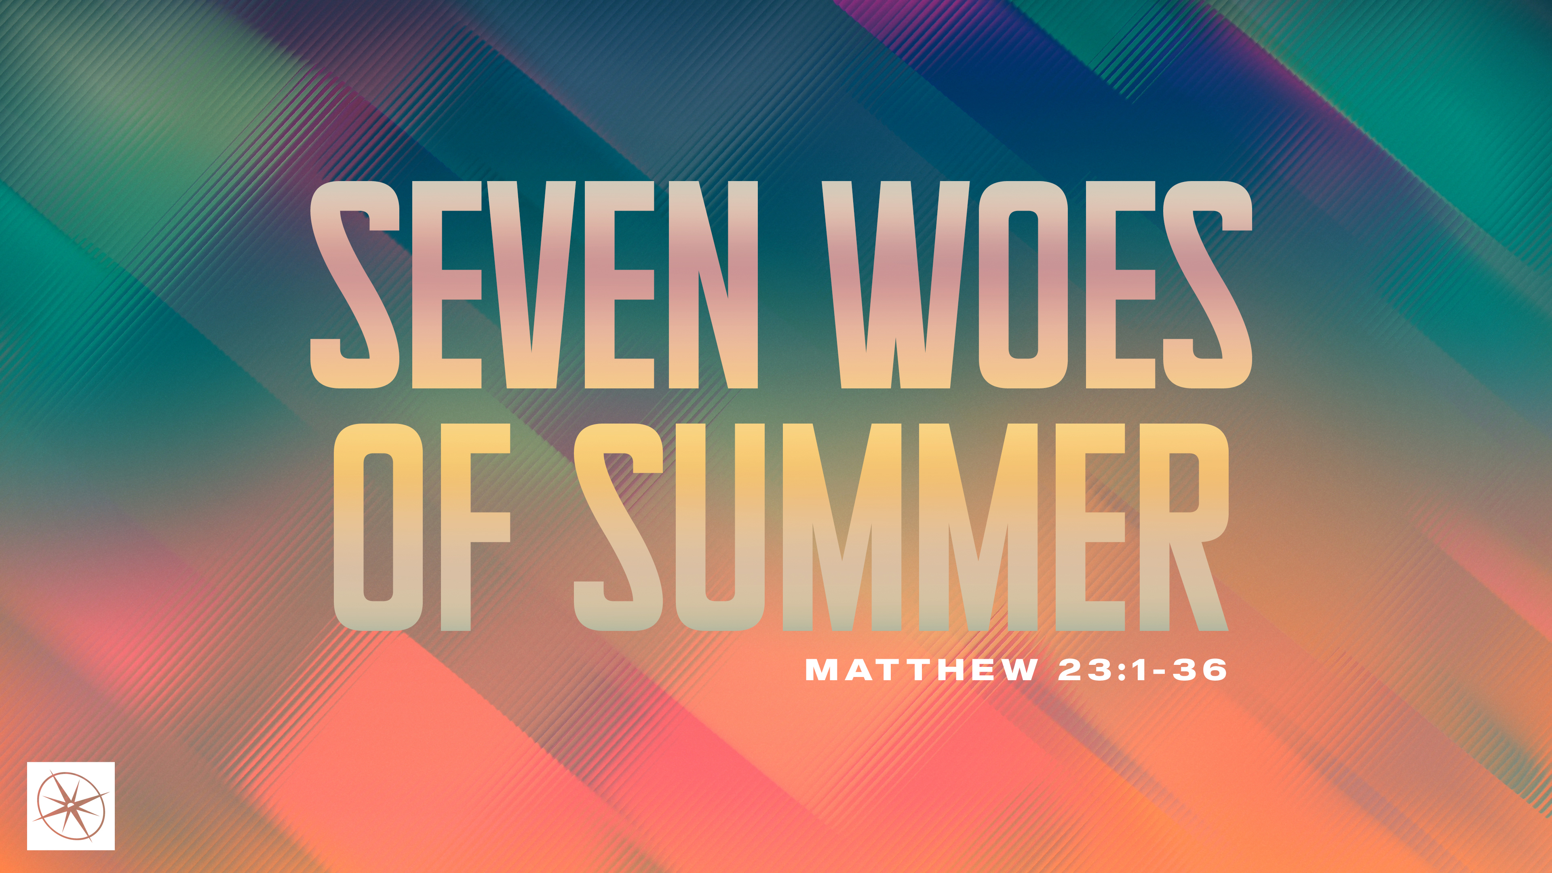
SEVEN WOES OF SUMMER
THE DANGER OF CULTURAL CHRISTIANITY
Pastor Hayden Thomas • Compass Bible Church Hill Country • August 2, 2026 • Msg. 26-28

PREACHING POINT: God wants us to reject a cultural Christianity that leads to judgment and appeal to him for a genuine righteousness that cleanses us from the inside out.

Matthew 23:25–28 (ESV)
25 “Woe to you, scribes and Pharisees, hypocrites! For you clean the outside of the cup and the plate, but inside they are full of greed and self-indulgence. 26 You blind Pharisee! First clean the inside of the cup and the plate, that the outside also may be clean. 27 “Woe to you, scribes and Pharisees, hypocrites! For you are like whitewashed tombs, which outwardly appear beautiful, but within are full of dead people’s bones and all uncleanness. 28 So you also outwardly appear righteous to others, but within you are full of hypocrisy and lawlessness.

- See ____________________________________ (v.25)

- Appeal __________________________________ (v.26)
Have a question about this sermon? Send it via the QR code or link below and the pastors will do their best to address it in this week’s EQUIP podcast.

qrco.de/askaquestion

- Expect _________________________________ (vv.27-28)

Application Questions
These questions are provided for your further study and application of today’s sermon. Thoughtfully writing out the answers to these questions will help to drive home the point of today’s study. It is also helpful when you are able to discuss your answers with others. For more information about LifeGroups at Compass Bible Church that utilize these questions as the basis for their weekly discussion, please visit compasshillcountry.org/lifegroups or email us at info@compasshillcountry.org.

- Write down one observation or application you found helpful from this week’s sermon. Why did it stand out to you?
This Week’s
Bible Reading Schedule
August 2nd
Psalms 68-69 & Romans 3
August 3rd
Psalms 70-72 & Romans 4
August 4th
Psalms 73-74 & Romans 5
August 5th
Psalms 75-77 & Romans 6
August 6th
Psalms 78 & Romans 7
August 7th
Ps 79-81 & Romans 8:1-18
August 8th
Ps 82-84 & Romans 8:19-39
August 9th
Psalms 85-87 & Romans 9
- Read Matthew 15:7–9. Why do you think cultural Christianity is so appealing?
  - In what ways are people tempted to settle for outward religion instead of trusting in Christ to make them righteous before God and transform them from the inside out? Why is settling for this kind of religion ultimately futile?
- Read Ezekiel 36:26–27 and 2 Corinthians 5:21. According to these passages, what distinguishes someone who has genuinely been converted from someone who merely practices cultural Christianity?
  - How would you approach a gospel conversation with someone who is starting to think they are a cultural Christian?
- Read Matthew 7:21–23, Revelation 3:1–3, and 2 Timothy 3:1-5. What warnings do these passages give about having the appearance of godliness without genuine conversion?
- Read 1 John 5:13. How can you pursue biblical assurance without falling into either false confidence or unnecessary doubt?
See this sermon and all Compass-related videos on YouTube.com/
CompassBibleChurchHillCountry
Subscribe to Weekend Sermons, CompassU & LifeGroup Leader Podcasts: compasshillcountry.org/
podcasts


