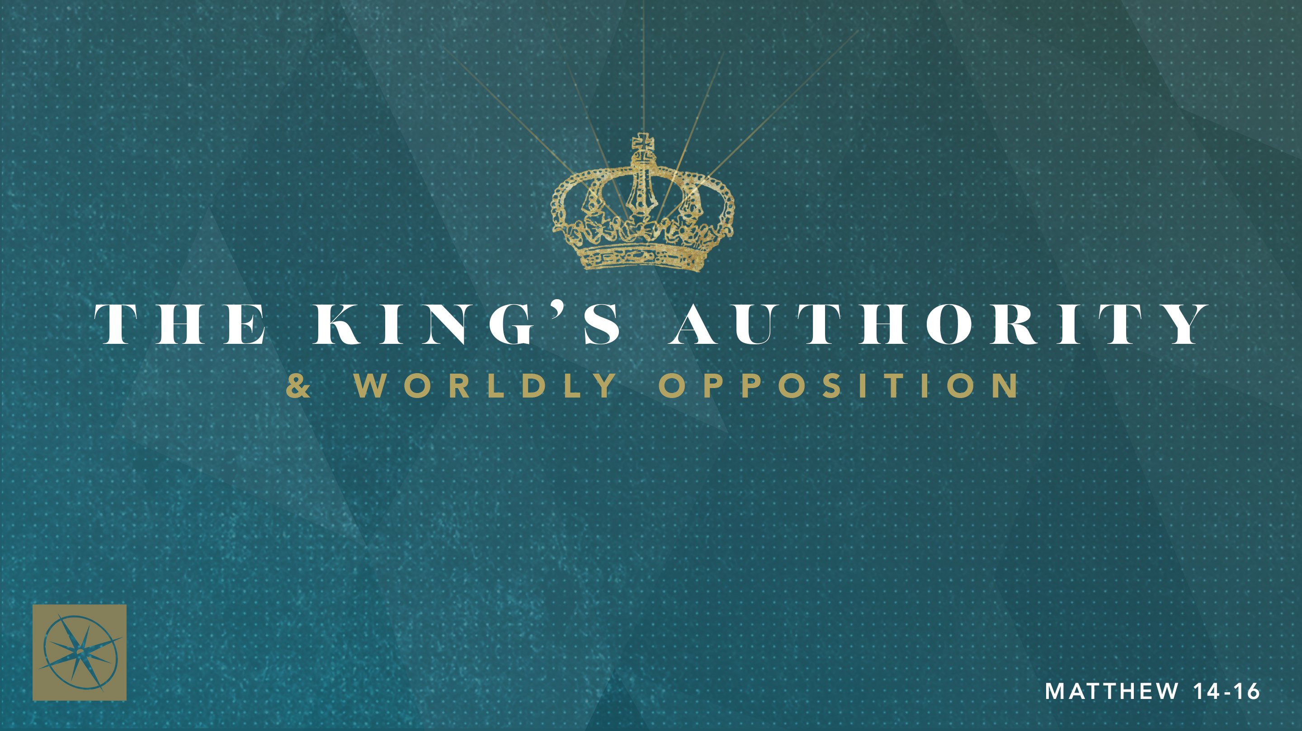

**THE KING’S AUTHORITY & WORLDLY OPPOSITION**

**THE COSTS AND BENEFITS OF FOLLOWING THE KING**Pastor Hayden Thomas • Compass Bible Church Hill Country • August 17, 2025 • Msg. 25-32

**PREACHING POINT: Every Christian must willingly accept the costs associated with following Jesus, knowing that the sacrifices made in this life pale in comparison to the benefits of eternity in God’s Kingdom.**

**Matthew 16:24–28 (ESV)**

24 Then Jesus told his disciples, “If anyone would come after me, let him deny himself and take up his cross and follow me. 25 For whoever would save his life will lose it, but whoever loses his life for my sake will find it. 26 For what will it profit a man if he gains the whole world and forfeits his soul? Or what shall a man give in return for his soul? 27 For the Son of Man is going to come with his angels in the glory of his Father, and then he will repay each person according to what he has done. 28 Truly, I say to you, there are some standing here who will not taste death until they see the Son of Man coming in his kingdom.”

1. **Ask: __________________________________ (v.24)**
2. **Soberly ______________________________ (vv.25-26)**
3. **Live _________________________________(vv.27-28)**

**Application Questions**

*These questions are provided for your further study and application of today’s sermon. Thoughtfully writing out the answers to these questions will help to drive home the point of today’s study. It is also helpful when you are able to discuss your answers with others. For more information about LifeGroups at Compass Bible Church that utilize these questions as the basis for their weekly discussion, please visit compasshillcountry.org/lifegroups or email us at info@compasshillcountry.org.*

1. Write down one observation or application you found helpful from this week’s sermon.

*This Week’s  
Bible Reading Schedule*

**August 17th**

*Ps 107-108 & Rom 15:21-33*

**August 18th**

*Ps 109-111 & Romans 16*

**August 19th**

*Psalms 112-115 & 1 Cor 1*

**August 20th**

*Psalms 116-118 & 1 Cor 2*

**August 21st**

*Psalms 119:1-48 & 1 Cor 3*

**August 22nd**

*Psalms 119:49-104 & 1 Cor 4*

**August 23rd**

*Ps 119:105-176 & 1 Cor 5*

**August 24th**

*Psalms 120-123 & 1 Cor 6*

1. Read Matthew 7:21-23 and Luke 6:46-49. How should Jesus' words give you urgency to ensure you and those around you honestly answer the question, “Am I really following Jesus”?   
     
     
     
   1. What can you do to help your friends and loved ones elevate their concern for the way they answer this question?
2. Read Matthew 16:24. How are you doing in the three areas Jesus identified to help you know if you are following Him? (Deny yourself, Take up your cross, Follow Jesus)
3. Read Matthew 16:25-26 and Luke 12:13-21. When faced with daily choices, how do you decide whether to choose your own desires or deny yourself and follow Christ?  
     
     
     
   1. How would you warn someone who is trying to ride the fence when it comes to living as much as they can for themselves while still confessing to follow Jesus?
4. Read Revelation 22:12-13 and Matthew 16:27. Why should keeping Christ’s final recompense in view transform the way you think and feel about the costs of self-denial, sacrifice, and devotion to Him?  
     
     
     
     
   1. As you fix your eyes on Christ’s return and His promised reward, how has it reshaped the way you view the cost of self-denial and sacrificial living?