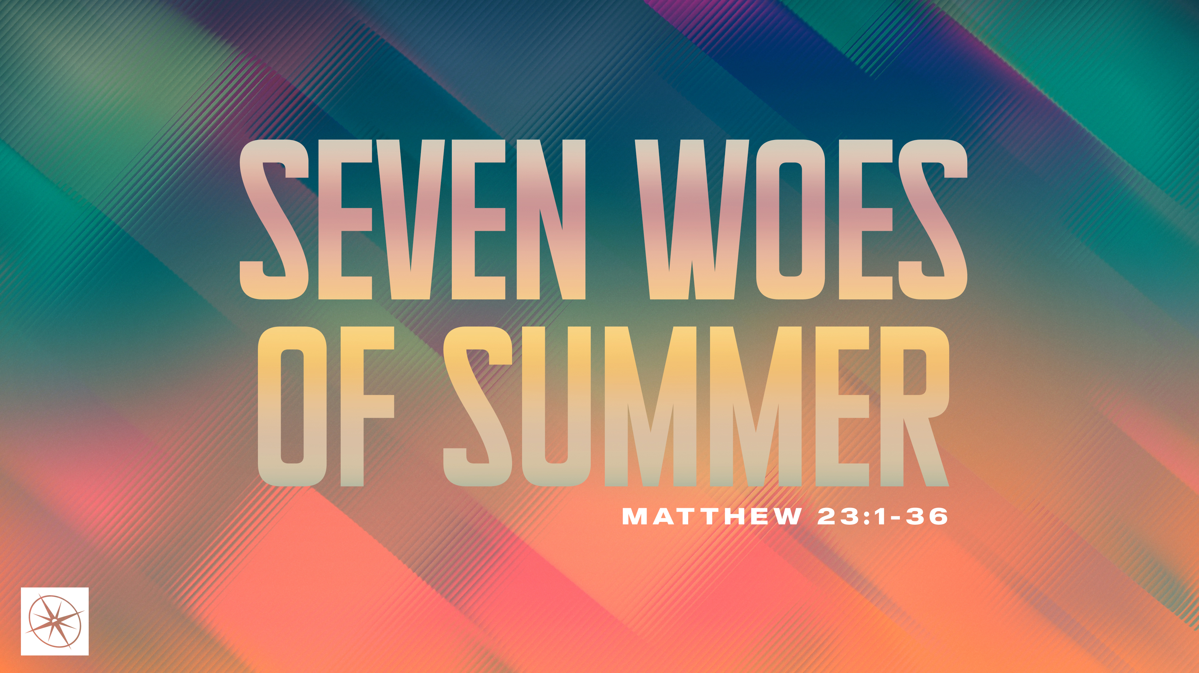
SEVEN WOES OF SUMMER
THE DANGER OF MAJORING ON THE MINORS
Pastor Hayden Thomas • Compass Bible Church Hill Country • July 26, 2026 • Msg. 26-27

PREACHING POINT: Knowing what God values most should lead us to prioritize the weightier matters of Scripture without neglecting the rest.

Matthew 23:23–24 (ESV)
23 “Woe to you, scribes and Pharisees, hypocrites! For you tithe mint and dill and cumin, and have neglected the weightier matters of the law: justice and mercy and faithfulness. These you ought to have done, without neglecting the others. 24 You blind guides, straining out a gnat and swallowing a camel!

- Distinguish _______________________________ (v.23a)

- Pursue __________________________________ (v.23b)
Have a question about this sermon? Send it via the QR code or link below and the pastors will do their best to address it in this week’s EQUIP podcast.

qrco.de/askaquestion

- Recognize _________________________________ (v.24)

Application Questions
These questions are provided for your further study and application of today’s sermon. Thoughtfully writing out the answers to these questions will help to drive home the point of today’s study. It is also helpful when you are able to discuss your answers with others. For more information about LifeGroups at Compass Bible Church that utilize these questions as the basis for their weekly discussion, please visit compasshillcountry.org/lifegroups or email us at info@compasshillcountry.org.

- Write down one observation or application you found helpful from this week’s sermon. Why did it stand out to you?
This Week’s
Bible Reading Schedule
July 26th
Psalms 47-49 & Acts 26
July 27th
Psalms 50-52 & Acts 27:1-25
July 28th
Psalms 53-55 & Acts 27:26-44
July 29th
Psalms 56-58 & Acts 28:1-15
July 30th
Psalms 59-61 & Acts 28:16-31
July 31st
Psalms 62-64 & Romans 1
August 1st
Psalms 65-67 & Acts 25
August 2nd
Psalms 68-69 & Acts 26
- Read Matthew 23:23 and Hosea 6:6. How can you grow in your ability to distinguish between the weightier things of God’s Word and the lighter matters of God’s Word?
  - What dangers arise when Christians fail to distinguish between the weightier and lighter matters of Scripture?
  - Why is growing in this kind of spiritual discernment so necessary?
- Read Matthew 23:23b (starting with the word “these”) and Matthew 5:19. What balance does Jesus expect you to maintain between the weightier matters of Scripture and the rest of God's commands?
  - What does pursuing faithfulness in everything while distinguishing between the weightier matters and lighter matters of scripture look like at church, at work and at home?
- Read Amos 5:21–24. Why did God reject Israel's worship? How can you be guilty of obeying some of God’s commands, while ignoring some of the weightier commands of God throughout the week?
- Read Matthew 23:24. If Jesus evaluated your life the way he evaluated the Scribes and Pharisees, where might he say you are "straining out a gnat while swallowing a camel"? (e.g., favorite theological topics, easier areas of obedience, hobby horses, current hot topics, etc.)?
  - After identifying an area where you may be "majoring on the minors," write out a prayer of confession and repentance that reflects your desire to live according to God’s priorities.
See this sermon and all Compass-related videos on YouTube.com/
CompassBibleChurchHillCountry
Subscribe to Weekend Sermons, CompassU & LifeGroup Leader Podcasts: compasshillcountry.org/
podcasts


