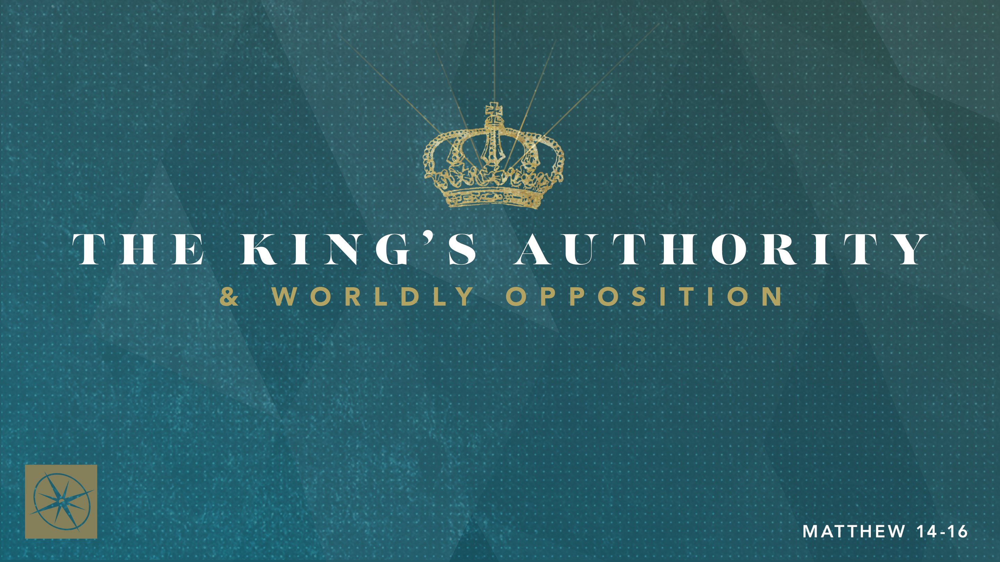

**THE KING’S AUTHORITY & WORLDLY OPPOSITION**

**FRAGILE FAITH AND FALSE TEACHERS**Pastor Hayden Thomas • Compass Bible Church Hill Country • July 20, 2025 • Msg. 25-30

**PREACHING POINT: In a world flooded with dangerous and deceptive teaching, we must continue maturing in our faith or risk being swept away by error.**

**Matthew 16:5–12 (ESV)**

5 When the disciples reached the other side, they had forgotten to bring any bread. 6 Jesus said to them, “Watch and beware of the leaven of the Pharisees and Sadducees.” 7 And they began discussing it among themselves, saying, “We brought no bread.” 8 But Jesus, aware of this, said, “O you of little faith, why are you discussing among yourselves the fact that you have no bread? 9 Do you not yet perceive? Do you not remember the five loaves for the five thousand, and how many baskets you gathered? 10 Or the seven loaves for the four thousand, and how many baskets you gathered? 11 How is it that you fail to understand that I did not speak about bread? Beware of the leaven of the Pharisees and Sadducees.” 12 Then they understood that he did not tell them to beware of the leaven of bread, but of the teaching of the Pharisees and Sadducees.

1. **Identify _____________________________ (vv.5-7)**
2. **Make _____________________________ (vv.8-11a)**
3. **Put _______________________________________ (vv.11b-12)**

**Application Questions**

*These questions are provided for your further study and application of today’s sermon. Thoughtfully writing out the answers to these questions will help to drive home the point of today’s study. It is also helpful when you are able to discuss your answers with others. For more information about LifeGroups at Compass Bible Church that utilize these questions as the basis for their weekly discussion, please visit compasshillcountry.org/lifegroups or email us at info@compasshillcountry.org.*

1. Write down one observation or application you found helpful from this week’s sermon.

*This Week’s  
Bible Reading Schedule*

**July 20th**

*Psalms 31-33 & Acts 21:15-40*

**July 21st**

*Psalms 34-35 & Acts 22*

**July 22th**

*Psalms 36-37 & Acts 23:1-11*

**July 23td**

*Psalms 38-40 & Acts 23:12-35*

**July 24th**

*Psalms 41-43 & Acts 24*

**July 25th**

*Psalms 44-46 & Acts 25*

**July 26th**

*Psalms 47-49 & Acts 26*

**July 27th**

*Psalms 50-52 & Acts 27:1-25*

1. Read Colossians 2:6-8 and Jude 3-21. How do these passages emphasize God’s desire for you to both guard against false teaching and actively grow in spiritual maturity?  
     
     
     
   1. What are the dangers of disregarding one or both of these?
2. Read Matthew 16:5-12. How have you been guilty of worrying about earthly things when Jesus was expecting you to focus on Him and His teachings?  
     
     
     
   1. If you are maturing in your faith, how has growing in spiritual maturity changed the way you handle moments of “felt needs” with godliness instead of spiritual immaturity.
3. Read 2 Peter 1:5-11 and Romans 12:1-2. What specific steps can you take to make growing in spiritual maturity a clear and consistent priority in your daily life?
4. Read Hebrews 5:11-6:1 and Colossians 1:9-10. Spiritual maturity isn’t just about knowing more; it’s about living differently. In what ways should growing in Christian maturity change your attitude, direct your actions, and realign your affections?  
     
     
     
   1. Increasing in spiritual maturity produces godly discernment. How does godly discernment bridge the gap between what you know and how you live?
   2. What role should discernment play in applying biblical truth with wisdom in a world full of false teaching?