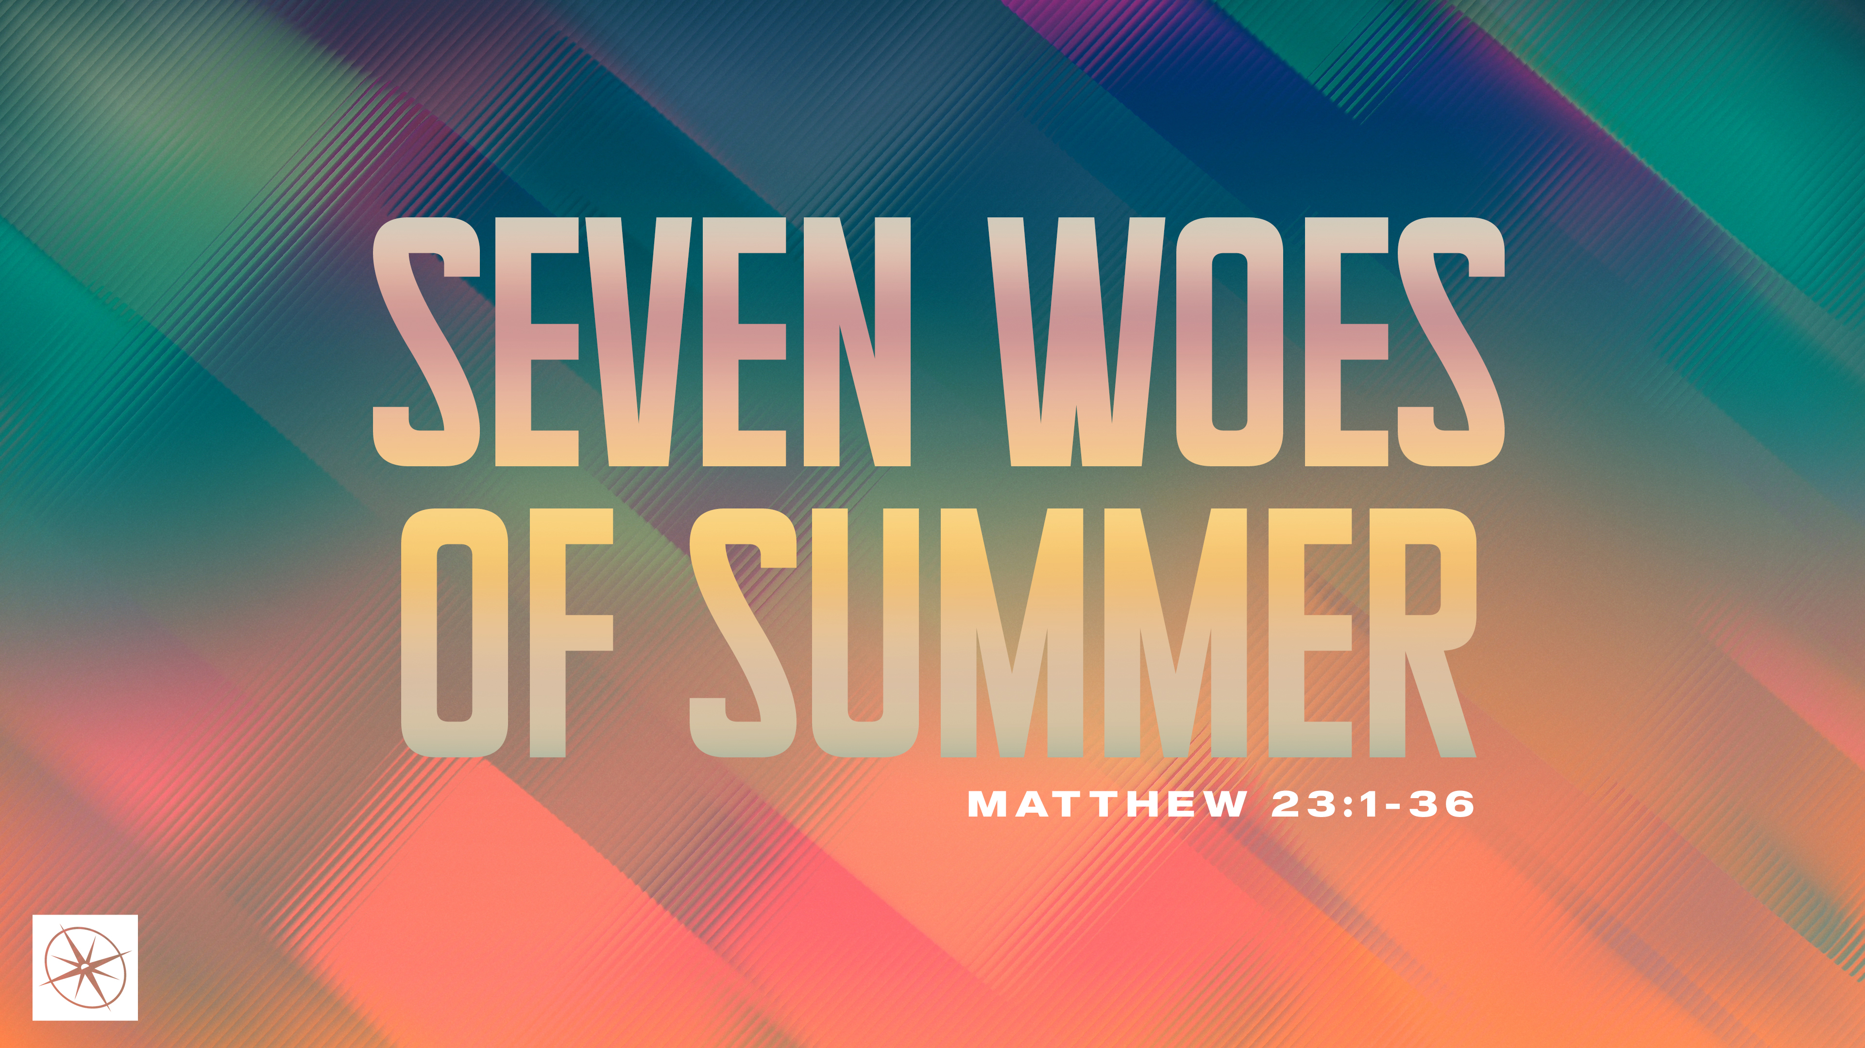
SEVEN WOES OF SUMMER
COMBATING DECEPTION
Pastor Hayden Thomas • Compass Bible Church Hill Country • July 19, 2026 • Msg. 26-26

PREACHING POINT: Knowing that every word is spoken before God should remind us to reject all forms of deception and to speak with honesty, clarity, and integrity.

Matthew 23:16–22 (ESV)
16 “Woe to you, blind guides, who say, ‘If anyone swears by the temple, it is nothing, but if anyone swears by the gold of the temple, he is bound by his oath.’ 17 You blind fools! For which is greater, the gold or the temple that has made the gold sacred? 18 And you say, ‘If anyone swears by the altar, it is nothing, but if anyone swears by the gift that is on the altar, he is bound by his oath.’ 19 You blind men! For which is greater, the gift or the altar that makes the gift sacred? 20 So whoever swears by the altar swears by it and by everything on it. 21 And whoever swears by the temple swears by it and by him who dwells in it. 22 And whoever swears by heaven swears by the throne of God and by him who sits upon it.

- Know _________________________________ (vv.21-22)

- Refuse ________________________________ (vv.16-20)
Have a question about this sermon? Send it via the QR code or link below and the pastors will do their best to address it in this week’s EQUIP podcast.

qrco.de/askaquestion

- Aim __________________________________ (vv.20-22)

Application Questions
These questions are provided for your further study and application of today’s sermon. Thoughtfully writing out the answers to these questions will help to drive home the point of today’s study. It is also helpful when you are able to discuss your answers with others. For more information about LifeGroups at Compass Bible Church that utilize these questions as the basis for their weekly discussion, please visit compasshillcountry.org/lifegroups or email us at info@compasshillcountry.org.

- Write down one observation or application you found helpful from this week's sermon. Why did it stand out to you?
This Week’s
Bible Reading Schedule
July 19th
Psalms 28-30 & Acts 21:1-14
July 20th
Psalms 31-33 & Acts 21:15-40
July 21st
Psalms 34-35 & Acts 22
July 22nd
Psalms 36-37 & Acts 23:1-11
July 23rd
Psalms 38-40 & Acts 23:12-35
July 24th
Psalms 41-43 & Acts 24
July 25th
Psalms 44-46 & Acts 25
July 26th
Psalms 47-49 & Acts 26
- Read Psalm 19:14 and Matthew 12:36–37. What do these passages teach you about the weight and accountability of your words before God?
  - Where in your life do you speak carelessly, acting as though God is not listening?
  - What would have changed in your conversations over the past seven days if you remembered that God heard every word you said?
- Read Proverbs 12:22, Acts 5:1–11, and 2 Corinthians 4:1–2. What do these passages teach about God’s view of deception and his desire for truthfulness?
  - Where are you most tempted to employ deception, even subtle kinds, at work, at home, at church, or online?
  - What is one specific habit of deceptive speech you need to put away this week, and what truthful alternative should replace it?
- Read Matthew 5:33–37 and James 5:12. Why does Scripture call Christian’s to a simple ‘yes’ or ‘no’ rather than a system of oaths, qualifiers, and assurances?
  - In what kinds of conversations are you most tempted to avoid plain, straightforward honesty?
  - What is one practical way you can grow in simple, straightforward honesty this week, and who can help hold you accountable?
See this sermon and all Compass-related videos on YouTube.com/
CompassBibleChurchHillCountry
Subscribe to Weekend Sermons, CompassU & LifeGroup Leader Podcasts: compasshillcountry.org/
podcasts


