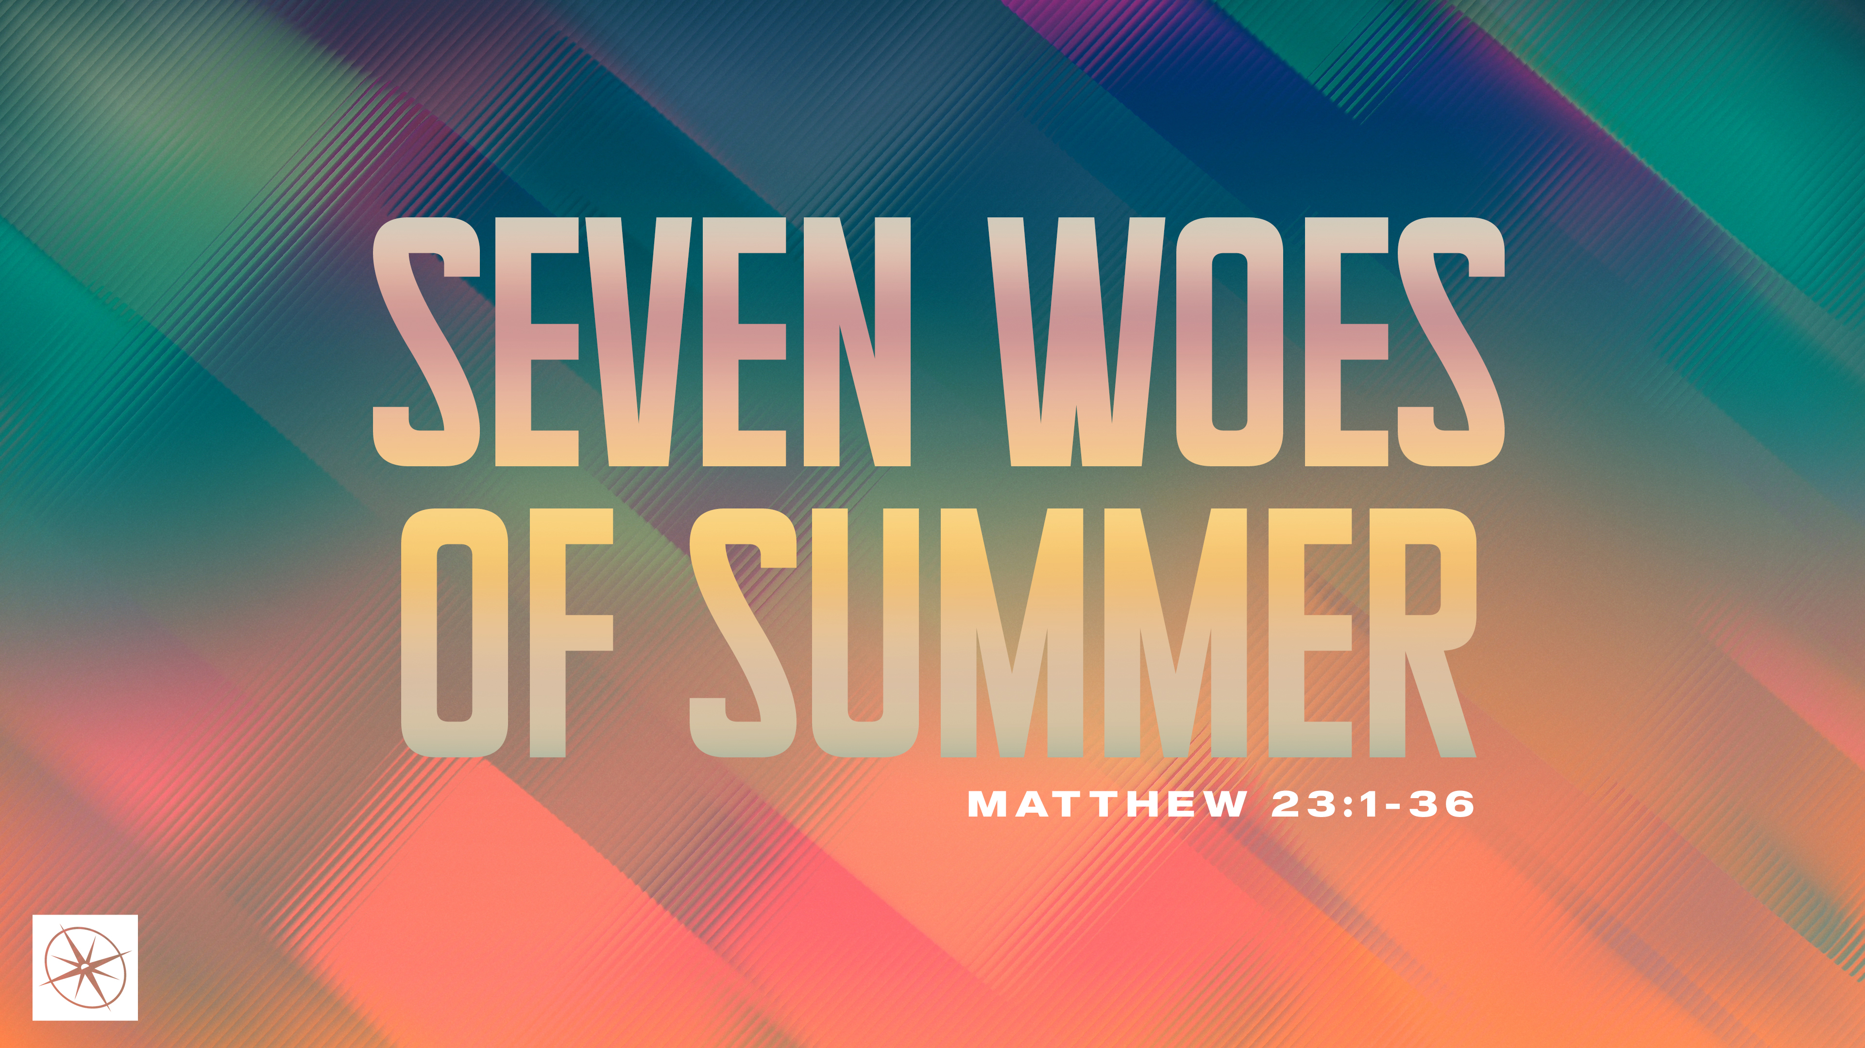
SEVEN WOES OF SUMMER
THE DANGER OF FALSE TEACHERS
Pastor Hayden Thomas • Compass Bible Church Hill Country • July 12, 2026 • Msg. 26-25

PREACHING POINT: Because false teachers zealously lead people away from Christ and toward judgment, we must reject their teaching and faithfully embrace the biblical gospel.

Matthew 23:13–15 (ESV)
13 “But woe to you, scribes and Pharisees, hypocrites! For you shut the kingdom of heaven in people’s faces. For you neither enter yourselves nor allow those who would enter to go in. 15 Woe to you, scribes and Pharisees, hypocrites! For you travel across sea and land to make a single proselyte, and when he becomes a proselyte, you make him twice as much a child of hell as yourselves.

- Guard __________________________________ (v.13)

- Don’t __________________________________ (v.15a)
Have a question about this sermon? Send it via the QR code or link below and the pastors will do their best to address it in this week’s EQUIP podcast.

qrco.de/askaquestion

- Protect _________________________________ (v.15b)

Application Questions
These questions are provided for your further study and application of today’s sermon. Thoughtfully writing out the answers to these questions will help to drive home the point of today’s study. It is also helpful when you are able to discuss your answers with others. For more information about LifeGroups at Compass Bible Church that utilize these questions as the basis for their weekly discussion, please visit compasshillcountry.org/lifegroups or email us at info@compasshillcountry.org.

- Write down one observation or application you found helpful from this week’s sermon. Why did it stand out to you?
This Week’s
Bible Reading Schedule
July 12th
Psalms 7-9 & Acts 17:1-15
July 13th
Psalms 10-12 & Acts 13:24-52
July 14th
Psalms 13-16 & Acts 14
July 15th
Psalms 17-18 & Acts 15:1-21
July 16th
Job 40-42 & Acts 15:22-41
July 17th
Psalms 1-3 & Acts 16:1-15
July 18th
Psalms 4-6 & Acts 16:16-40
July 19th
Psalms 7-9 & Acts 17:1-15
- Read John 14:6 and Galatians 1:6–9. What do these passages teach about why a message that distorts the gospel of Jesus is not simply another path to God but a false one that keeps people out of Heaven?
  - Which false gospels are most common in our community, and why do you think people find them attractive?
  - What Scriptures help you address the false gospels you mentioned above?
- Read Romans 10:1–3 and Acts 26:9–11. What are some of the dangers of zeal, sincerity, and religious devotion that are not guided by a biblical gospel?
  - How can you keep yourself and help others from being misled about beliefs that might be held with sincerity or zeal, but are contrary to the gospel?
- Read Matthew 7:21–23 and 2 Peter 2:1–3. What do these passages teach about the danger of following, or becoming a teacher whose message is not rooted in the biblical gospel
  - Not every gospel distortion is immediately obvious. What are some subtle ways a person can drift away from the biblical gospel without immediately realizing it?
- Read Jude 3–4 and Jude 23. What responsibility do you have to protect others from false teaching?
  - How can you improve your ability to help protect people from the pervasive problem of false teaching in our culture?
See this sermon and all Compass-related videos on YouTube.com/
CompassBibleChurchHillCountry
Subscribe to Weekend Sermons, CompassU & LifeGroup Leader Podcasts: compasshillcountry.org/
podcasts


