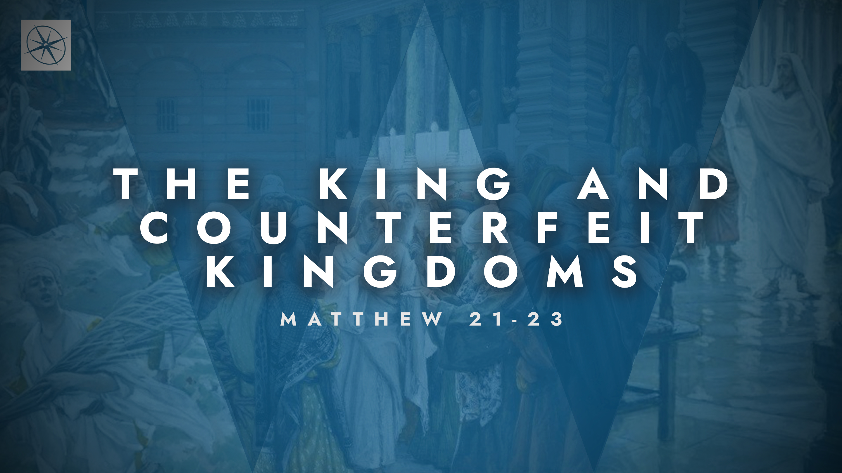
THE KING AND COUNTERFEIT KINGDOMS
RIGHTLY IDENTIFYING OUR KING
Pastor Hayden Thomas • Compass Bible Church Hill Country • June 28, 2026 • Msg. 26-23

PREACHING POINT: If we want to rightly worship Jesus, we must embrace him as both David’s Son and David’s Lord.

Matthew 22:41–46 (ESV)
41 Now while the Pharisees were gathered together, Jesus asked them a question, 42 saying, “What do you think about the Christ? Whose son is he?” They said to him, “The son of David.” 43 He said to them, “How is it then that David, in the Spirit, calls him Lord, saying, 44 “ ‘The Lord said to my Lord, “Sit at my right hand, until I put your enemies under your feet” ’? 45 If then David calls him Lord, how is he his son?” 46 And no one was able to answer him a word, nor from that day did anyone dare to ask him any more questions.

- Reject _____________________________ (vv.41-43a)

- Use ______________________________ (vv.43b-45)
See this sermon and all Compass-related videos on YouTube.com/
CompassBibleChurchHillCountry
Subscribe to Weekend Sermons, CompassU & LifeGroup Leader Podcasts: compasshillcountry.org/
podcasts

Have a question about this sermon? Send it via the QR code or link below and the pastors will do their best to address it in this week’s EQUIP podcast.

qrco.de/askaquestion

- Allow _______________________________ (v.46)

Application Questions
These questions are provided for your further study and application of today’s sermon. Thoughtfully writing out the answers to these questions will help to drive home the point of today’s study. It is also helpful when you are able to discuss your answers with others. For more information about LifeGroups at Compass Bible Church that utilize these questions as the basis for their weekly discussion, please visit compasshillcountry.org/lifegroups or email us at info@compasshillcountry.org.

- Write down one observation or application you found helpful from this week’s sermon. Why did it stand out to you?
This Week’s
Bible Reading Schedule
June 28th
Job 13-15 & Acts 8:26-40
June 29th
Job 16-18 & Acts 9:1-22
June 30th
Job 19-20 & Acts 9:23-43
July 1st
Job 21-22 & Acts 10:1-23
July 2nd
Job 23-25 & Acts 10:24-48
July 3rd
Job 26-28 & Acts 11
July 4th
Job 29-30 & Acts 12
July 5th
Job 31-32 & Acts 13:1-23
- Read some of these passages: Romans 1:3–4, Colossians 2:9, Hebrews 1:1–3, Isaiah 9:6-7, Psalm 2, Luke 1:30-33, Psalm 110, Daniel 7:13–14, Philippians 2:5–11, John 1:1–5, and John 1:14. What do these passages together teach about the full identity of Jesus?
  - Why is it spiritually dangerous to reduce Jesus to merely a great moral teacher, a spiritual guide, a human hero, or even only your personal Savior? What aspects of his identity would you be ignoring?
  - Which aspect of Jesus' identity do you most naturally overlook — his humanity, his deity, his kingship, his authority, his coming judgment, his compassion, his lordship, or some other aspect? How should a fuller understanding of who Jesus is change the way you worship, obey, and follow him this week?
- Read John 5:39–40 and Hebrews 1:1–3. Why does Jesus insist that the Scriptures are the proper place to discover who he truly is?
  - What are some specific ways you’ve seen people defining Jesus outside of Scripture using — their experience, culture, personal preference, or tradition. Why are those definitions insufficient?
  - What are some ways scripture has clarified your view of Jesus? And how are you cultivating the habit of letting Scripture shape your view of Jesus rather than the other way around?
- Read James 1:22–25 and Hebrews 4:12–13. What are the dangers of being confronted by Scripture and yet refusing to let it have the final word?
  - What can this kind of silent resistance to God’s Word look like in everyday life, and where in your life are you most tempted to hear clear biblical teaching yet walk away unchanged?
  - How will you commit to allowing Scripture to have the final word this week rather than simply acknowledging it or ignoring it?

