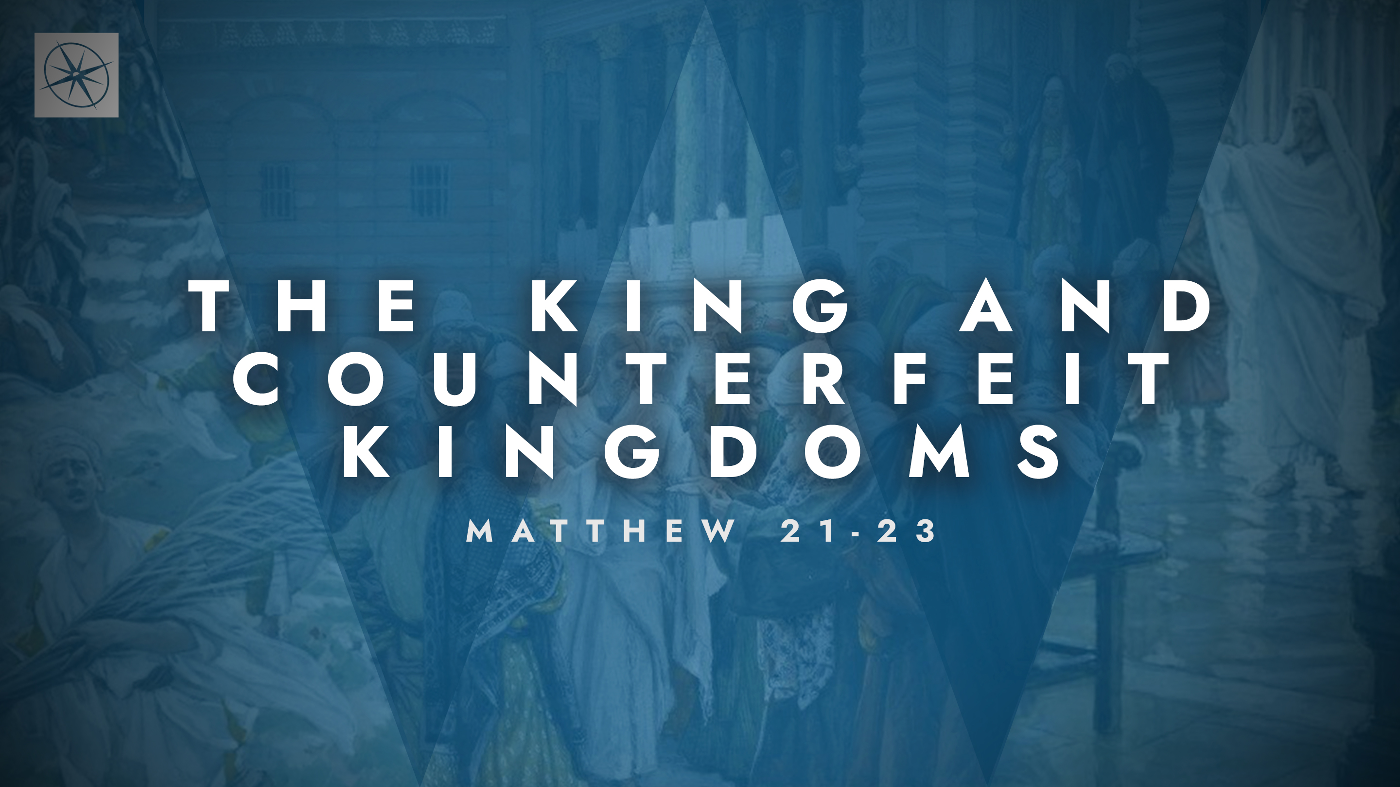
THE KING AND COUNTERFEIT KINGDOMS
THE GREAT COMMANDMENT
Pastor Hayden Thomas • Compass Bible Church Hill Country • June 21, 2026 • Msg. 26-22

PREACHING POINT: Jesus teaches us to measure genuine faith by how comprehensively we love God and how sincerely we love others.

Matthew 22:34–40 (ESV)
34 But when the Pharisees heard that he had silenced the Sadducees, they gathered together. 35 And one of them, a lawyer, asked him a question to test him. 36 “Teacher, which is the great commandment in the Law?” 37 And he said to him, “You shall love the Lord your God with all your heart and with all your soul and with all your mind. 38 This is the great and first commandment. 39 And a second is like it: You shall love your neighbor as yourself. 40 On these two commandments depend all the Law and the Prophets.”

- Ask: _____________________________ (vv.34-36)

- Love _____________________________ (vv.37-38)
- Love _____________________________ (vv.39-40)

Application Questions
These questions are provided for your further study and application of today’s sermon. Thoughtfully writing out the answers to these questions will help to drive home the point of today’s study. It is also helpful when you are able to discuss your answers with others. For more information about LifeGroups at Compass Bible Church that utilize these questions as the basis for their weekly discussion, please visit compasshillcountry.org/lifegroups or email us at info@compasshillcountry.org.

- Write down one observation or application you found helpful from this week's sermon. Why did it stand out to you?
This Week’s
Bible Reading Schedule
June 21st
Esther 1-3 & Acts 5:1-16
June 22nd
Esther 4-6 & Acts 5:17-42
June 23rd
Esther 7-10 & Acts 6
June 24th
Job 1-3 & Acts 7:1-19
June 25th
Job 4-6 & Acts 7:20-43
June 26th
Job 7-9 & Acts 7:44-60
June 27th
Job 10-12 & Acts 8:1-25
June 28th
Job 13-15 & Acts 8:26-40
See this sermon and all Compass-related videos on YouTube.com/
CompassBibleChurchHillCountry
Subscribe to Weekend Sermons, CompassU & LifeGroup Leader Podcasts: compasshillcountry.org/
podcasts

- Read Deuteronomy 10:12–13 and 1 John 3:23. Although there are specific ways God asks us to love, how do these summaries help clarify your role as a Christian and simplify your understanding of God’s general expectations for you?
  - How might your daily decisions and commitments change if you viewed every decision through the lens of “how will this love God and love others?”
- Read Deuteronomy 6:4–5. What does it practically look like to love God with all your heart, soul, and strength?
  - Which area of your life most clearly reveals a lack of wholehearted love for God right now?
- Read Deuteronomy 30:6. What hope does this passage give Christians concerning their ability to grow in love for God?
  - How does God's promise to transform your heart encourage you to keep pursuing Him?
- Read John 15:12–13 and Mark 12:31. How would you honestly evaluate your love for all of the people God has placed around you?
  - Make a list of ways Christ has loved you and ways you naturally care for yourself. How can you intentionally show those same kinds of love to others this week?
- Read 1 John 4:7–12 and 1 John 4:19–21. What do these passages teach about the connection between loving God and loving others?
  - What areas of loving others have you neglected, avoided, or need to improve? What specific step can you take this week to improve in your love for those around you?
Have a question about this sermon? Send it via the QR code or link below and the pastors will do their best to address it in this week’s EQUIP podcast.

qrco.de/askaquestion

