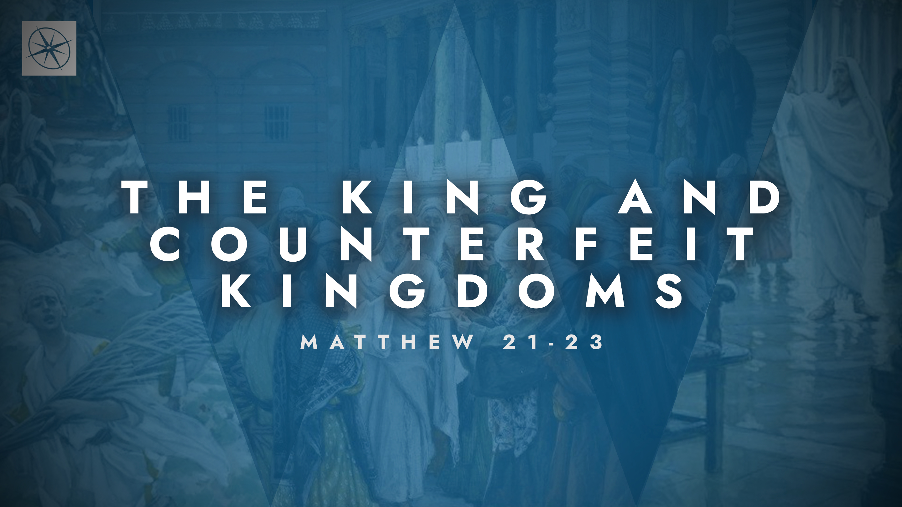
THE KING AND COUNTERFEIT KINGDOMS
GETTING IT RIGHT ABOUT GOD AND GOVERNMENT
Pastor Hayden Thomas • Compass Bible Church Hill Country • May 31, 2026 • Msg. 26-20

PREACHING POINT: Jesus’ words should corner our rebellious hearts and cause us to regularly submit to our God-given earthly authorities, while reserving our ultimate allegiance and submission for the King of Kings.

Matthew 22:15–22 (ESV)
15 Then the Pharisees went and plotted how to entangle him in his words. 16 And they sent their disciples to him, along with the Herodians, saying, “Teacher, we know that you are true and teach the way of God truthfully, and you do not care about anyone’s opinion, for you are not swayed by appearances. 17 Tell us, then, what you think. Is it lawful to pay taxes to Caesar, or not?” 18 But Jesus, aware of their malice, said, “Why put me to the test, you hypocrites? 19 Show me the coin for the tax.” And they brought him a denarius. 20 And Jesus said to them, “Whose likeness and inscription is this?” 21 They said, “Caesar’s.” Then he said to them, “Therefore render to Caesar the things that are Caesar’s, and to God the things that are God’s.” 22 When they heard it, they marveled. And they left him and went away.

- Address _____________________________ (vv.15-18)

- Honor _____________________________ (vv.19-21a)
- Supremely __________________________ (vv.21b-22)
Application Questions
These questions are provided for your further study and application of today’s sermon. Thoughtfully writing out the answers to these questions will help to drive home the point of today’s study. It is also helpful when you are able to discuss your answers with others. For more information about LifeGroups at Compass Bible Church that utilize these questions as the basis for their weekly discussion, please visit compasshillcountry.org/lifegroups or email us at info@compasshillcountry.org.

- Write down one insight or application that you found helpful from this week’s sermon. Why did it stand out to you?
This Week’s
Bible Reading Schedule
May 31st
2 Chron 1-3 & John 12:1-19
June 1st
2 Chron 4-6 & John 12:20-50
June 2nd
2 Chron 7-9 & John 13:1-17
June 3rd
2 Chron 10-12 & John 13:18-38
June 4th
2 Chron 13-16 & John 14
June 5th
2 Chron 17-19 & John 15
June 6th
2 Chron 20-22 & John 16:1-15
June 7th
2 Chron 23-25 & John 16:16-33
See this sermon and all Compass-related videos on YouTube.com/
CompassBibleChurchHillCountry
Subscribe to Weekend Sermons, CompassU & LifeGroup Leader Podcasts: compasshillcountry.org/
podcasts

- Read Matthew 22:15–22. How would you honestly describe your attitude toward authority in your home, workplace, church, government etc.?
  - Read Romans 8:7. Where do you see rebellion most clearly? Is it outward defiance, quiet grumbling, outward compliance with inward resistance, or something else?
  - What does that pattern reveal about your heart?
- Read Mark 7:9–13. In what ways are you tempted to look for apparent loopholes, exceptions, or different interpretations of scripture in order to dismiss the authorities God has placed over you? How can you fight this temptation?
- Read Romans 13:1–7 and 1 Peter 2:13–25. What objections to submitting to earthly authority do these passages directly address?
  - How can these passages reshape your attitude toward imperfect leaders and institutions as you strive to live for Christ?
- Read 1 Chronicles 29:11 and Colossians 1:15–17. What are the implications of these passages in your life?
  - Write down five practical applications that these passages bring to mind when it comes to supremely honoring God’s authority in your life.
Have a question about this sermon? Send it via the QR code or link below and the pastors will do their best to address it in this week’s EQUIP podcast.

qrco.de/askaquestion

