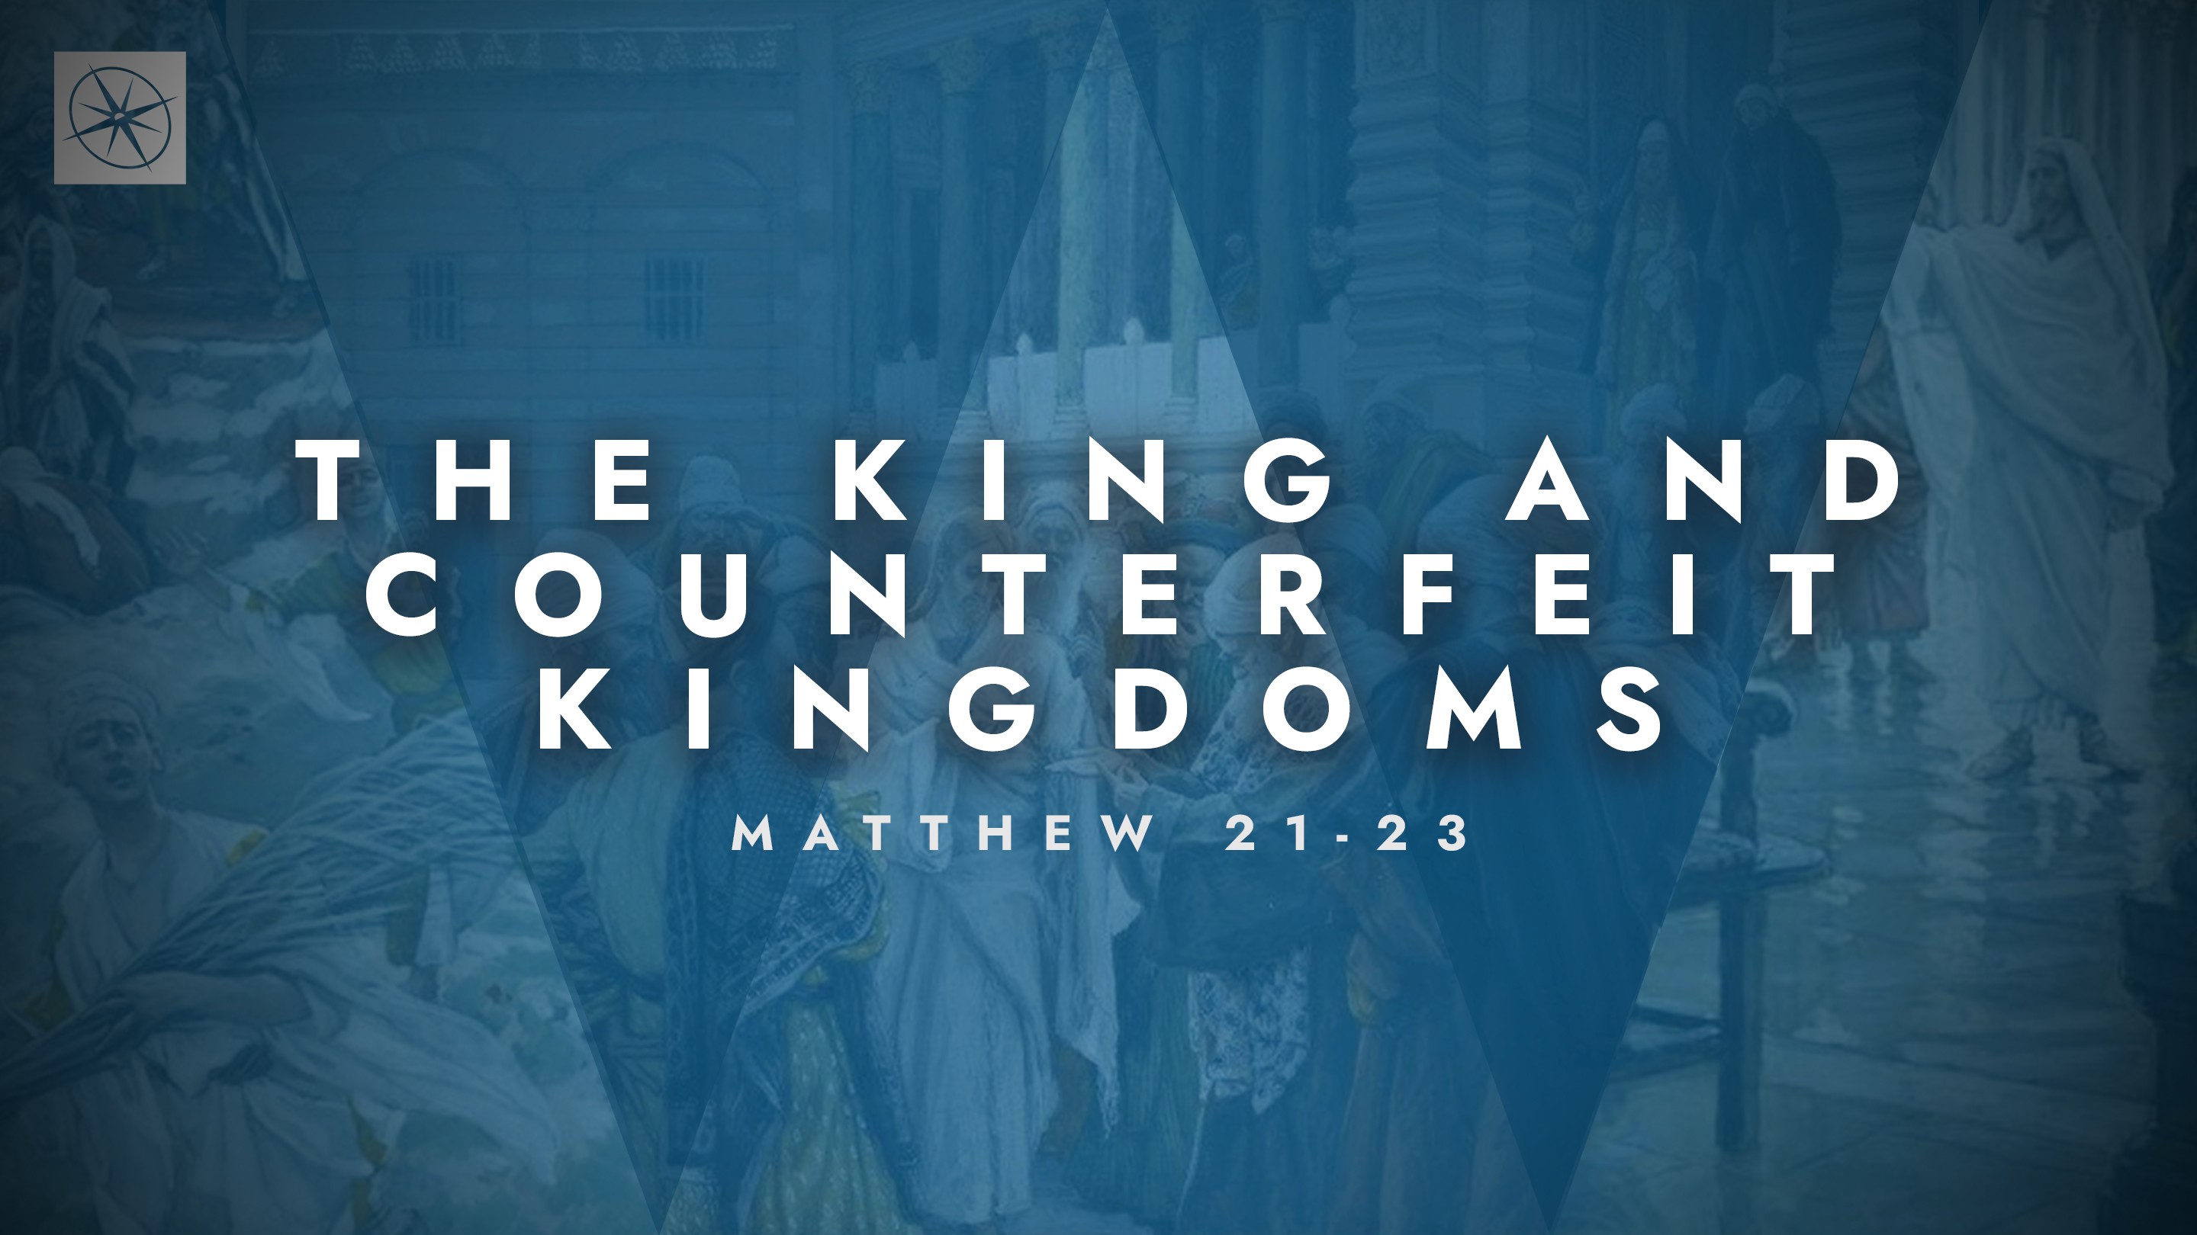
THE KING AND COUNTERFEIT KINGDOMS
COUNTERFEIT CONFESSIONS
Pastor Hayden Thomas • Compass Bible Church Hill Country • May 3, 2026 • Msg. 26-17

PREACHING POINT: Knowing how much God despises counterfeit confessions should strengthen our resolve to come to him with genuine faith marked by repentance and obedience.

Matthew 21:28–32 (ESV)
28 “What do you think? A man had two sons. And he went to the first and said, ‘Son, go and work in the vineyard today.’ 29 And he answered, ‘I will not,’ but afterward he changed his mind and went. 30 And he went to the other son and said the same. And he answered, ‘I will, sir,’ but did not go. 31 Which of the two did the will of his father?” They said, “The first.” Jesus said to them, “Truly, I say to you, the tax collectors and the prostitutes go into the kingdom of God before you. 32 For John came to you in the way of righteousness, and you did not believe him, but the tax collectors and the prostitutes believed him. And even when you saw it, you did not afterward change your minds and believe him.

- Understand __________________________ (vv.28-31a)

- Respond ___________________________ (vv.31b-32)

Application Questions
These questions are provided for your further study and application of today’s sermon. Thoughtfully writing out the answers to these questions will help to drive home the point of today’s study. It is also helpful when you are able to discuss your answers with others. For more information about LifeGroups at Compass Bible Church that utilize these questions as the basis for their weekly discussion, please visit compasshillcountry.org/lifegroups or email us at info@compasshillcountry.org.

- Read Matthew 21:28–32. Why exactly did Jesus condemn the religious leaders?
This Week’s
Bible Reading Schedule
May 3rd
1 Kings 6-7 & Luke 23:27-38
May 4th
1 Kings 8-9 & Luke 23:39-56
May 5th
1 Kings 10-11 & Luke 24:1-35
May 6th
1 Kings 12-13 & Luke 24:36-53
May 7th
1 Kings 14-15 & John 1:1-28
May 8th
1 Kings 16-18 & John 1:29-51
May 9th
1 Kings 19-20 & John 2
May 10th
1 Kings 21-22 & John 3:1-21
See this sermon and all Compass-related videos on YouTube.com/
CompassBibleChurchHillCountry
Subscribe to Weekend Sermons, CompassU & LifeGroup Leader Podcasts: compasshillcountry.org/
podcasts

  - What should you take away from this parable?
- Read Luke 6:46–49. What does Jesus’ parable in Luke 6 teach you about the nature of genuine faith?
  - Why must obedience be determinative in examining whether or not you truly follow Jesus?
- James 1:22–25. How do James’ words help you grasp what God thinks about the person who hears his words and does not act on them?
- Where in your life are you most tempted to say the right things to God but fail to follow through? Be specific.
- Read Luke 24:46–47 and Mark 1:14–15. Repentance and faith are the foundational elements to responding to Jesus. What dangers arise when faith is defined purely as “a mental ascent to the facts” and the importance of repentance is diminished or outright rejected?
  - How would you explain the concept of repentance and faith as they pertain to the gospel to a non-Christian?
  - How would you tell a Christian how they can apply repentance and faith in their life each day?
Have a question about this sermon? Send it via the QR code or link below and the pastors will do their best to address it in this week’s EQUIP podcast.

qrco.de/askaquestion

