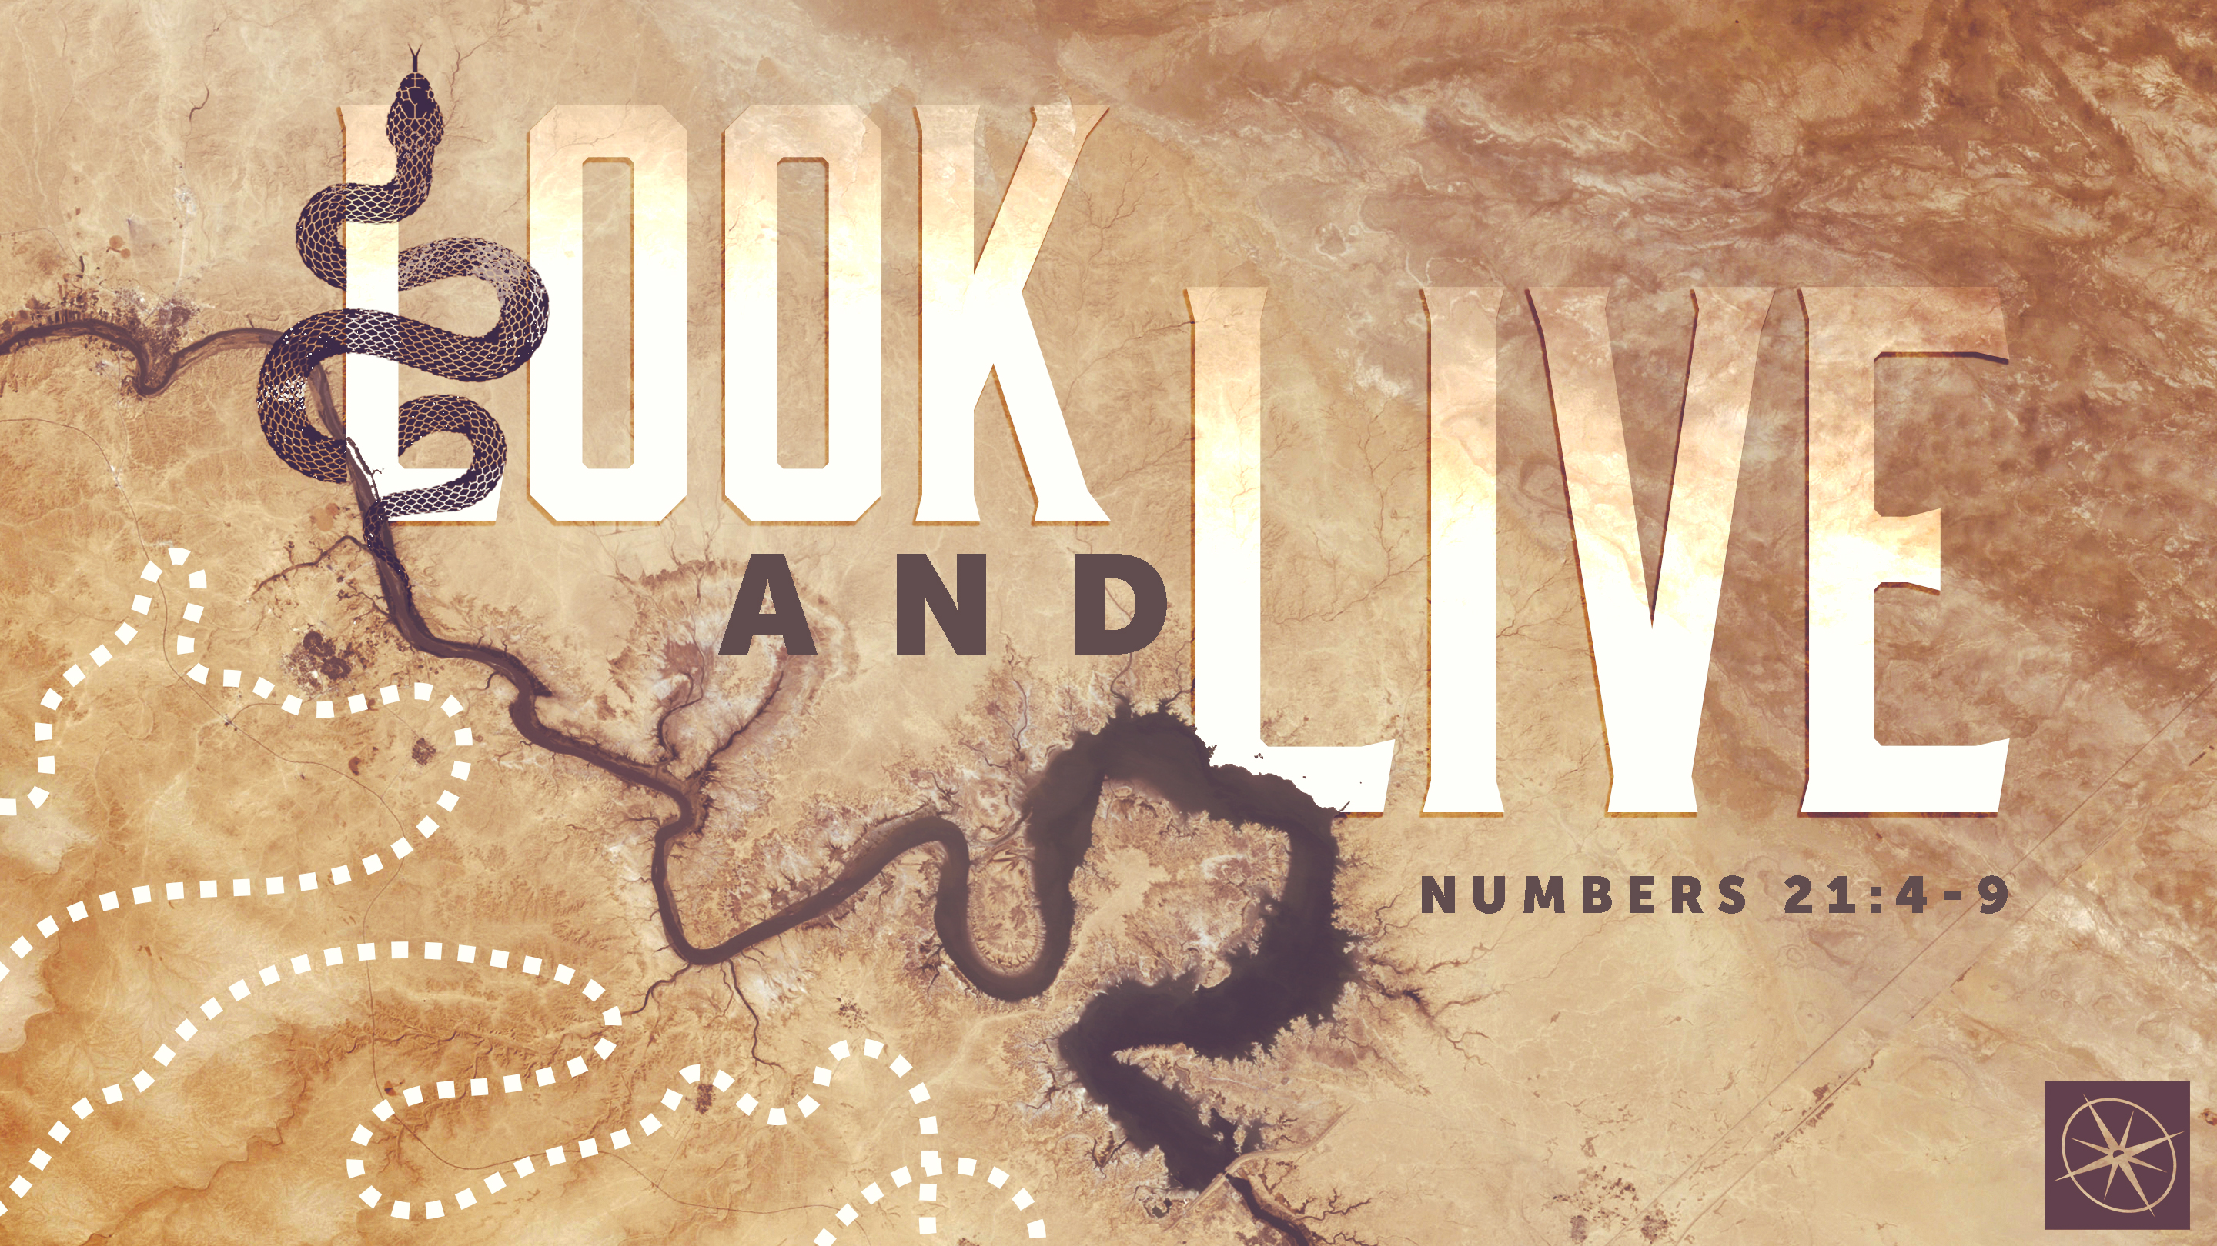
LOOK AND LIVE
THE BRONZE SERPENT
Pastor Caleb Dragna • Compass Bible Church Hill Country • May 24, 2026 • Msg. G26-04

PREACHING POINT: Though sin brings death, God offers life through a repentant, faith-filled response to His appointed means.

Numbers 21:4-9 (ESV)
4 From Mount Hor they set out by the way to the Red Sea, to go around the land of Edom. And the people became impatient on the way. 5 And the people spoke against God and against Moses, “Why have you brought us up out of Egypt to die in the wilderness? For there is no food and no water, and we loathe this worthless food.” 6 Then the LORD sent fiery serpents among the people, and they bit the people, so that many people of Israel died. 7 And the people came to Moses and said, “We have sinned, for we have spoken against the LORD and against you. Pray to the LORD, that he take away the serpents from us.” So Moses prayed for the people. 8 And the LORD said to Moses, “Make a fiery serpent and set it on a pole, and everyone who is bitten, when he sees it, shall live.” 9 So Moses made a bronze serpent and set it on a pole. And if a serpent bit anyone, he would look at the bronze serpent and live.

- Recognize _____________________________ (vv.4-6)

- Admit _________________________________ (v.7)
- Respond _____________________________ (vv.8-9)
Application Questions
These questions are provided for your further study and application of today’s sermon. Thoughtfully writing out the answers to these questions will help to drive home the point of today’s study. It is also helpful when you are able to discuss your answers with others. For more information about LifeGroups at Compass Bible Church that utilize these questions as the basis for their weekly discussion, please visit compasshillcountry.org/lifegroups or email us at info@compasshillcountry.org.

- Read James 1:14-15. In Numbers 21:4–5, why do you think Israel’s discouragement during the detour turned so quickly into complaining against God? What does this reveal about the spiritual danger of unchecked frustration?
This Week’s
Bible Reading Schedule
May 24th
1 Chron 11-13 & John 9:1-23
May 25th
1 Chron 14-16 & John 9:24-41
May 26th
1 Chron 17-19 & John 10:1-21
May 27th
1 Chron 20-22 & John 10:22-42
May 28th
1 Chron 23-25 & John 11:1-17
May 29th
2 Chron 26-27 & John 11:18-46
May 30th
1 Chron 28-29 & John 11:47-57
May 31st
2 Chron 1-3 & John 12:1-19
See this sermon and all Compass-related videos on YouTube.com/
CompassBibleChurchHillCountry
Subscribe to Weekend Sermons, CompassU & LifeGroup Leader Podcasts: compasshillcountry.org/
podcasts

  - Read Proverbs 3:5-6 and James 1:2-4. When life takes an unexpected “detour,” what is your natural response: trust, anxiety, self-pity, anger? What might your response reveal about your heart?
- Read Proverbs 28:13. Have you truly confessed specific sins before God lately, or have your prayers become vague and surface-level? What keeps you from honest repentance?
  - Read 1 Timothy 2:5 and Hebrews 4:14-16. The Israelites needed a mediator. How does Jesus being our perfect Mediator change the way you approach God after failure or sin?
  - Read Colossians 3:1-4. What does it practically look like to “look to Christ” in moments of temptation, shame, suffering, or discouragement?
- The Israelites looked and immediately lived. How does the immediacy of God’s grace challenge the idea that we must “clean ourselves up” before coming to Christ?
  - Where in your life right now do you most need to stop looking inward, outward, or backward—and instead look upward to Christ in faith?
Have a question about this sermon? Send it via the QR code or link below and the pastors will do their best to address it in this week’s EQUIP podcast.

qrco.de/askaquestion

