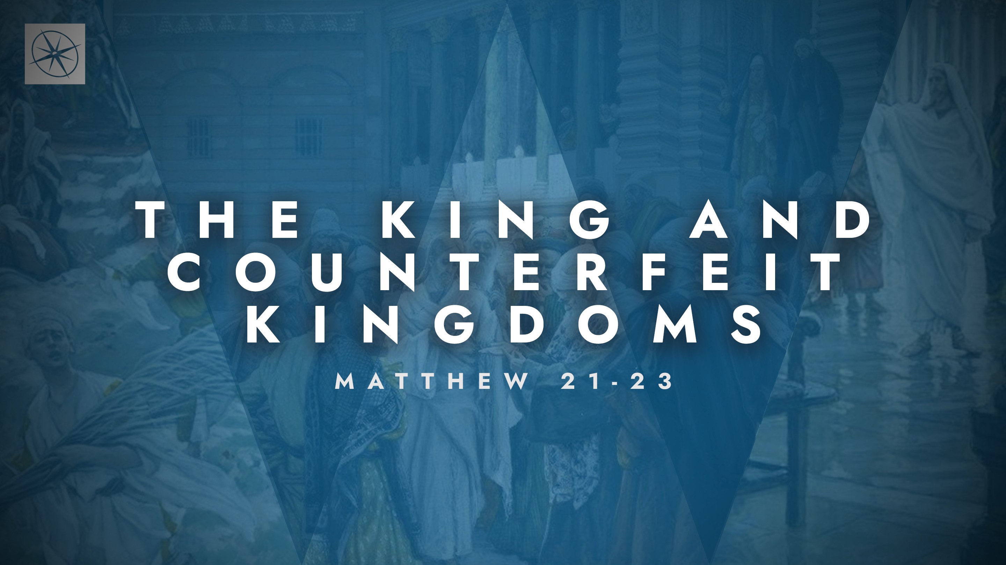
THE KING AND COUNTERFEIT KINGDOMS
PREPARING FOR GOD’S GREAT BANQUET
Pastor Hayden Thomas • Compass Bible Church Hill Country • May 17, 2026 • Msg. 26-19

PREACHING POINT: We must respond appropriately to God’s gracious invitation to his Son’s banquet, or risk being excluded from his eschatological celebration.

Matthew 22:1–14 (ESV)
1 And again Jesus spoke to them in parables, saying, 2 “The kingdom of heaven may be compared to a king who gave a wedding feast for his son, 3 and sent his servants to call those who were invited to the wedding feast, but they would not come. 4 Again he sent other servants, saying, ‘Tell those who are invited, “See, I have prepared my dinner, my oxen and my fat calves have been slaughtered, and everything is ready. Come to the wedding feast.” ’ 5 But they paid no attention and went off, one to his farm, another to his business, 6 while the rest seized his servants, treated them shamefully, and killed them. 7 The king was angry, and he sent his troops and destroyed those murderers and burned their city. 8 Then he said to his servants, ‘The wedding feast is ready, but those invited were not worthy. 9 Go therefore to the main roads and invite to the wedding feast as many as you find.’ 10 And those servants went out into the roads and gathered all whom they found, both bad and good. So the wedding hall was filled with guests. 11 “But when the king came in to look at the guests, he saw there a man who had no wedding garment. 12 And he said to him, ‘Friend, how did you get in here without a wedding garment?’ And he was speechless. 13 Then the king said to the attendants, ‘Bind him hand and foot and cast him into the outer darkness. In that place there will be weeping and gnashing of teeth.’ 14 For many are called, but few are chosen.”

- Don’t _____________________________ (vv.1-7)

- Prepare ___________________________ (vv.8-13)
- Call _______________________________ (v.14)
Application Questions
These questions are provided for your further study and application of today’s sermon. Thoughtfully writing out the answers to these questions will help to drive home the point of today’s study. It is also helpful when you are able to discuss your answers with others. For more information about LifeGroups at Compass Bible Church that utilize these questions as the basis for their weekly discussion, please visit compasshillcountry.org/lifegroups or email us at info@compasshillcountry.org.

- Write down one observation or application that you found helpful from this week's sermon. Why did it stand out to you?
This Week’s
Bible Reading Schedule
May 17th
2 Kings 18-19 & John 6:22-44
May 18th
2 Kings 20-22 & John 6:45-71
May 19th
2 Kings 23-25 & John 7:1-31
May 20th
1 Chronicles 1-2 & Jn 7:32-53
May 21st
1 Chronicles 3-5 & John 8:1-20
May 22nd
2 Chronicles 6-7 & Jn 8:21-36
May 23rd
1 Chronicles 8-10 & Jn 8:37-59
May 24th
2 Chronicles 11-13 & Jn 9:1-23
See this sermon and all Compass-related videos on YouTube.com/
CompassBibleChurchHillCountry
Subscribe to Weekend Sermons, CompassU & LifeGroup Leader Podcasts: compasshillcountry.org/
podcasts

- Read Isaiah 65:12–15 and Hebrews 2:1–4. How do these passages show you that "neglect" is not a neutral middle ground but its own form of rejection?
  - What "farms" and "businesses" (Matthew 22:5), work, hobbies, kids' activities, side projects, domestic activities, etc., are most likely to steal your attention from God's eschatological banquet?
  - What is one specific, concrete step you can take this week to put them in their proper place?
- Read Revelation 19:6–8, Isaiah 61:10–11, and Matthew 22:8–13. What do these passages teach you about the significance of coming to God’s eschatological banquet with the appropriate attire?
  - What does the speechless man in Matthew 22:11–12 expose about the danger of someone coming to God’s eschatological banquet on their own terms?
  - Read Philippians 3:8–11 and Galatians 3:26–27. How does being clothed in Christ, rather than in your own moral performance, religious activity, or theological knowledge qualify you for the wedding banquet?
- Read Ezekiel 33:1–9 and Acts 20:25–27. Salvation is God's sovereign choice, but God's sovereignty does not remove human responsibility. That means not only is each person responsible to respond to God’s invitation, but each believer is also responsible to call everyone and warn everyone concerning salvation and judgment. How does Ezekiel's warning to the watchman and Paul's confident "I am innocent of the blood of all" (Acts 20:26) sharpen your sense of personal accountability for those who do not yet know Christ?
Have a question about this sermon? Send it via the QR code or link below and the pastors will do their best to address it in this week’s EQUIP podcast.

qrco.de/askaquestion

