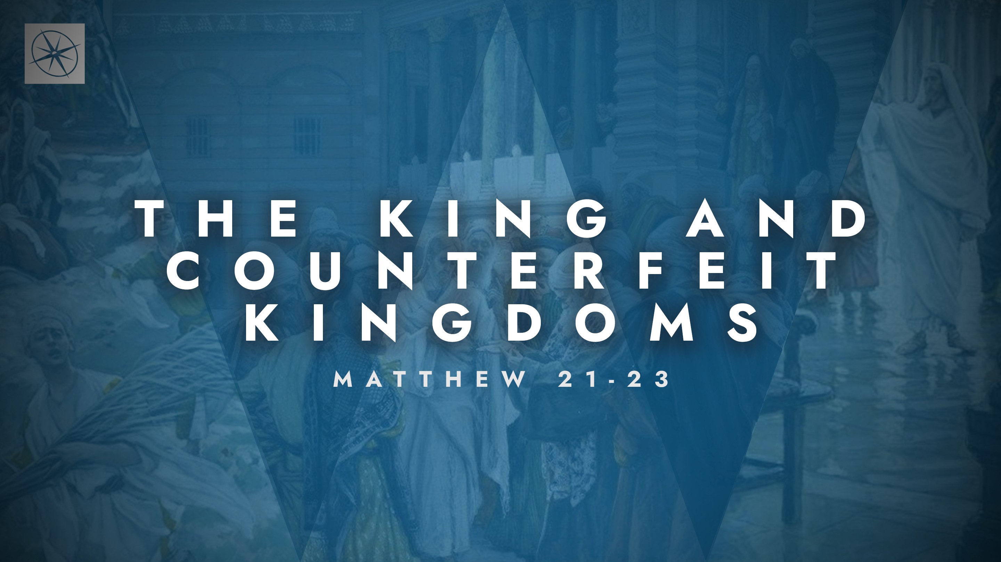
THE KING AND COUNTERFEIT KINGDOMS
PRAISE TO THE KING
Pastor Hayden Thomas • Compass Bible Church Hill Country • March 29, 2026 • Msg. 26-11

PREACHING POINT: We must respond to Jesus’ authority with humility and praise, knowing that our response reveals whether our relationship with God is genuine or merely a counterfeit commitment to Christ.

Matthew 21:14–17 (ESV)
14 And the blind and the lame came to him in the temple, and he healed them. 15 But when the chief priests and the scribes saw the wonderful things that he did, and the children crying out in the temple, “Hosanna to the Son of David!” they were indignant, 16 and they said to him, “Do you hear what these are saying?” And Jesus said to them, “Yes; have you never read, “ ‘Out of the mouth of infants and nursing babies you have prepared praise’?” 17 And leaving them, he went out of the city to Bethany and lodged there.

- Notice _____________________________ (vv.14,15b)

- Distinguish _______________________ (vv.15a,15c,16a)
- Speak _____________________________ (vv.16b-17)
Application Questions
These questions are provided for your further study and application of today’s sermon. Thoughtfully writing out the answers to these questions will help to drive home the point of today’s study. It is also helpful when you are able to discuss your answers with others. For more information about LifeGroups at Compass Bible Church that utilize these questions as the basis for their weekly discussion, please visit compasshillcountry.org/lifegroups or email us at info@compasshillcountry.org.

- Write down one observation or application you found helpful from this week’s sermon. Why did it stand out to you?
This Week’s
Bible Reading Schedule
March 29th
Joshua 23-24 & Luke 6:27-49
March 30th
Judges 1-2 & Luke 7:1-30
March 31st
Judges 3-5 & Luke 7:31-50
April 1st
Judges 6-7 & Luke 8:1-21
April 2nd
Judges 8-9 & Luke 8:22-56
April 3rd
Judges 10-11 & Luke 9:1-36
April 4th
Judges 12-14 & Luke 9:37-62
April 5th
Judges 15-17 & Luke 10:1-24
See this sermon and all Compass-related videos on YouTube.com/
CompassBibleChurchHillCountry
Subscribe to Weekend Sermons, CompassU & LifeGroup Leader Podcasts: compasshillcountry.org/
podcasts

- Read Matthew 18:3-4, James 4:6 and Isaiah 57:15. What do these passages teach you about the kind of people who truly come to Jesus?
  - What area of your life do you need the reminder that God opposes the proud but draws near to the humble and contrite?
- Read Acts 17:22-31. Why is it possible to be very religious and yet not truly know God? What are some ways this can show up even in a church context?
  - Where might you be relying on religious habits, knowledge, or background instead of genuine trust in the person and work of Jesus?
- Read Romans 14:23. Paul teaches that whatever does not proceed from faith is sin. Where are you tempted to engage in “religious activity” that is not flowing from real faith?
  - What steps can you take to ensure that your beliefs, convictions, and actions are flowing from a genuine relationship with Christ and submission to his authority?
- Read 1 Corinthians 1:26-29 and 1 Peter 2:9. How are you doing at speaking wonderfully of Jesus in your interactions with others?
  - Where are you most tempted to stay quiet about Jesus? How can you be more bold about speaking more wonderfully about Jesus in your daily life?
Have a question about this sermon? Send it via the QR code or link below and the pastors will do their best to address it in this week’s EQUIP podcast.

qrco.de/askaquestion

