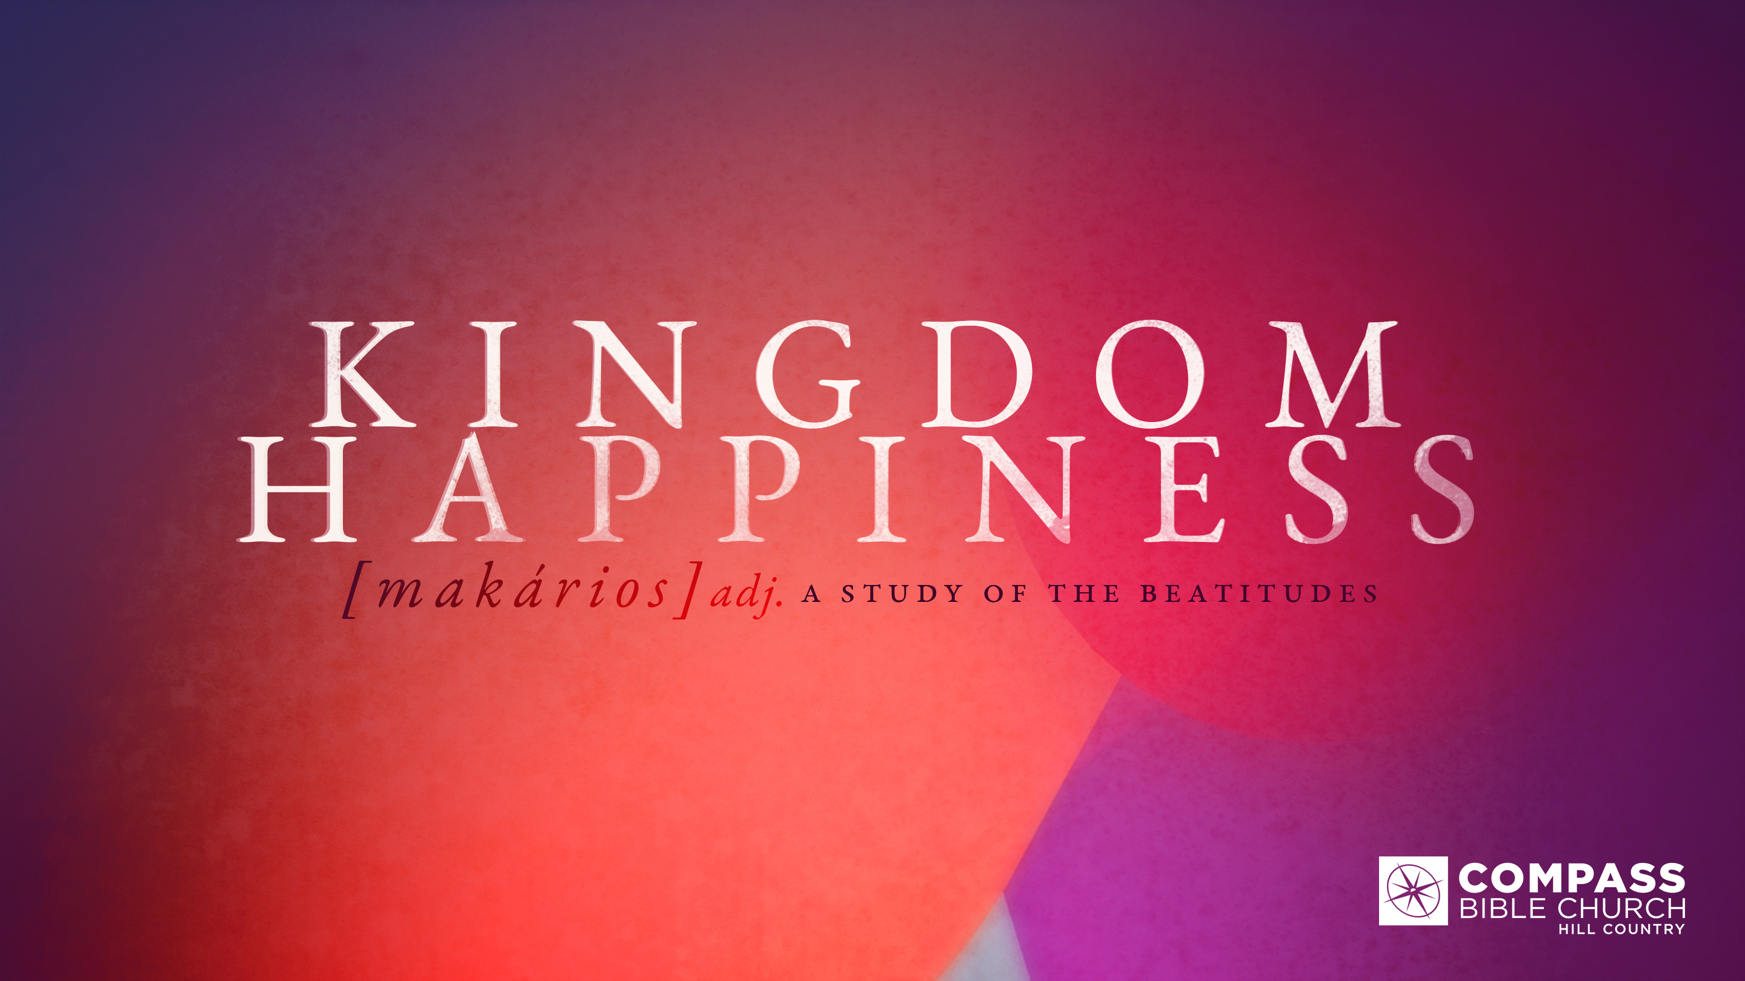
KINGDOM HAPPINESS
THE MEEK RECEIVE THE WORLD
Matthew 5:5
Pastor Evan Jacobsen • Compass Bible Church Hill Country • March 19, 2023 • Msg. G23-01

Matthew 5:5
5 “Blessed are the meek, for they shall inherit the earth. (ESV)

1. Find _______________________________ (v.5)

2. Persevere ___________________________ (v.5)

3. Yearn ______________________________ (v.5)

Application Questions
These questions are provided for your further study and application of today’s sermon. Thoughtfully writing out the answers to these questions will help to drive home the point of today’s study. It is also helpful when you are able to discuss your answers with others. For more information about LifeGroups at Compass Bible Church that utilize these questions as the basis for their weekly discussion, please visit compasshillcountry.org/lifegroups or email us at info@compasshillcountry.org.

- What is one observation you found helpful from this week’s sermon? Why?
- Read Psalm 37:1-11. How does this passage help you see the benefits of faithfully following God despite the culture's success without God? In what ways do you need to apply Psalm 37 practically?
- Read Psalm 112:1, Luke 11:28, & Matthew 7:24–25. How does following God's Will lead someone to kingdom happiness? What specific circumstances do you need to address according to God's Word, knowing it will be inconvenient in the short term but will bring long-term kingdom happiness?

- Read Revelation 3:10-11 & Hebrews 10:36. How do passages like these help you to persevere in submitting to God's Word instead of your wisdom, especially in times of high stress?
- Read Hebrews 10:24-25 & 1 Thessalonians 5:11. Why is being deeply connected in the community of believers (the local church) critical for you to persevere in meekness? What changes do you need to make to prioritize the community at this church?
- Read Romans 8:18-23 & 2 Corinthians 4:16–18. Why is a clear focus on the coming of God's perfect kingdom necessary for you to continually submit to God's Will?
- Read Revelation 21:1-4 & Revelation 22:1-5. Share some of the joy you have, knowing that this is the future for all believers in Jesus Christ. What specific ways can you live differently with the future in mind?
This Week’s
Bible Reading Schedule
March 19th
Deut 33-34 & Luke 1:24-56
March 20th
Joshua 1-3 & Luke 1:57-80
March 21st
Joshua 4-6 & Luke 2:1-24
March 22nd
Joshua 7-8 & Luke 2:25-52
March 23rd
Joshua 9-10 & Luke 3
March 24th
Joshua 11-13 & Luke 4:1-32
March 25th
Joshua 14-15 & Luke 4:33-44
March 26th
Joshua 16-18 & Luke 5:1-16

See this sermon and all Compass-related videos on YouTube.com/
CompassBibleChurchHillCountry
Subscribe to Weekend Sermons, Compass Equip & LifeGroup Leader Podcasts: compasshillcountry.org/
podcasts

