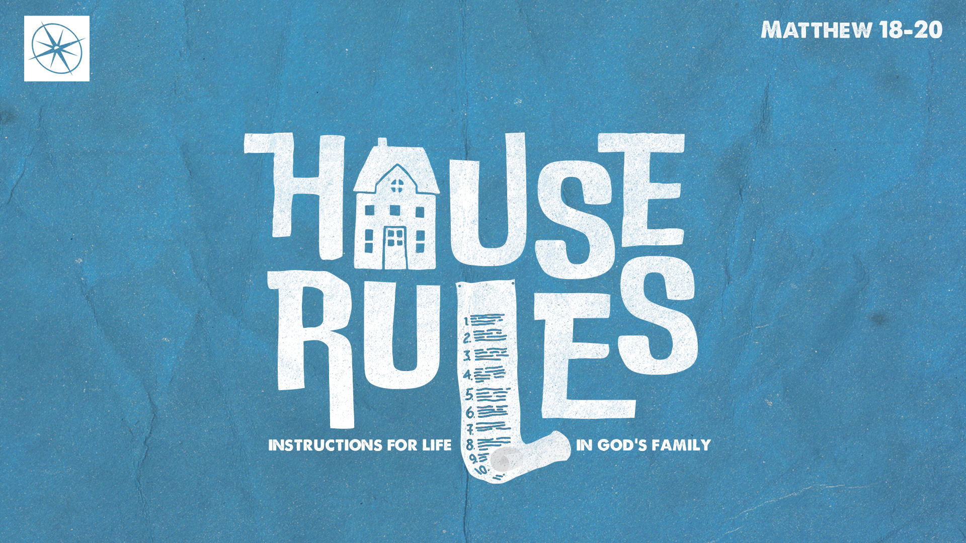
HOUSE RULES: INSTRUCTIONS FOR LIFE IN GOD’S FAMILY
GOD’S WILL WILL BE DONE
Pastor Hayden Thomas • Compass Bible Church Hill Country • February 8, 2026 • Msg. 26-05

PREACHING POINT: We must unequivocally accept that God uses human means, including human evil, to accomplish his sovereign, predetermined will, chiefly displayed in the suffering and death of Jesus, which secured our salvation.

Matthew 20:17–19 (ESV)
17 And as Jesus was going up to Jerusalem, he took the twelve disciples aside, and on the way he said to them, 18 “See, we are going up to Jerusalem. And the Son of Man will be delivered over to the chief priests and scribes, and they will condemn him to death 19 and deliver him over to the Gentiles to be mocked and flogged and crucified, and he will be raised on the third day.”

- Recognize ___________________________ (vv.17-19)

- Accept _____________________________ (vv.17-19)
Application Questions
These questions are provided for your further study and application of today’s sermon. Thoughtfully writing out the answers to these questions will help to drive home the point of today’s study. It is also helpful when you are able to discuss your answers with others. For more information about LifeGroups at Compass Bible Church that utilize these questions as the basis for their weekly discussion, please visit compasshillcountry.org/lifegroups or email us at info@compasshillcountry.org.

- Write down one observation or application you found helpful from this week’s sermon. Why did it stand out to you?
This Week’s
Bible Reading Schedule
February 8th
Leviticus 4-6 & Matt 25:1-30
February 9th
Leviticus 7-9 & Matt 25:31-46
February 10th
Leviticus 10-12 & Matt 26:1-19
February 11th
Leviticus 13 & Matt 26:20-54
February 12th
Leviticus 14 & Matt 26:55-75
February 13th
Leviticus 15-17 & Matt 27:1-31
February 14th
Lev 18-19 & Matt 27:32-66
February 15th
Leviticus 20-21 & Matt 28:1-20
See this sermon and all Compass-related videos on YouTube.com/
CompassBibleChurchHillCountry
Subscribe to Weekend Sermons, CompassU & LifeGroup Leader Podcasts: compasshillcountry.org/
podcasts

- Read Matthew 20:17-19, Acts 2:22-24, and Acts 4:27-28. What do these passages teach you about God’s sovereign control over the suffering and death of Jesus?
- Read Acts 2:23. Peter tells the people of Israel that “you” crucified and killed Jesus, even though this happened according to God’s definite plan. Why is it important to hold together both God’s sovereignty and human responsibility?
  - Where are you most tempted to emphasize one at the expense of the other?
- Read Isaiah 46:9-1, Genesis 50:15-21, and Psalm 139:16. How do these passages influence your understanding that God is orchestrating both the greatest events of history and the smallest details of life according to his will?
  - How should this perspective change the way you understand hardship, injustice, or disappointment?
- Read Proverbs 19:21, Proverbs 21:1, and Philippians 2:12-13. What do these passages teach you about the relationship between God’s sovereign plans and human decisions?
  - How can a firm belief in God’s sovereignty bring you comfort, confidence, and humility this week?
Have a question about this sermon? Send it via the QR code or link below and the pastors will do their best to address it in this week’s EQUIP podcast.

qrco.de/askaquestion

