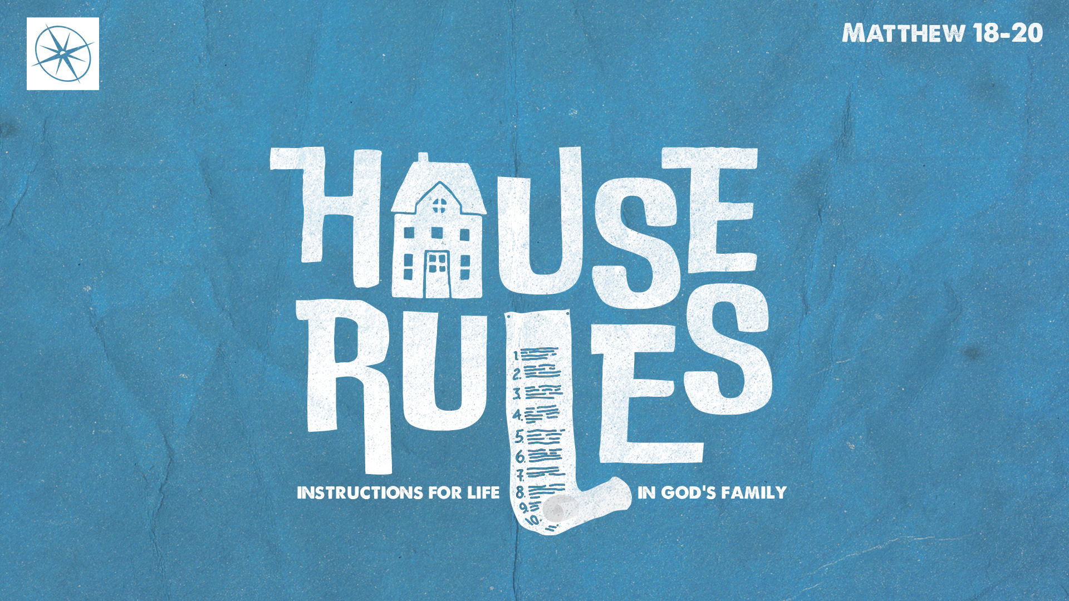
HOUSE RULES: INSTRUCTIONS FOR LIFE IN GOD’S FAMILY
HOW YOU CAN BE GREAT!
Pastor Hayden Thomas • Compass Bible Church Hill Country • February 15, 2026 • Msg. 26-06

PREACHING POINT: We must pursue greatness not by amassing power and authority, or by seeking greater status, but by serving and sacrificing for others as Christ did for us.

Matthew 20:20–28 (ESV)
20 Then the mother of the sons of Zebedee came up to him with her sons, and kneeling before him she asked him for something. 21 And he said to her, “What do you want?” She said to him, “Say that these two sons of mine are to sit, one at your right hand and one at your left, in your kingdom.” 22 Jesus answered, “You do not know what you are asking. Are you able to drink the cup that I am to drink?” They said to him, “We are able.” 23 He said to them, “You will drink my cup, but to sit at my right hand and at my left is not mine to grant, but it is for those for whom it has been prepared by my Father.” 24 And when the ten heard it, they were indignant at the two brothers. 25 But Jesus called them to him and said, “You know that the rulers of the Gentiles lord it over them, and their great ones exercise authority over them. 26 It shall not be so among you. But whoever would be great among you must be your servant, 27 and whoever would be first among you must be your slave, 28 even as the Son of Man came not to be served but to serve, and to give his life as a ransom for many.”

- Stop _____________________________ (vv.20-21)

- Trust _____________________________ (vv.22-24)
- Imitate ____________________________ (vv.25-28)
Application Questions
These questions are provided for your further study and application of today’s sermon. Thoughtfully writing out the answers to these questions will help to drive home the point of today’s study. It is also helpful when you are able to discuss your answers with others. For more information about LifeGroups at Compass Bible Church that utilize these questions as the basis for their weekly discussion, please visit compasshillcountry.org/lifegroups or email us at info@compasshillcountry.org.

- Write down one observation or application you found helpful from this week’s sermon. Why did it stand out to you?
This Week’s
Bible Reading Schedule
February 15th
Leviticus 20-21 & Matt 28:1-20
February 16th
Lev 22-23 & Mark 1:1-22
February 17th
Lev 24-25 & Mark 1:23-45
February 18th
Lev 26-27 & Mark 2
February 19th
Numbers 1-2 & Mark 3:1-21
February 20th
Numbers 3-4 & Mark 3:22-35
February 21st
Numbers 5-6 & Mark 4:1-20
February 22nd
Numbers 7 & Mark 4:21-41
See this sermon and all Compass-related videos on YouTube.com/
CompassBibleChurchHillCountry
Subscribe to Weekend Sermons, CompassU & LifeGroup Leader Podcasts: compasshillcountry.org/
podcasts

- Read James 3:13-16 and 2 Corinthians 10:17-18. Where are you most tempted to selfishly seek power, status, or recognition, and how can that pursuit hinder your relationship with God?
  - How would you distinguish between a selfish pursuit of status and a humble ambition that seeks to honor God through excellence?
  - Read Matthew 20:20-21. How can you make sure that the things you want are not selfish attempts at grabbing power, status, or recognition?
- Read 1 Peter 5:6-7 and 1 Chronicles 29:12. Why can trusting God’s plan for your life and your eternity be so difficult?
  - How does trusting God’s placement for you free you to serve sacrificially instead of worrying about missed opportunities?
- Read John 13:12-16 and Matthew 20:25-28. What does imitating Christ’s costly service look like to you?
  - Where can you imitate Christ’s costly service this week, and what might that service or sacrifice look like practically?
Have a question about this sermon? Send it via the QR code or link below and the pastors will do their best to address it in this week’s EQUIP podcast.

qrco.de/askaquestion

