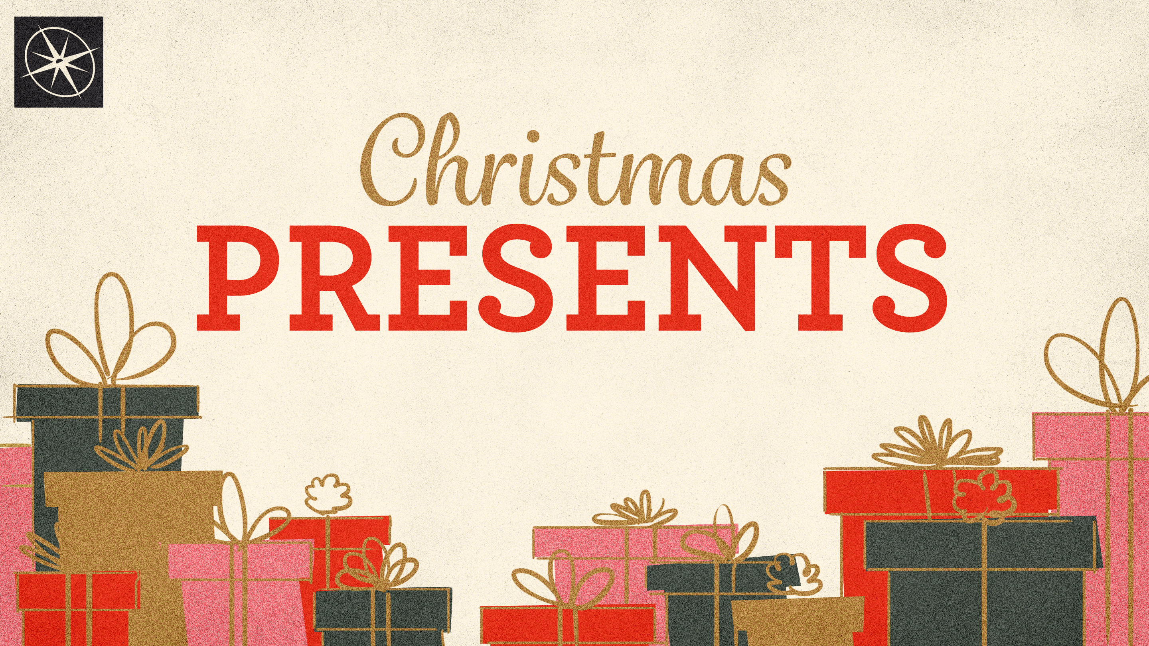
MYRRH, A SACRIFICIAL GIFT
CHRISTMAS PRESENTS
Pastor Hayden Thomas • Compass Bible Church Hill Country • December 21, 2025 • Msg. 25-49

PREACHING POINT: The gift of myrrh symbolizes Christ’s sacrificial death on the cross for our sins, a reality we must reflect on and respond to this Christmas season.

Matthew 2:1-12 (ESV)
1 Now after Jesus was born in Bethlehem of Judea in the days of Herod the king, behold, wise men from the east came to Jerusalem, 2 saying, “Where is he who has been born king of the Jews? For we saw his star when it rose and have come to worship him.” 3 When Herod the king heard this, he was troubled, and all Jerusalem with him; 4 and assembling all the chief priests and scribes of the people, he inquired of them where the Christ was to be born. 5 They told him, “In Bethlehem of Judea, for so it is written by the prophet: 6 “ ‘And you, O Bethlehem, in the land of Judah, are by no means least among the rulers of Judah; for from you shall come a ruler who will shepherd my people Israel.’ ” 7 Then Herod summoned the wise men secretly and ascertained from them what time the star had appeared. 8 And he sent them to Bethlehem, saying, “Go and search diligently for the child, and when you have found him, bring me word, that I too may come and worship him.” 9 After listening to the king, they went on their way. And behold, the star that they had seen when it rose went before them until it came to rest over the place where the child was. 10 When they saw the star, they rejoiced exceedingly with great joy. 11 And going into the house, they saw the child with Mary his mother, and they fell down and worshiped him. Then, opening their treasures, they offered him gifts, gold and frankincense and myrrh. 12 And being warned in a dream not to return to Herod, they departed to their own country by another way.

- Acknowledge _____________________________

- Grasp _________________________________
- Accept ________________________________
Application Questions
These questions are provided for your further study and application of today’s sermon. Thoughtfully writing out the answers to these questions will help to drive home the point of today’s study. It is also helpful when you are able to discuss your answers with others. For more information about LifeGroups at Compass Bible Church that utilize these questions as the basis for their weekly discussion, please visit compasshillcountry.org/lifegroups or email us at info@compasshillcountry.org.

- What is one observation or application you found helpful from this week’s sermon?
This Week’s
Bible Reading Schedule
December 21st
Micah 6-7 & Revelation 12
December 22nd
Nahum 1-3 & Revelation 13
December 23rd
Habakkuk 1-3 & Revelation 14
December 24th
Zephaniah 1-3 & Revelation 15
December 25th
Haggai 1-2 & Revelation 16
December 26th
Zechariah 1-3 & Revelation 17
December 27th
Zechariah 4-6 & Revelation 18
December 28th
Zechariah 7-9 & Revelation 19
See this sermon and all Compass-related videos on YouTube.com/
CompassBibleChurchHillCountry
Subscribe to Weekend Sermons, CompassU & LifeGroup Leader Podcasts: compasshillcountry.org/
podcasts

- Read Galatians 4:4-5 and Matthew 1:20-21. How should acknowledging the sacrificial purpose of Jesus’ birth change the way you think and even celebrate Christmas?
  - How will the sacrificial purpose of Jesus’ birth shape your Christmas traditions and celebrations this year and moving forward?
- Read Psalm 22:14-17 and Isaiah 52:14. How do these passages protect you from a purely sentimental view of Christmas and redirect your heart to the seriousness of sin and God’s solution through Christ’s birth?
- Read 2 Corinthians 5:21 and 1 Peter 2:24. The birth of Jesus marks the beginning of him “subbing in” for us, in his mission to take away our sin. Why can we easily forget or minimize the substitutionary aspect of Jesus' birth during Christmas?
  - How can you make the substitutionary aspect of Jesus' birth a prominent feature of your Christmas celebrations this year?

