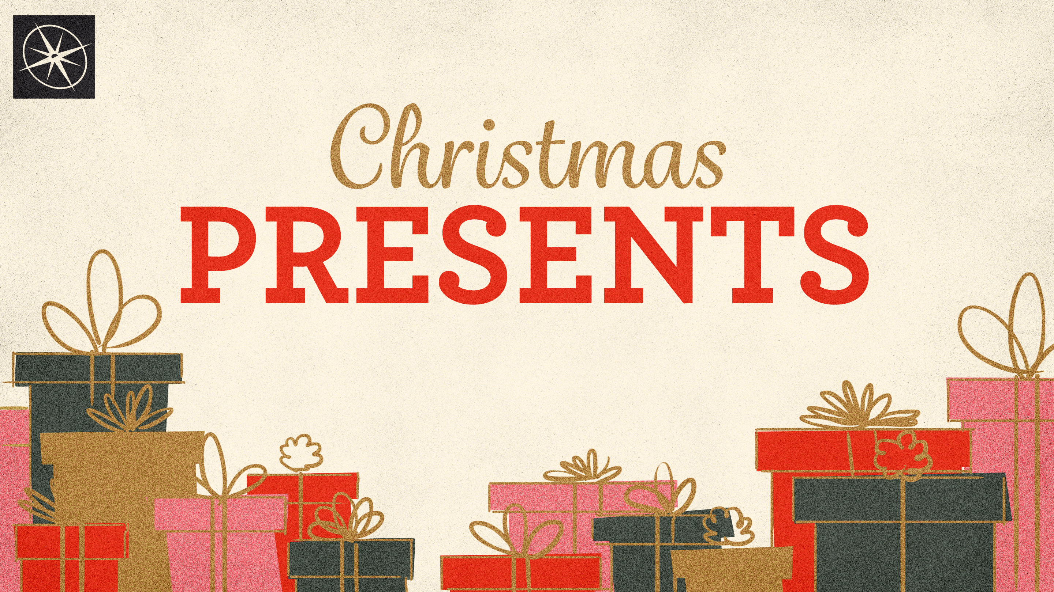
FRANKINCENSE, A HIGH PRIESTLY GIFT
CHRISTMAS PRESENTS
Pastor Hayden Thomas • Compass Bible Church Hill Country • December 14, 2025 • Msg. 25-48

PREACHING POINT: The gift of frankincense serves as a poignant reminder of Christ’s mediatorial work on our behalf and should cause us to offer spiritual sacrifices that are pleasing to God through Christ!

Matthew 2:1-12 (ESV)
1 Now after Jesus was born in Bethlehem of Judea in the days of Herod the king, behold, wise men from the east came to Jerusalem, 2 saying, “Where is he who has been born king of the Jews? For we saw his star when it rose and have come to worship him.” 3 When Herod the king heard this, he was troubled, and all Jerusalem with him; 4 and assembling all the chief priests and scribes of the people, he inquired of them where the Christ was to be born. 5 They told him, “In Bethlehem of Judea, for so it is written by the prophet: 6 “ ‘And you, O Bethlehem, in the land of Judah, are by no means least among the rulers of Judah; for from you shall come a ruler who will shepherd my people Israel.’ ” 7 Then Herod summoned the wise men secretly and ascertained from them what time the star had appeared. 8 And he sent them to Bethlehem, saying, “Go and search diligently for the child, and when you have found him, bring me word, that I too may come and worship him.” 9 After listening to the king, they went on their way. And behold, the star that they had seen when it rose went before them until it came to rest over the place where the child was. 10 When they saw the star, they rejoiced exceedingly with great joy. 11 And going into the house, they saw the child with Mary his mother, and they fell down and worshiped him. Then, opening their treasures, they offered him gifts, gold and frankincense and myrrh. 12 And being warned in a dream not to return to Herod, they departed to their own country by another way.

- Grasp _________________________________

- Confidently ______________________________
- Affirm _________________________________
- Look _________________________________
- Celebrate _______________________________
Application Questions
These questions are provided for your further study and application of today’s sermon. Thoughtfully writing out the answers to these questions will help to drive home the point of today’s study. It is also helpful when you are able to discuss your answers with others. For more information about LifeGroups at Compass Bible Church that utilize these questions as the basis for their weekly discussion, please visit compasshillcountry.org/lifegroups or email us at info@compasshillcountry.org.

- What is one observation or application you found helpful from this week’s sermon?
This Week’s
Bible Reading Schedule
December 14th
Amos 1-3 & Revelation 5
December 15th
Amos 4-6 & Revelation 6
December 16th
Amos 7-9 & Revelation 7
December 17th
Obadiah & Revelation 8
December 18th
Jonah 1-4 & Revelation 9
December 19th
Micah 1-3 & Revelation 10
December 20th
Micah 4-5 & Revelation 11
December 21st
Micah 6-7 & Revelation 12
See this sermon and all Compass-related videos on YouTube.com/
CompassBibleChurchHillCountry
Subscribe to Weekend Sermons, CompassU & LifeGroup Leader Podcasts: compasshillcountry.org/
podcasts

- Read Exodus 30:34-38 and Matthew 2:11. What is the significance of the gift of frankincense in relation to Jesus' identity?
- How does Hebrews 4:14-16 and Hebrews 7:26-28 describe Jesus as our High Priest?
- Read Hebrews 5:1. What does the role of a High Priest entail in the context of the Old Testament?
- Read 1 Timothy 2:5-6 . Why is Christ referred to as the only effective mediator between God and man?
  - Why can we confidently approach God through Christ in our daily lives?
- Read Hebrews 13:15-16. In what ways can you respond to the priestly work of Christ with joy-filled spiritual sacrifices of your own?
- Read Hebrews 10:11-18. What is meant by saying that Christ's sacrificial work is 'finished'?
- How can you include the high priestly office of Jesus in your celebrations, reflections and traditions this Christmas?

