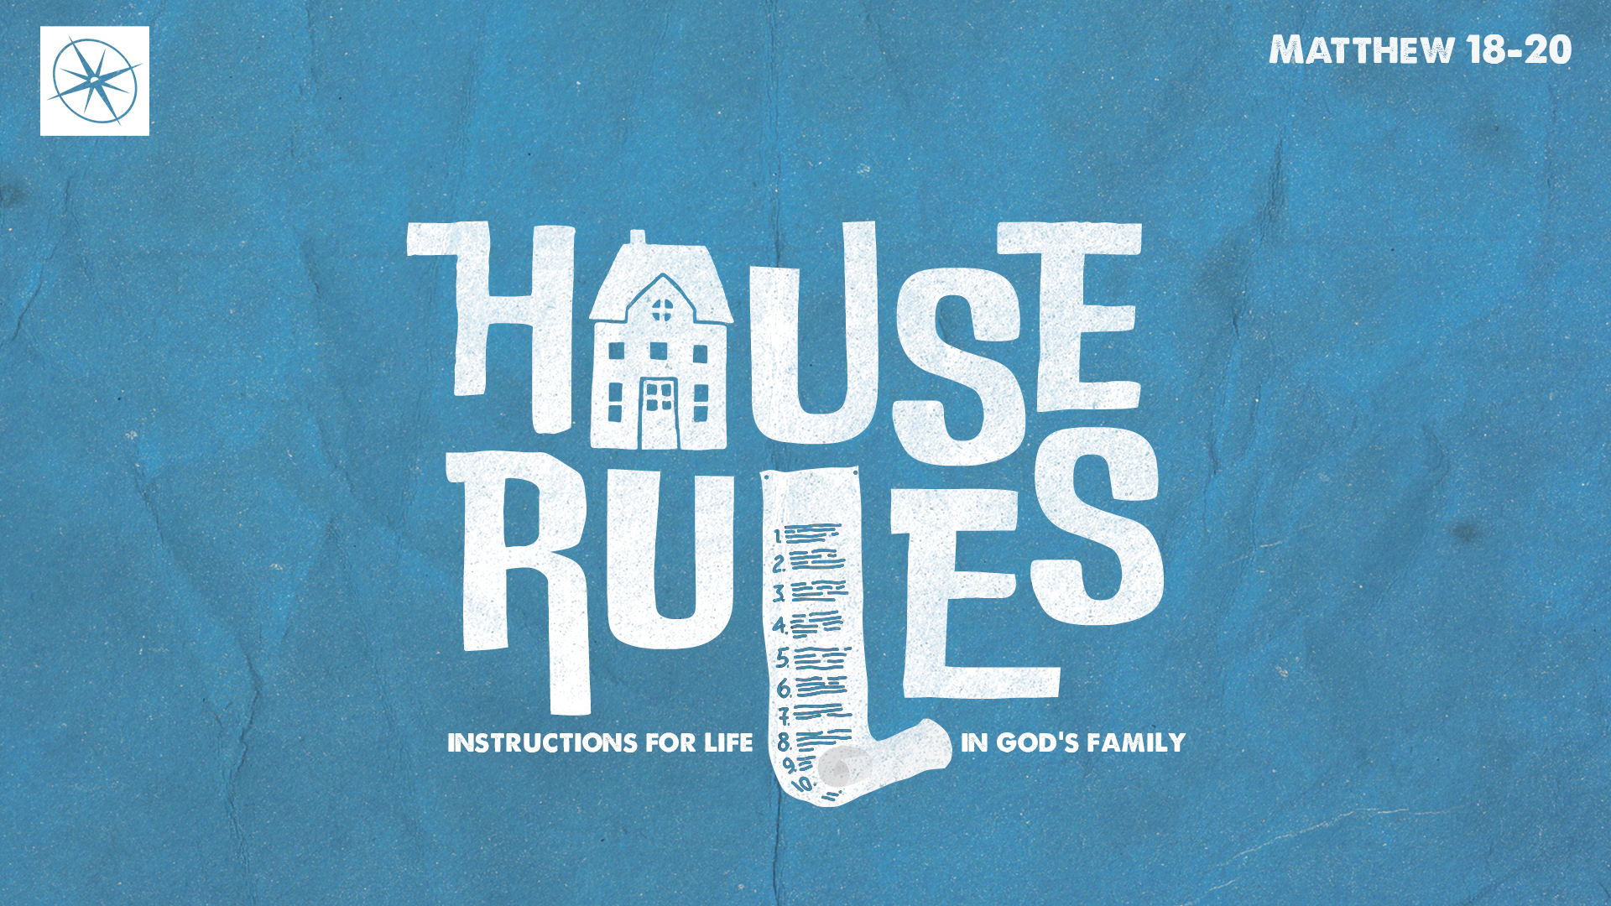
HOUSE RULES: INSTRUCTIONS FOR LIFE IN GOD’S FAMILY
MONEY, STUFF AND ETERNITY
Pastor Hayden Thomas • Compass Bible Church Hill Country • November 23, 2025 • Msg. 25-46

PREACHING POINT: To become God’s kid, you must reject idolatry in all forms and decisively follow Jesus, knowing that those who do will receive eternal life and the lasting rewards God promises to all who follow Him.

Matthew 19:16–30 (ESV)
16 And behold, a man came up to him, saying, “Teacher, what good deed must I do to have eternal life?” 17 And he said to him, “Why do you ask me about what is good? There is only one who is good. If you would enter life, keep the commandments.” 18 He said to him, “Which ones?” And Jesus said, “You shall not murder, You shall not commit adultery, You shall not steal, You shall not bear false witness, 19 Honor your father and mother, and, You shall love your neighbor as yourself.” 20 The young man said to him, “All these I have kept. What do I still lack?” 21 Jesus said to him, “If you would be perfect, go, sell what you possess and give to the poor, and you will have treasure in heaven; and come, follow me.” 22 When the young man heard this he went away sorrowful, for he had great possessions. 23 And Jesus said to his disciples, “Truly, I say to you, only with difficulty will a rich person enter the kingdom of heaven. 24 Again I tell you, it is easier for a camel to go through the eye of a needle than for a rich person to enter the kingdom of God.” 25 When the disciples heard this, they were greatly astonished, saying, “Who then can be saved?” 26 But Jesus looked at them and said, “With man this is impossible, but with God all things are possible.” 27 Then Peter said in reply, “See, we have left everything and followed you. What then will we have?” 28 Jesus said to them, “Truly, I say to you, in the new world, when the Son of Man will sit on his glorious throne, you who have followed me will also sit on twelve thrones, judging the twelve tribes of Israel. 29 And everyone who has left houses or brothers or sisters or father or mother or children or lands, for my name’s sake, will receive a hundredfold and will inherit eternal life. 30 But many who are first will be last, and the last first.

- Remove ____________________________ (vv.16-22)

- Depend ____________________________ (vv.23-26)
- Anticipate _________________________ (vv.27-30)
Application Questions
These questions are provided for your further study and application of today’s sermon. Thoughtfully writing out the answers to these questions will help to drive home the point of today’s study. It is also helpful when you are able to discuss your answers with others. For more information about LifeGroups at Compass Bible Church that utilize these questions as the basis for their weekly discussion, please visit compasshillcountry.org/lifegroups or email us at info@compasshillcountry.org.

- What is one observation or application that you found helpful from this week’s sermon?
This Week’s
Bible Reading Schedule
November 23rd
Ezekiel 29-31 & James 5
November 24th
Ezekiel 32-33 & 1 Peter 1
November 25th
Ezekiel 34-35 & 1 Peter 2
November 26th
Ezekiel 36-37 & 1 Peter 3
November 27th
Ezekiel 38-39 & 1 Peter 4
November 28th
Ezekiel 40 & 1 Peter 5
November 29th
Ezekiel 41-42 & 2 Peter 1
November 30th
Ezekiel 43-44 & 2 Peter 2
See this sermon and all Compass-related videos on YouTube.com/
CompassBibleChurchHillCountry
Subscribe to Weekend Sermons, CompassU & LifeGroup Leader Podcasts: compasshillcountry.org/
podcasts

- Read Matthew 19:16-24. What are some potential idols in your life that need to be removed so they will not stand between you and God?
- Read Matthew 19:25-26 and John 1:9-13. What are some things people can be tempted to depend on to earn salvation? (ex. good works, moralism, spiritual discipline check list)?
  - How does a clear grasp of who Christ is and what He did for you guard
you against relying on yourself or anything else to bring you to God?
- Read Matthew 19:27-30 and 1 Corinthians 3:12–15. How should the promised rewards of the coming age act as a deterrent to the temptations and attractions of this world?

