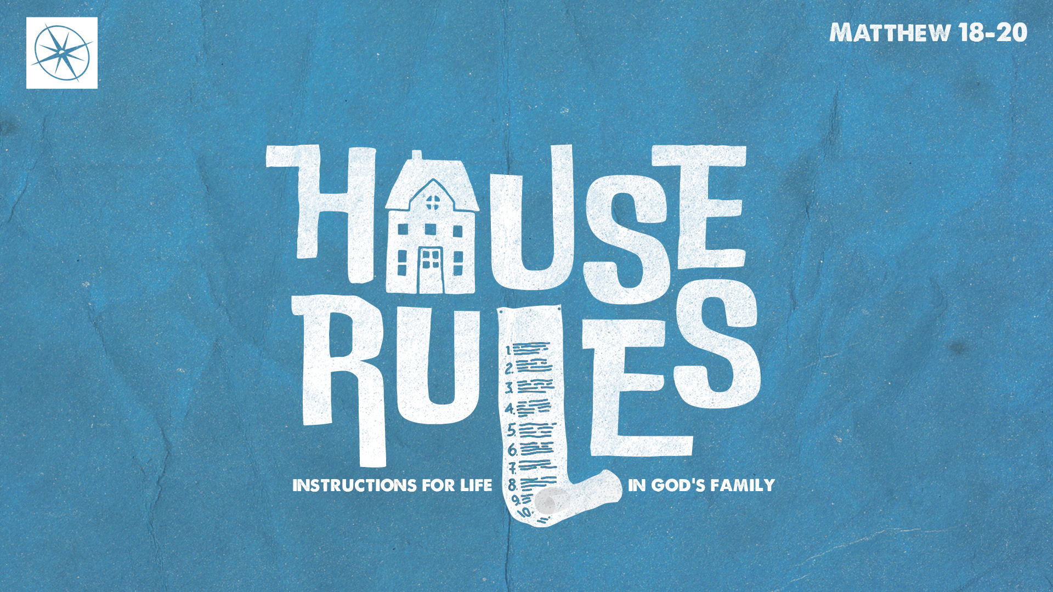
HOUSE RULES: INSTRUCTIONS FOR LIFE IN GOD’S FAMILY
FORGIVING GOD’S KIDS
Pastor Hayden Thomas • Compass Bible Church Hill Country • November 2, 2025 • Msg. 25-43

PREACHING POINT: As God’s kids, we must consistently reflect our Heavenly Father’s character by extending the same extravagant forgiveness toward his children that he extends to us.

Matthew 18:21–35 (ESV)
21 Then Peter came up and said to him, “Lord, how often will my brother sin against me, and I forgive him? As many as seven times?” 22 Jesus said to him, “I do not say to you seven times, but seventy-seven times. 23 “Therefore the kingdom of heaven may be compared to a king who wished to settle accounts with his servants. 24 When he began to settle, one was brought to him who owed him ten thousand talents. 25 And since he could not pay, his master ordered him to be sold, with his wife and children and all that he had, and payment to be made. 26 So the servant fell on his knees, imploring him, ‘Have patience with me, and I will pay you everything.’ 27 And out of pity for him, the master of that servant released him and forgave him the debt. 28 But when that same servant went out, he found one of his fellow servants who owed him a hundred denarii, and seizing him, he began to choke him, saying, ‘Pay what you owe.’ 29 So his fellow servant fell down and pleaded with him, ‘Have patience with me, and I will pay you.’ 30 He refused and went and put him in prison until he should pay the debt. 31 When his fellow servants saw what had taken place, they were greatly distressed, and they went and reported to their master all that had taken place. 32 Then his master summoned him and said to him, ‘You wicked servant! I forgave you all that debt because you pleaded with me. 33 And should not you have had mercy on your fellow servant, as I had mercy on you?’ 34 And in anger his master delivered him to the jailers, until he should pay all his debt. 35 So also my heavenly Father will do to every one of you, if you do not forgive your brother from your heart.”

- Get ______________________________ (vv.21-22)

- Grasp _____________________________ (vv.23-27)
- Confess ____________________________ (vv.28-30)
- Fear ______________________________ (vv.31-35)
Application Questions
These questions are provided for your further study and application of today’s sermon. Thoughtfully writing out the answers to these questions will help to drive home the point of today’s study. It is also helpful when you are able to discuss your answers with others. For more information about LifeGroups at Compass Bible Church that utilize these questions as the basis for their weekly discussion, please visit compasshillcountry.org/lifegroups or email us at info@compasshillcountry.org.

- Write down one observation or application you found helpful from this week’s sermon.
This Week’s
Bible Reading Schedule
November 2nd
Jeremiah 33-35 & Titus 3
November 3rd
Jeremiah 36-37 & Philemon
November 4th
Jeremiah 38-39 & Hebrews 1
November 5th
Jeremiah 40-42 & Hebrews 2
November 6th
Jeremiah 43-45 & Hebrews 3
November 7th
Jeremiah 46-48 & Hebrews 4
November 8th
Jeremiah 49-50 & Hebrews 5
November 9th
Jeremiah 51-52 & Hebrews 6
See this sermon and all Compass-related videos on YouTube.com/
CompassBibleChurchHillCountry
Subscribe to Weekend Sermons, CompassU & LifeGroup Leader Podcasts: compasshillcountry.org/
podcasts

- Read Colossians 3:12-14 and Matthew 18:21-22. Why do you think forgiveness is so difficult to give, even within the church, despite us being the most forgiven people in the world?
  - In what ways are you tempted to keep count of how many times you forgive, and what practical steps can help you imitate God’s abundant forgiveness?
- Read Matthew 18:23-27 and Psalm 130:3-4. How does starting with your unpayable debt before God reshape your attitude toward those who sin against you?
- Read Matthew 18:28-30 and 1 John 4:20-21. Explain the hypocrisy of someone who celebrates the mercy of God in their life while refusing to show mercy to others.
  - What does God say about such a person?
- Read Matthew 18:31-35 and Matthew 6:14-15. How does viewing the act of forgiveness as evidence of genuine salvation clarify both your capacity and your responsibility to forgive?
  - In light of Jesus’ warnings, why should a persistent unwillingness to forgive cause concern about the genuineness of your salvation?

