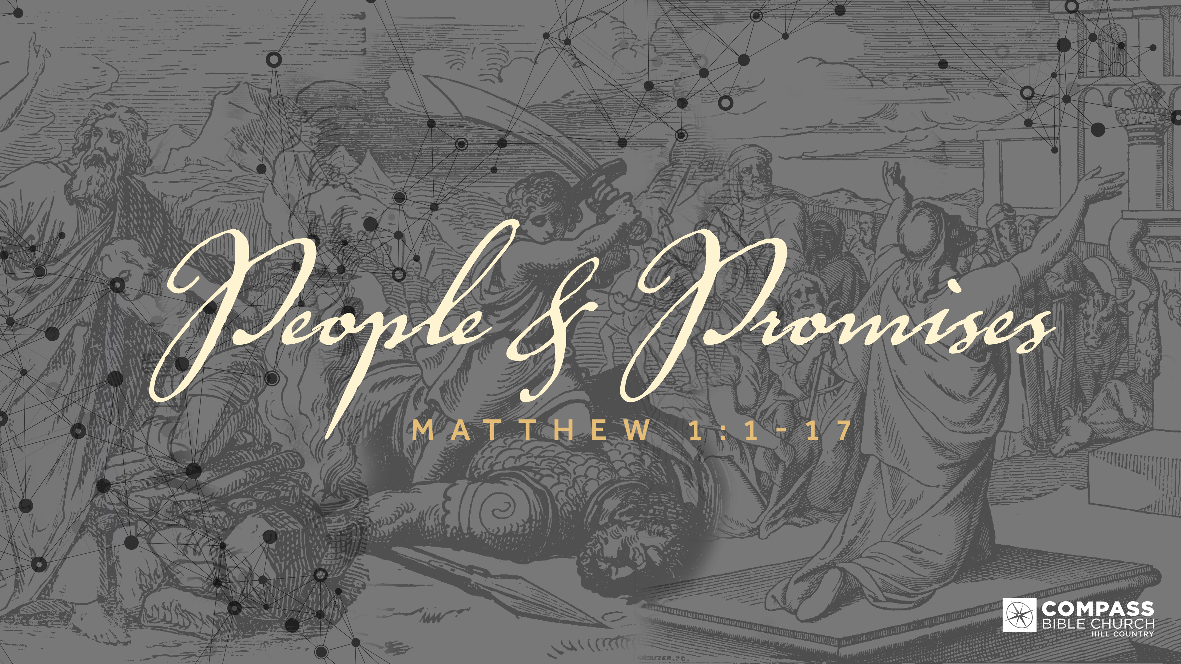
PEOPLE & PROMISES
EXILED FROM GOD
Matthew 1:7-11
Pastor Hayden Thomas • Compass Bible Church Hill Country • October 9, 2022 • Msg. 22-37

Matthew 1:7-11
7 and Solomon the father of Rehoboam, and Rehoboam the father of Abijah, and Abijah the father of Asaph, 8 and Asaph the father of Jehoshaphat, and Jehoshaphat the father of Joram, and Joram the father of Uzziah, 9 and Uzziah the father of Jotham, and Jotham the father of Ahaz, and Ahaz the father of Hezekiah, 10 and Hezekiah the father of Manasseh, and Manasseh the father of Amos,
and Amos the father of Josiah, 11 and Josiah the father of Jechoniah and his brothers, at the time of the deportation to Babylon. (ESV)

1. Fully _______________________________ (vv.7-11)

2. Eliminate ____________________________ (vv.7-11)

3. Patiently _____________________________ (v.11)

Application Questions
These questions are provided for your further study and application of today’s sermon. Thoughtfully writing out the answers to these questions will help to drive home the point of today’s study. It is also helpful when you are able to discuss your answers with others. For more information about LifeGroups at Compass Bible Church that utilize these questions as the basis for their weekly discussion, please visit compasshillcountry.org/lifegroups or email us at info@compasshillcountry.org.

1. Write down one observation you found particularly helpful from this week's sermon.

2. Read Hebrews 8:6–13. Unlike the bilateral covenant given to Moses, how do the
unilateral Covenants between King David (Davidic Covenant) and King Jesus (New
Covenant) provide us with confidence to fully trust God’s covenant promise?

3. Read Colossians 3:5–8 and Romans 1:21–25. According to these verses, how
This Week’s
Bible Reading Schedule
October 9th
Isaiah 41-42 & Colossians 1
October 10th
Isaiah 43-44 & Colossians 2
October 11th
Isaiah 45=47 & Colossians 3
October 12th
Isaiah 48-49 & Colossians 4
October 13th
Isaiah 50-52 & 1 Thess 1
October 14th
Isaiah 53-55 & 1 Thess 2
October 15th
Isaiah 56-58 & 1 Thess 3
October 16th
Isaiah 59-61 & 1 Thess 4

do you define an Idol?

- How can you identify Idols in your own life?

- What does eliminating idols consist of in the life of a Christian?

4. Read Revelation 22:10–12 and Isaiah 11:1–10. How do Jesus' words in Revelation and Isaiah's description of the coming reign of Christ help you arrive at a proper response to this waiting period before the future vindication of Christ?

This Week’s Memory Verse
Ephesians 4:1-2 (ESV)
1 I therefore, a prisoner for the Lord, urge you to walk in a manner worthy of the calling to which you have been called, 2 with all humility and gentleness, with patience, bearing with one another in love,
See this sermon and all
Compass-related videos on YouTube.com/
CompassBibleChurchHillCountry
Subscribe to Weekend Sermons, Compass Equip & LifeGroup Leader Podcasts:
CompassChurch.org/podcasts

