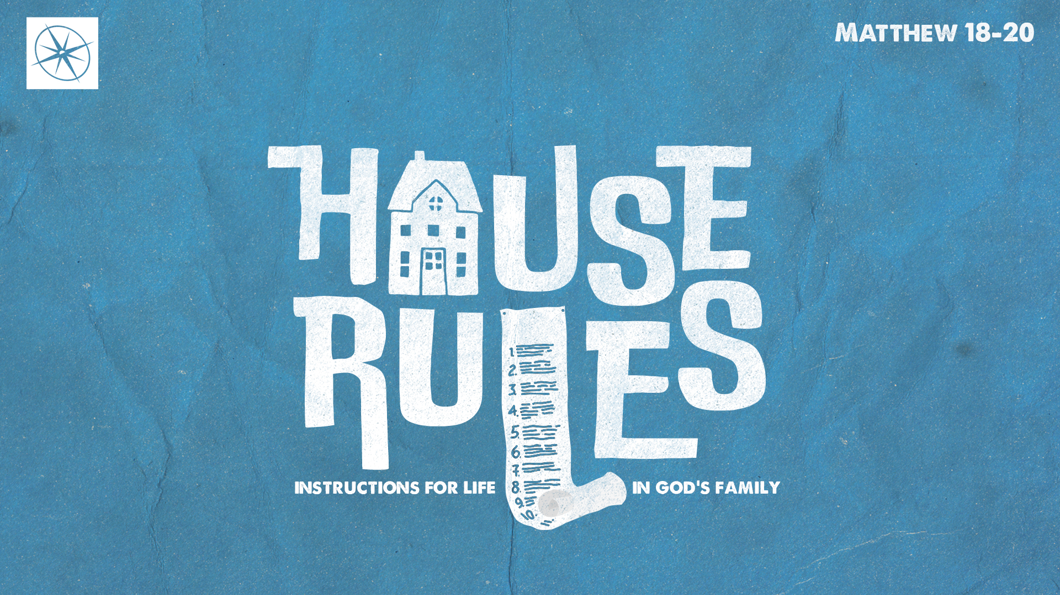

**HOUSE RULES: INSTRUCTIONS FOR LIFE IN GOD’S FAMILY   
CHERISH GOD’S CHILDREN**

Pastor Hayden Thomas • Compass Bible Church Hill Country • October 5, 2025 • Msg. 25-39

**PREACHING POINT: Christians must cherish one another as they cherish Christ by promoting behavior that prevents themselves and others from stumbling.**

**Matthew 18:5–9 (ESV)**

5 “Whoever receives one such child in my name receives me, 6 but whoever causes one of these little ones who believe in me to sin, it would be better for him to have a great millstone fastened around his neck and to be drowned in the depth of the sea. 7 “Woe to the world for temptations to sin! For it is necessary that temptations come, but woe to the one by whom the temptation comes! 8 And if your hand or your foot causes you to sin, cut it off and throw it away. It is better for you to enter life crippled or lame than with two hands or two feet to be thrown into the eternal fire. 9 And if your eye causes you to sin, tear it out and throw it away. It is better for you to enter life with one eye than with two eyes to be thrown into the hell of fire.

1. **Treat ________________________________ (v.5)**
2. **Prefer ________________________________ (v.6)**
3. **Dread _________________________________ (v.7)**

1. **Do _________________________________ (vv.8-9)**

**Application Questions**

*These questions are provided for your further study and application of today’s sermon. Thoughtfully writing out the answers to these questions will help to drive home the point of today’s study. It is also helpful when you are able to discuss your answers with others. For more information about LifeGroups at Compass Bible Church that utilize these questions as the basis for their weekly discussion, please visit compasshillcountry.org/lifegroups or email us at info@compasshillcountry.org.*

1. Write down one observation or application you found helpful from this week’s sermon.

*This Week’s  
Bible Reading Schedule*

**October 5th**

*Isaiah 31-33 & Philippians 1*

**October 6th**

*Isaiah 34-36 & Philippians 2*

**October 7th**

*Isaiah 37-38 & Philippians 3*

**October 8th**

*Isaiah 39-40 & Philippians 4*

**October 9th**

*Isaiah 41-42 & Ephesians 4*

**October 10th**

*Isaiah 43-44 & Ephesians 5*

**October 11th**

*Isaiah 45-47 & Ephesians 6*

**October 12th**

*Isaiah 48-49 & Philippians 1*

1. Read Matthew 5:8. How do you typically treat the average Christian you know? Do you cherish them as you would if they were Jesus?  
     
     
     
     
   1. How can you better cherish each Christian as God’s kid?
2. Read Matthew 18:6. What does this verse reveal about how seriously God views anyone who causes a believer to stumble?  
     
     
     
     
   1. How does the severity of Christ’s warning sharpen your own vigilance to ensure that you will not be the reason someone else trips spiritually?
3. Read 2 Peter 3:4-7 and Romans 14:10-12. Why should the sober reminder of God’s coming judgment keep you from adding more stumbling blocks in an already sinful world?
4. Read Romans 13:10-14 and Matthew 18:8-9. What do these verses offer to help you see the necessity of taking any measure necessary to eliminate opportunities for sin in your life?  
     
     
     
     
   1. What are some things you can eliminate in your life that are causes for sin, either for you or others?