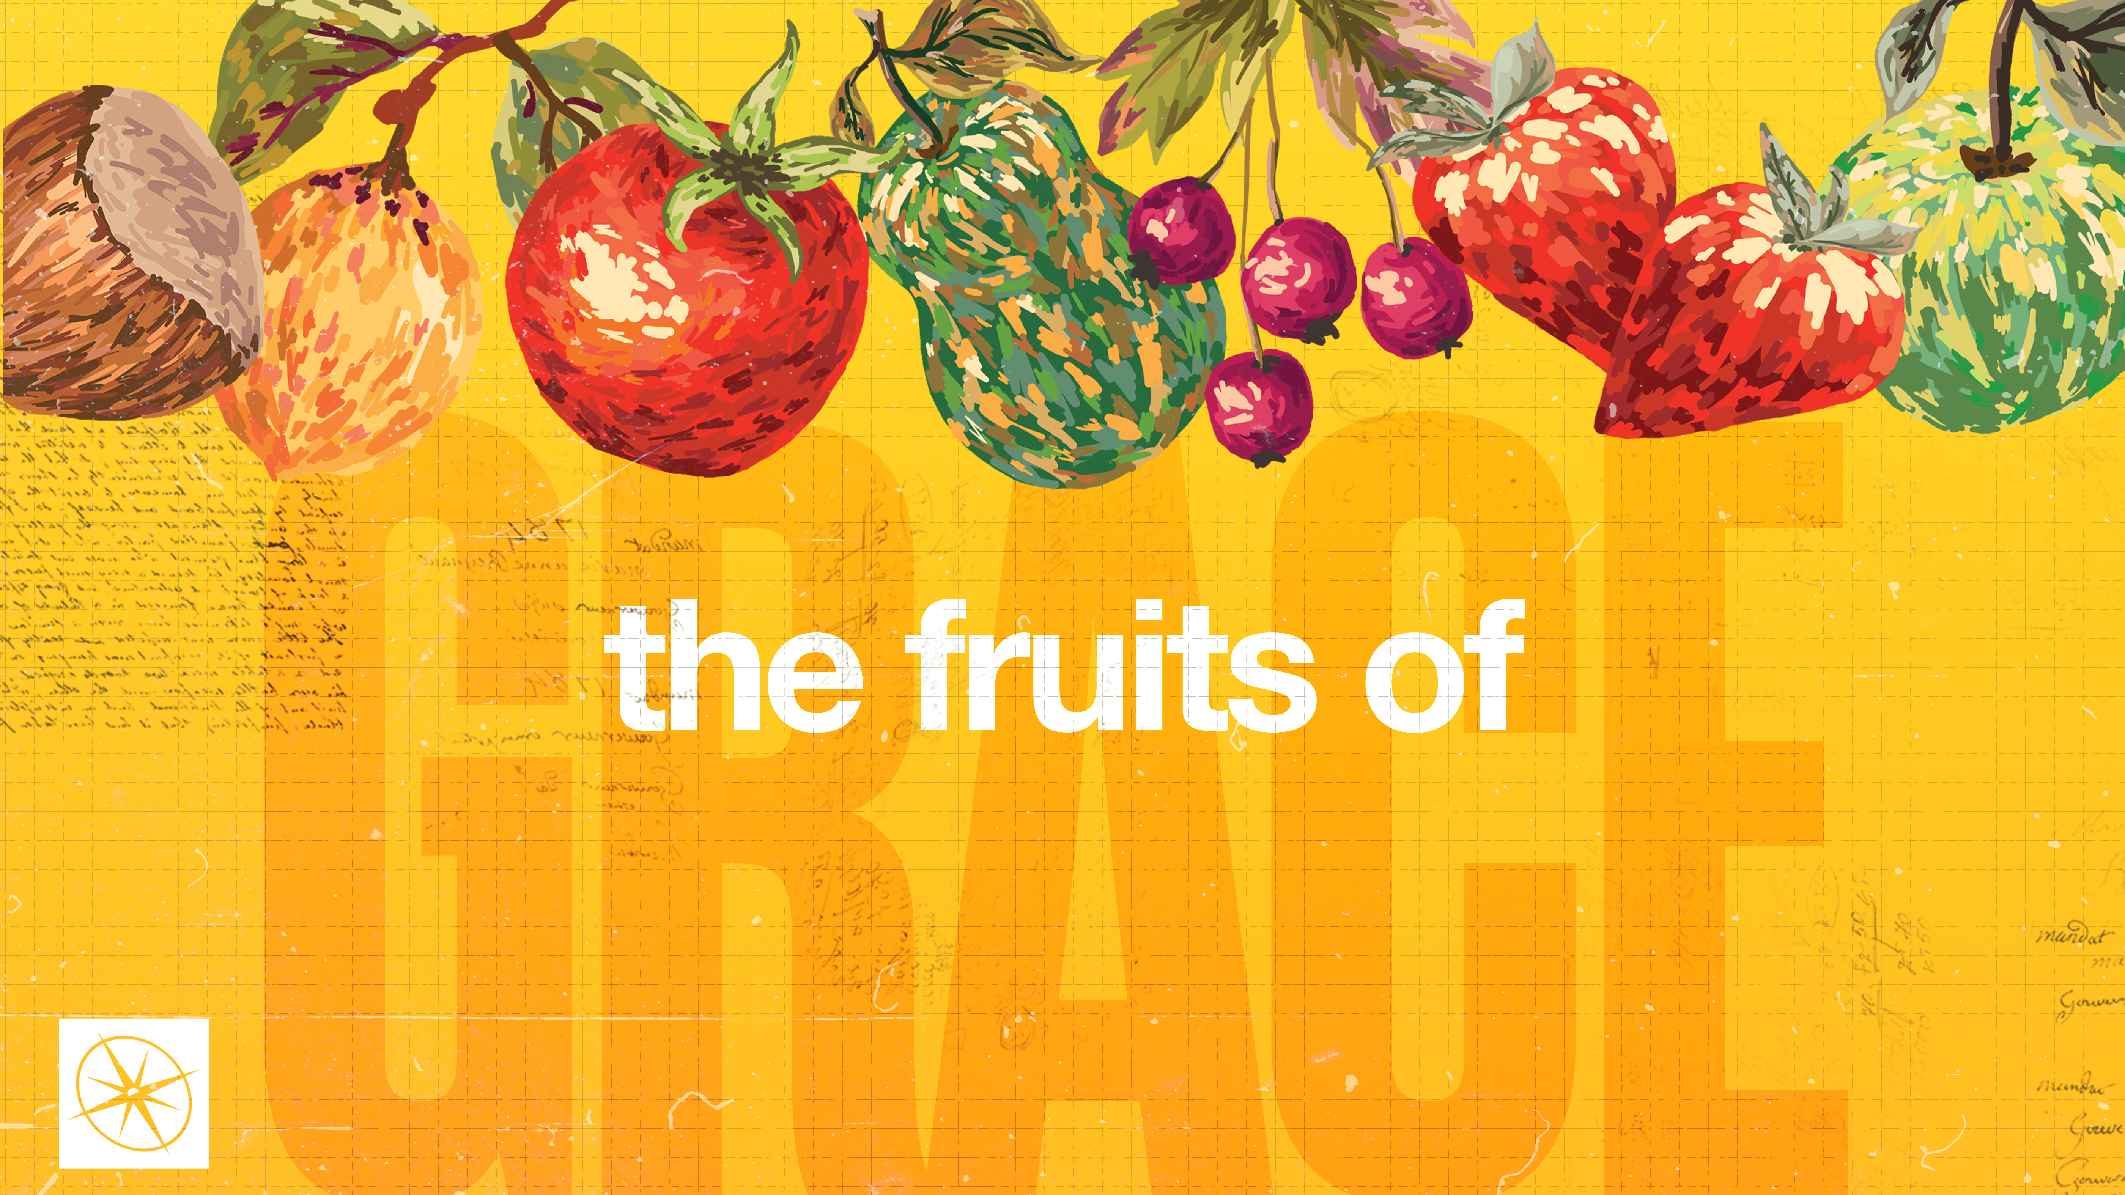

**THE FRUITS OF GRACE  
FAITHFULNESS**

Pastor Hayden Thomas • Compass Bible Church Hill Country • October 19, 2025 • Msg. 25-41

**PREACHING POINT: God’s faithfulness to fulfill all of his promises for us in Christ must propel our own spirit-empowered faithfulness in everyday life.**

**Galatians 5:16-23 (ESV)**

16 But I say, walk by the Spirit, and

you will not gratify the desires of the

flesh. 17 For the desires of the flesh

are against the Spirit, and the desires

of the Spirit are against the flesh, for

these are opposed to each other, to

keep you from doing the things you

want to do. 18 But if you are led by

the Spirit, you are not under the law.

19 Now the works of the flesh are

evident: sexual immorality, impurity,

sensuality, 20 idolatry, sorcery,

enmity, strife, jealousy, fits of anger,

rivalries, dissensions, divisions, 21

envy, drunkenness, orgies, and

things like these. I warn you, as I

warned you before, that those who

do such things will not inherit the

kingdom of God. 22 But the fruit of

the Spirit is love, joy, peace,

patience, kindness, goodness,

faithfulness, 23 gentleness, self-

control; against such things there is

no law.

1. **Recall ________________________________**
2. **Respond _______________________________**

1. **Exhibit ________________________________**

**Application Questions**

*These questions are provided for your further study and application of today’s sermon. Thoughtfully writing out the answers to these questions will help to drive home the point of today’s study. It is also helpful when you are able to discuss your answers with others. For more information about LifeGroups at Compass Bible Church that utilize these questions as the basis for their weekly discussion, please visit compasshillcountry.org/lifegroups or email us at info@compasshillcountry.org.*

1. Write down one observation or application you found helpful from this week’s sermon and baptisms.

*This Week’s  
Bible Reading Schedule*

**October 19th**

*Jeremiah 1-2 & 2 Thess 2*

**October 20th**

*Jeremiah 3-4 & 2 Thess 3*

**October 21st**

*Jeremiah 5-6 & 1 Timothy 1*

**October 22nd**

*Jeremiah 7-8 & 1 Timothy 2*

**October 23rd**

*Jeremiah 9-10 & Timothy 3*

**October 24th**

*Jeremiah 11-13 & 1 Timothy 4*

**October 25th**

*Jeremiah 14-16 & 1 Timothy 5*

**October 26th**

*Jeremiah 17-19 & 1 Timothy 6*

1. Read Deuteronomy 7:6-9 and Joshua 21:45. How do these verses help you define God’s faithfulness?  
     
     
   1. How have you seen God’s faithfulness in your own life?
2. Read 1 John 1:9. Why must God’s faithfulness be the starting point for salvation and forgiveness?   
     
     
   1. If God were only 99% faithful, how would that impact your confidence in your salvation?
   2. How does knowing that God is 100% faithful give you assurance in your relationship with him and motivate you to share the gospel with others?
3. Read 1 Corinthians 11:1. Paul tells the Corinthians to imitate him as he imitates Jesus. How does imitating Jesus impact your reliability in the eyes of others?   
     
     
     
   1. Give three examples of everyday Christlike reliability that you can exhibit in your interaction with others.
   2. Why should we care whether or not we are seen as reliable?
4. Read Proverbs 20:6. Why must we be aware of self-deception in the area of faithfulness?  
     
     
   1. What practical steps can you take to ensure your view of personal faithfulness aligns with God’s standard?