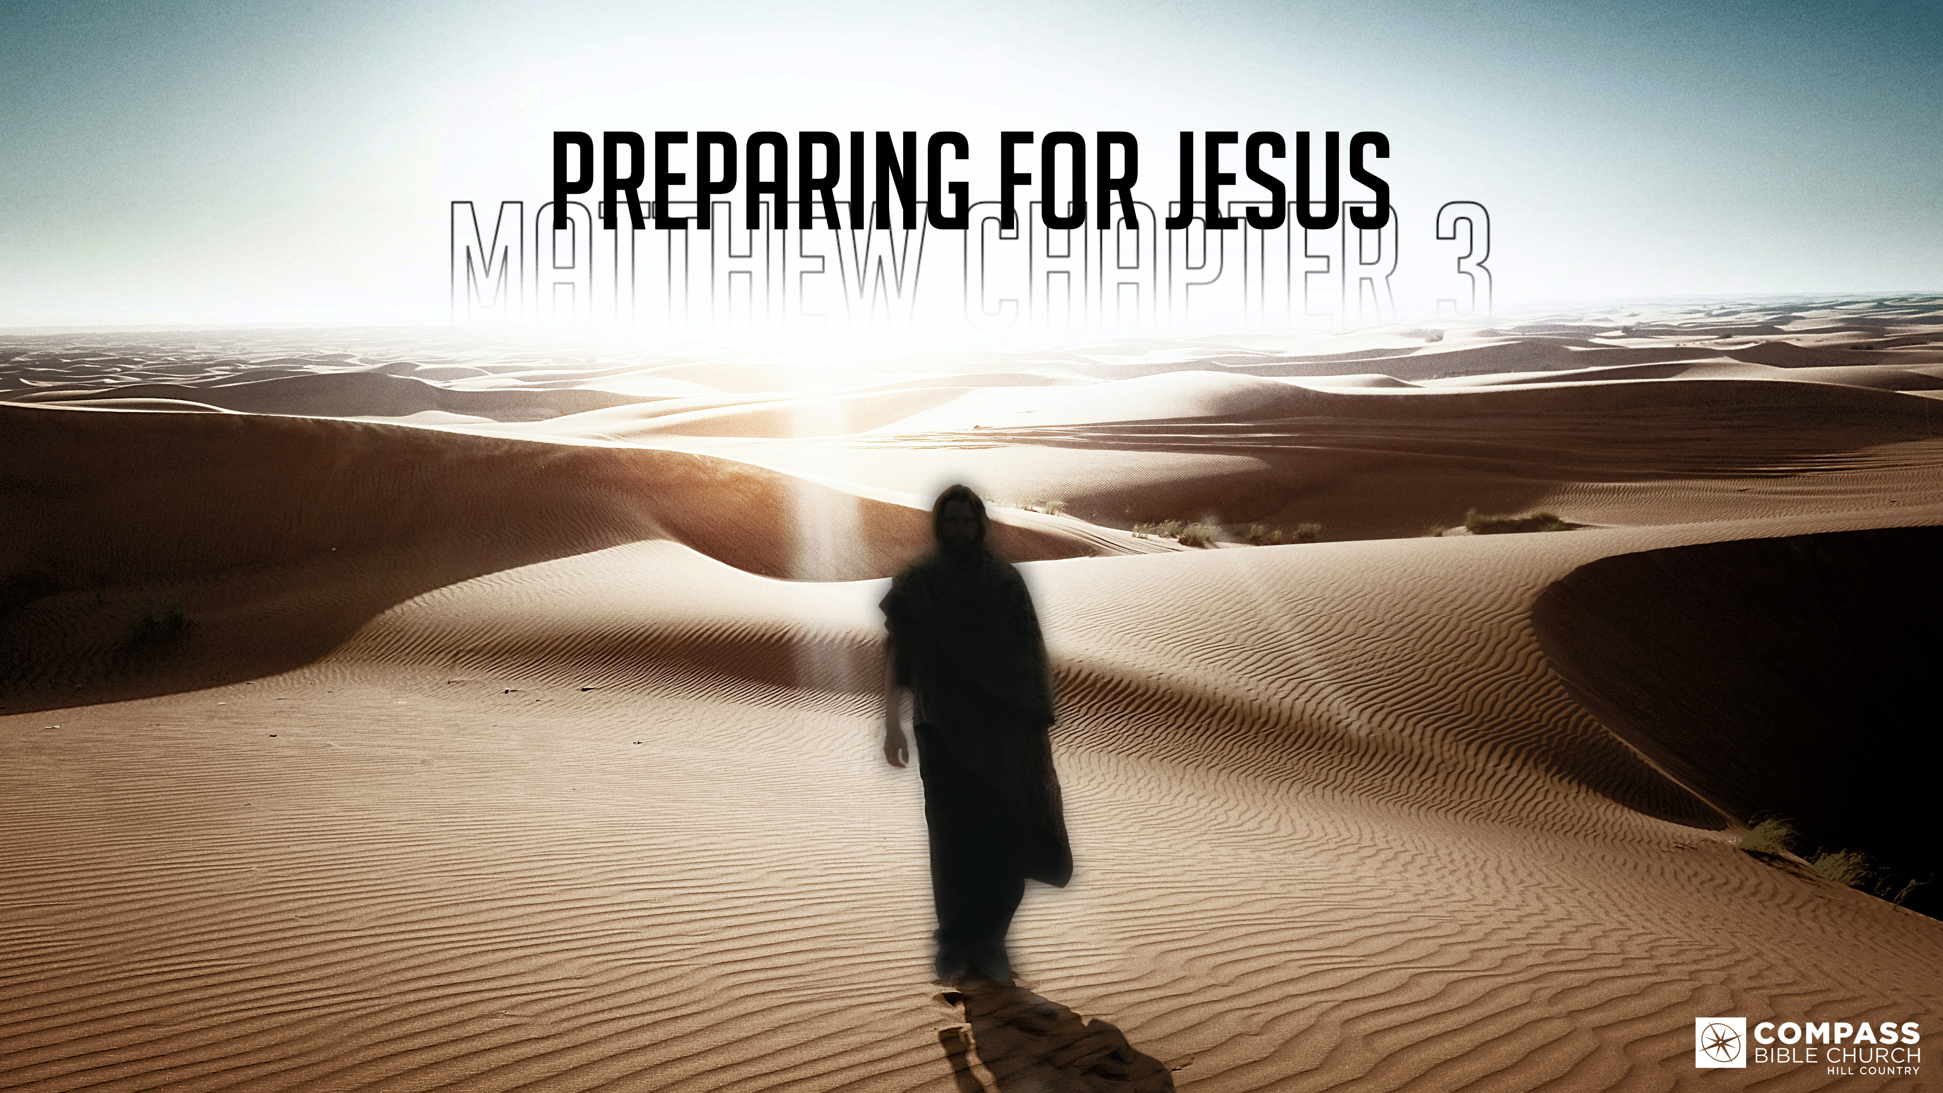
PREPARING FOR JESUS
THE REVELATION
Matthew 3:13-17
Pastor Hayden Thomas • Compass Bible Church Hill Country • January 29, 2023 • Msg. 23-05

Matthew 3:13-17
13 Then Jesus came from Galilee to the Jordan to John, to be baptized by him. 14 John would have prevented him, saying, “I need to be baptized by you, and do you come to me?” 15 But Jesus answered him, “Let it be so now, for thus it is fitting for us to fulfill all righteousness.” Then he consented. 16 And when Jesus was baptized, immediately he went up from the water, and behold, the heavens were opened to him, and he saw the Spirit of God descending like a dove and coming to rest on him; 17 and behold, a voice from heaven said, “This is my beloved Son, with whom I am well pleased.” (ESV)

1. Grasp ___________________________ (vv.13-16a)

2. Participate ________________________ (vv.16-17)

Application Questions
These questions are provided for your further study and application of today’s sermon. Thoughtfully writing out the answers to these questions will help to drive home the point of today’s study. It is also helpful when you are able to discuss your answers with others. For more information about LifeGroups at Compass Bible Church that utilize these questions as the basis for their weekly discussion, please visit compasshillcountry.org/lifegroups or email us at info@compasshillcountry.org.

- What is one observation you found particularly helpful from this week’s sermon?

- Read Philippians 2:3–8 & Isaiah 53:12. What does God sending his Son to associate Himself with the sinfulness of humanity say about God’s compassion for the lost?

- Read Romans 8:1–4. How does the Incarnation of the Son show the seriousness and power of sin?
This Week’s
Bible Reading Schedule
January 29th
Exodus 19-21 & Matt 20:1-16
January 30th
Exodus 22-24 & Matt 20:17-34
January 31st
Exodus 25-26 & Matt 21:1-22
February 1st
Exodus 27-28 & Matt 21:23-46
February 2nd
Exodus 29-30 & Matt 22:1-22
February 3rd
Exodus 31-32 & Matt 22:23-46
February 4th
Exodus 33-35 & Matt 23:1-22
February 5th
Exodus 36-37 & Matt 23:23-39

- Read John 15:26 & Matthew 28:18–20. What does this week’s sermon and these verses do to highlight God’s desire for his children to participate in the same mission as the Father, Son and Holy Spirit?
  - How does the amount of attention that our Triune God gives to the salvation of souls force us to reconsider how we manage our time regarding reaching people for Christ?
- Read Acts 10:37-38, 2 Corinthians 13:14, 1 Peter 1:2 & Matthew 28:19. How do these verses help make you aware that our one God exists in three persons, and all three persons are involved in the life of believers?
  - Why is this awareness important for your faith, specifically in how you relate to the Trinity?

See this sermon and all Compass-related videos on YouTube.com/
CompassBibleChurchHillCountry
Subscribe to Weekend Sermons, Compass Equip & LifeGroup Leader Podcasts: compasshillcountry.org/
podcasts

