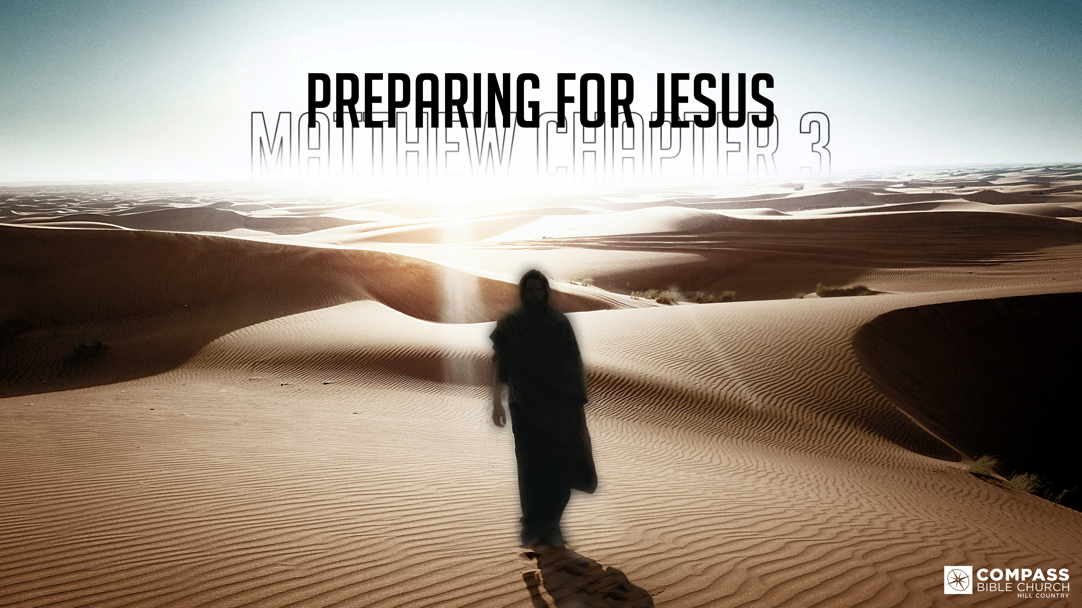
PREPARING FOR JESUS
PART 1
Matthew 3:1-6
Pastor Hayden Thomas • Compass Bible Church Hill Country • January 15, 2023 • Msg. 23-03

Matthew 3:1-6
3 In those days John the Baptist came preaching in the wilderness of Judea, 2 “Repent, for the kingdom of heaven is at hand.” 3 For this is he who was spoken of by the prophet Isaiah when he said, “The voice of one crying in the wilderness: ‘Prepare the way of the Lord; make his paths straight.’” 4 Now John wore a garment of camel's hair and a leather belt around his waist, and his food was locusts and wild honey. 5 Then Jerusalem and all Judea and all the region about the Jordan were going out to him, 6 and they were baptized by him in the river Jordan, confessing their sins. (ESV)

1. Herald _____________________________ (vv.1-2)

2. Associate ___________________________ (vv.3-4)

3. Invite ______________________________ (vv.5-6)

Application Questions
These questions are provided for your further study and application of today’s sermon. Thoughtfully writing out the answers to these questions will help to drive home the point of today’s study. It is also helpful when you are able to discuss your answers with others. For more information about LifeGroups at Compass Bible Church that utilize these questions as the basis for their weekly discussion, please visit compasshillcountry.org/lifegroups or email us at info@compasshillcountry.org.

- What is one observation you found helpful from this week’s sermon?

- Read Acts 1:7-11 & Matthew 25:31–46. What do these passages do to heighten your attentiveness toward telling everyone you can about the return of Christ?

- Read Luke 9:26, Romans 1:16–17 and 1 Corinthians 10:31–33. How do these verses explain the significance of associating with Christ and his gospel?
This Week’s
Bible Reading Schedule
January 15th
Genesis 36-37 & Matthew 11
January 16th
Genesis 38-40 & Matt 12:1-21
January 17th
Genesis 41 & Matt 12:22-50
January 18th
Genesis 42-43 & Matt 13:1-32
January 19th
Genesis 44-45 & Matt 13:33-58
January 20th
Genesis 46-48 & Matt 14:1-21
January 21st
Genesis 49-50 & Matt 14:22-36
January 22nd
Exodus 1-3 & Matthew 15:1-20

  - How have you been guilty of advertently or passively disassociating yourself from Jesus and his message when talking with others?
  - What are some ways you have or can begin associating yourself with Jesus and his gospel?

- Read 2 Corinthians 5:20–6:3. What is the role of an ambassador?
  - How does this description of an ambassador do an excellent job of defining the responsibility of every Christian?
  - In what scenario can you, as an ambassador of Christ, invite someone to rightly respond to the gospel of Jesus this week?
See this sermon and all Compass-related videos on YouTube.com/
CompassBibleChurchHillCountry
Subscribe to Weekend Sermons, Compass Equip & LifeGroup Leader Podcasts: compasshillcountry.org/
podcasts

