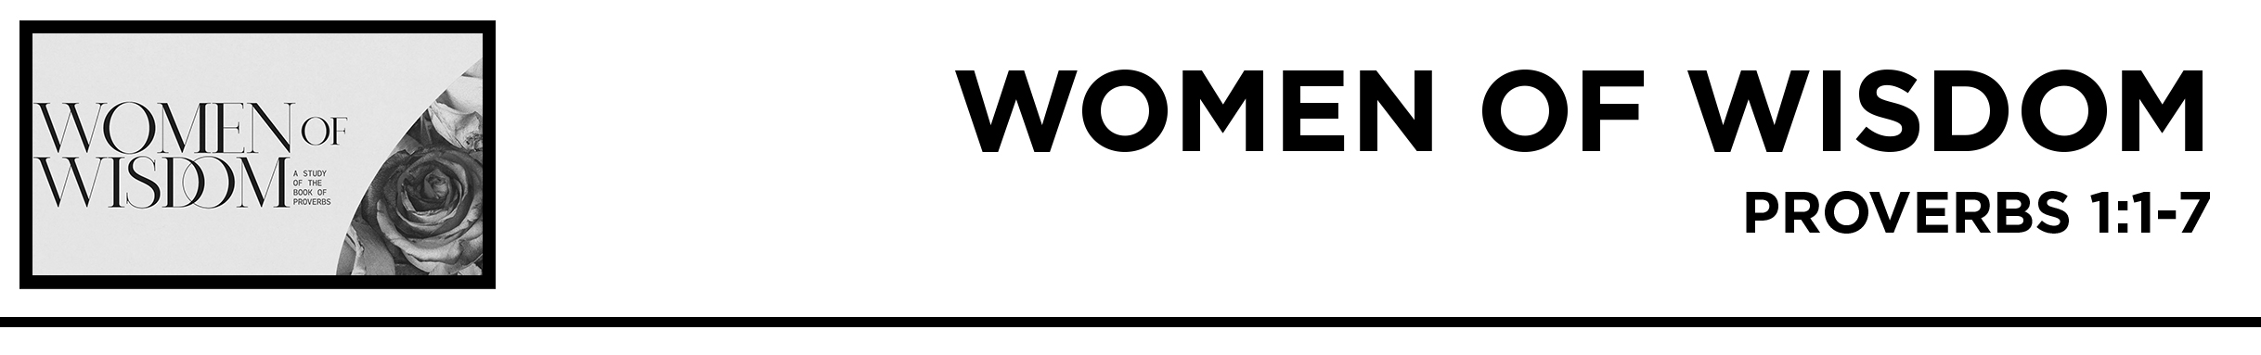
Kayla Thomas • Compass Bible Church Hill Country • July 31, 2021

Proverbs 1:1-7
The proverbs of Solomon, son of David, king of Israel: 2 To know wisdom and instruction, to understand words of insight, 3 to receive instruction in wise dealing, in righteousness, justice, and equity; 4 to give prudence to the simple, knowledge and discretion to the youth— 5 Let the wise hear and increase in learning, and the one who understands obtain guidance, 6 to understand a proverb and a saying, the words of the wise and their riddles. 7 The fear of the LORD is the beginning of knowledge; fools despise wisdom and instruction. (ESV)

1. Fear ________________________ (v.7a)

2. Embrace _________________________ (v.7b)

3. Flee ___________________________ (v.7b)

Application Questions
These questions are provided for your further study and application of today’s teaching. Thoughtfully writing out the answers to these questions will help to drive home the point of today’s study. It is also helpful when you are able to discuss your answers with others. For more information about LifeGroups at Compass Bible Church that utilize these questions as the basis for their weekly discussion, please visit compasshillcountry.org/lifegroups or email us at info@compasshillcountry.org.

1. Read Proverbs 1:1-7. Why is the fear of the Lord the first and most important step to becoming wise? Explain how choosing to fear the Lord isn’t just for the moment of conversion, but also for sanctification.

2. Read Proverbs 1:20-33. What is the danger of missing the warning to fear the Lord in Proverbs 1:7 and 1:29?

3. Read James 3:13-17 and James 1:5. Discuss the difference between Godly wisdom and worldly wisdom. In what ways can you grow in Godly wisdom? Give examples.

4. Describe some of the foolish wisdom you hear from the world? What are some common ways you might stumble from worldly wisdom?

