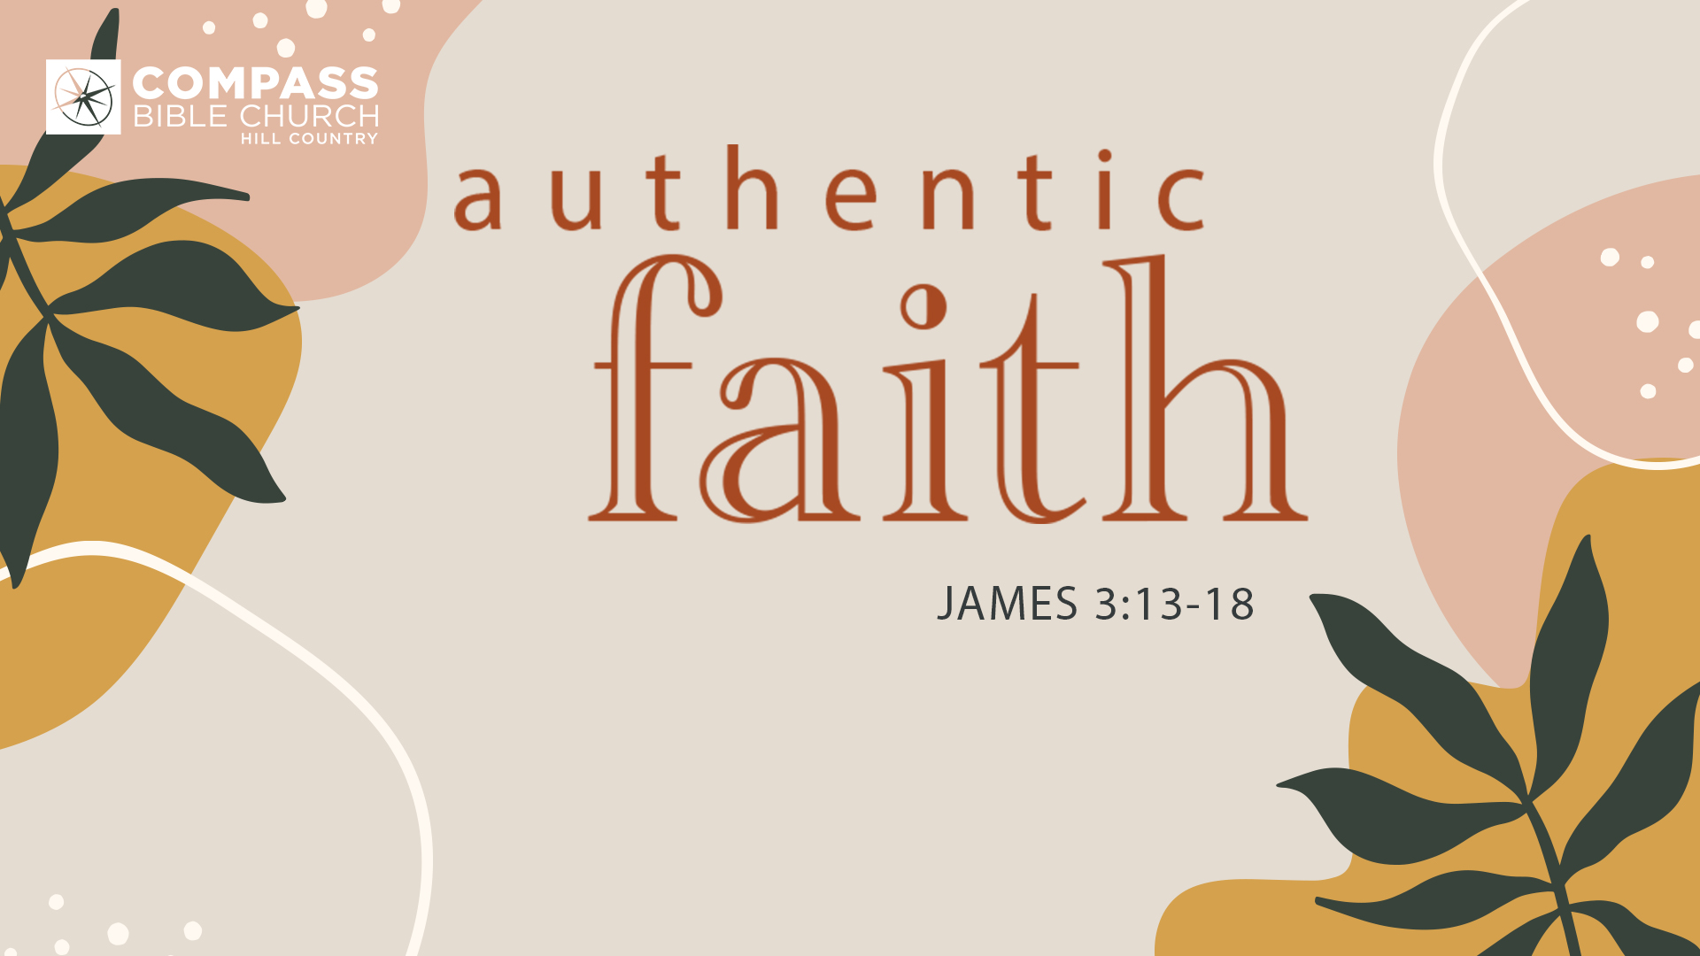
AUTHENTIC FAITH
WISDOM FROM ABOVE
James 3:13-18
Candice Jacobsen • Compass Bible Church Hill Country • October 22, 2022

James 3:13-18
13 Who is wise and understanding among you? By his good conduct let him show his works in the meekness of wisdom. 14 But if you have bitter jealousy and selfish ambition in your hearts, do not boast and be false to the truth. 15 This is not the wisdom that comes down from above, but is earthly, unspiritual, demonic. 16 For where jealousy and selfish ambition exist, there will be disorder and every vile practice. 17 But the wisdom from above is first pure, then peaceable, gentle, open to reason, full of mercy and good fruits, impartial and sincere. 18 And a harvest of righteousness is sown in peace by those who make peace. (ESV)

1. Evaluate ____________________________ (vv.13-14)

2. Uproot _____________________________ (vv.15-16)

3. Submit _____________________________ (vv.17-18)

Application Questions
These questions are provided for your further study and application of today’s teaching. Thoughtfully writing out the answers to these questions will help to drive home the point of today’s study. It is also helpful when you are able to discuss your answers with others. For more information about LifeGroups at Compass Bible Church that utilize these questions as the basis for their weekly discussion, please visit compasshillcountry.org/lifegroups or email us at info@compasshillcountry.org.

1. Write down one observation from the sermon that you found particularly helpful.

2. Read 2 Timothy 3:16 and Hebrews 4:12. What do these passages say about the Word of God? How do these verses change the way you view Scripture? With these passages in mind, how does your personal time spent in the Word need to change?

3. Read Ephesians 2:8-10 and Ephesians 4:22-24. Examining your own life in light of these passages, in what ways do you need to put off the old self, and put on the new self? In other words, how will you practically put off selfishness and do what God wants you to do?

4. Read James 3:17-18, and Philippians 4:8. What can you do this week to invest in the "harvest of righteousness" described by James? How might you be hindering your potential for greater sanctification?

JOIN US! Compass Women Christmas Coffee – Saturday, December 3rd
If you’d like to host a table, use the QR Code to signup!

